**Image 1 - A boy is sitting against a tree, smiling, and looking at the screen of a laptop. His arms are raised.

Graphic - Bookshare logo in a orange box.

Image 2 - A man is looking intently at a tablet screen.**

**How-to Guide**Request Books from the NIMAC

**Image 3 - A boy and woman are smiling as they look at a computer screen. A open book is in the foreground.

Graphic - Blue box.

Image 4 - A woman is smiling as she looks at a tablet screen.**

Need a textbook for your student that isn’t available in Bookshare? For students with IEPs, textbooks often can be acquired through the National Instructional Materials Access Center (NIMAC), a federally-funded repository of digital versions of K-12 print textbooks and related printed core instructional materials.

Most [states](https://www.bookshare.org/cms/help-center/which-states-have-named-bookshare-authorized-user-nimac) have named Bookshare as an Authorized User (AU) of the NIMAC. These states give Bookshare permission to obtain books from the NIMAC on their behalf, upon request from educators. In other states, Bookshare operates as a NIMAC Accessible Media Producer (AMP).

Please note: Only K-12 students who have public school IEPs and are on organizational accounts (or have individual memberships that are connected to organizational accounts) can receive NIMAC-sourced books.

## How Schools and Students Get NIMAC-Sourced Books through Bookshare

# In [States](https://www.bookshare.org/cms/help-center/which-states-have-named-bookshare-authorized-user-nimac) Where Bookshare Operates as an AU

1. If the textbook is not in [Bookshare](https://www.bookshare.org/cms/), [search](https://nimac.overdrive.com/ContentInventory) for it in the NIMAC. If the book is in the NIMAC, take note of the Identifier.

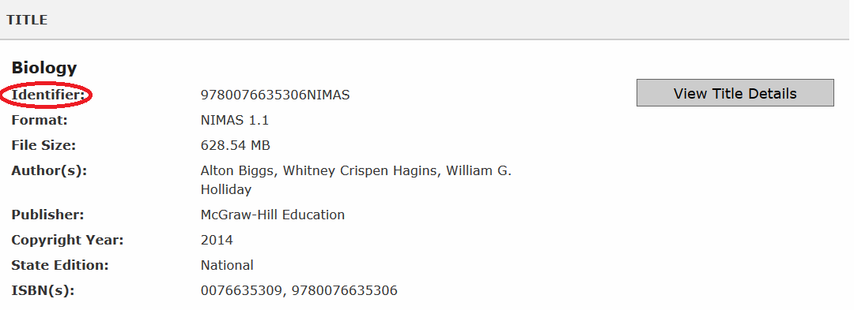

1. When logged into Bookshare, go to the “[Request a Book](https://www.bookshare.org/bookRequest)” link to fill out the request form. Complete the Book Request form and, under “Additional Comments,” include the Identifier from Step 1.

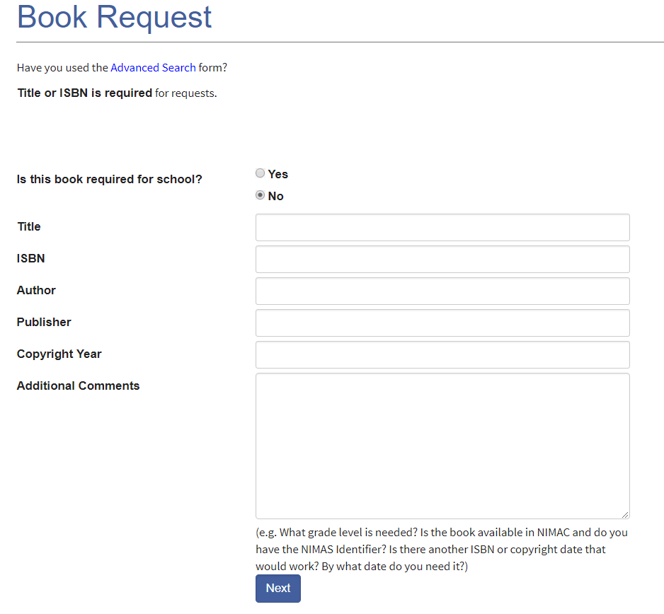

1. Bookshare will obtain the book on behalf of the state/educator/student and add it to the collection. Turnaround time is typically 1-2 weeks from the request date. The Bookshare team will notify you once the book is added. You can also track the status of your request on your “My Bookshare” page through the “My Requests” link.

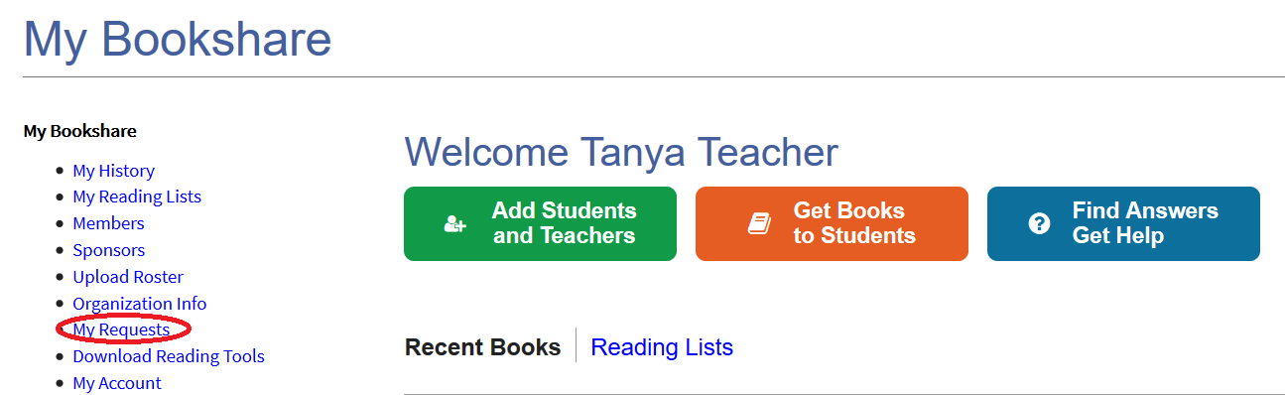

# In States Where Bookshare Operates as an AMP

1. If the textbook is not in Bookshare, [search](https://nimac.overdrive.com/ContentInventory) for it in the NIMAC. If the book is in the NIMAC, take note of the Identifier.



1. Ask your [State's NIMAC Coordinator](http://aem.cast.org/supporting/aem-state-contacts-sea-information.html) to assign the book to Bookshare.
2. Once Bookshare receives notification that the book has been assigned to us, we will process the book and notify the requesting educator when the book has been added to collection. Turnaround time depends on how long it takes the State Coordinator to assign the book to Bookshare.

Once the NIMAC book is in the Bookshare collection, Sponsors on organizational accounts can assign it to their student(s) with IEPs via the [Assign & Read feature](https://www.bookshare.org/cms/help-center/training/assign-and-read) or on a [Reading List](https://www.bookshare.org/cms/help-center/training/reading-lists). Students then simply log in with their usernames and passwords and read on the devices of their choice. To learn more about how students access their assigned books, review the [How to Guide: How Students Access Assigned Books](https://www.bookshare.org/cms/sites/default/files/how_to_guide_how_students_access_assigned_books.pdf).