Add a Group of Sponsors

- Select "Sponsors" on the "My Bookshare" page, then select the "Upload Roster” icon.
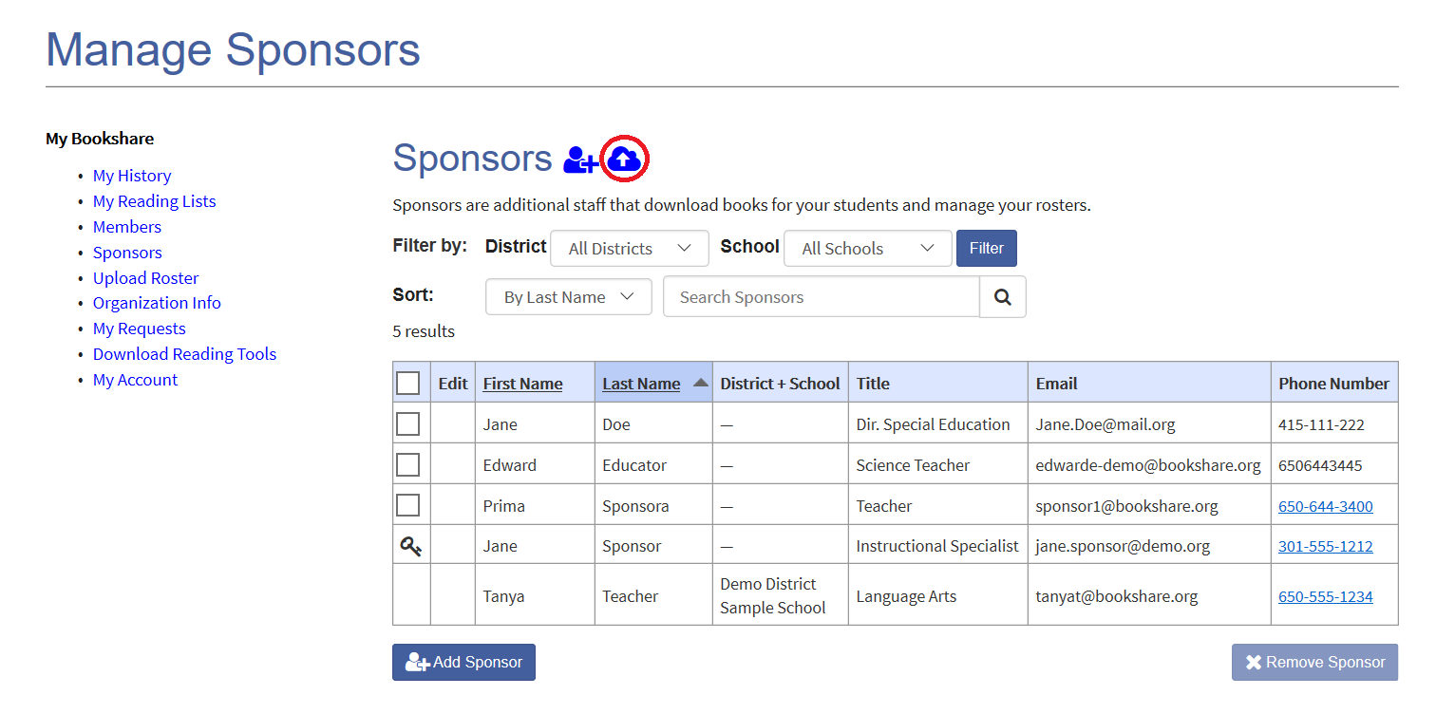

- Download the “New Member/Sponsor Roster Template”.
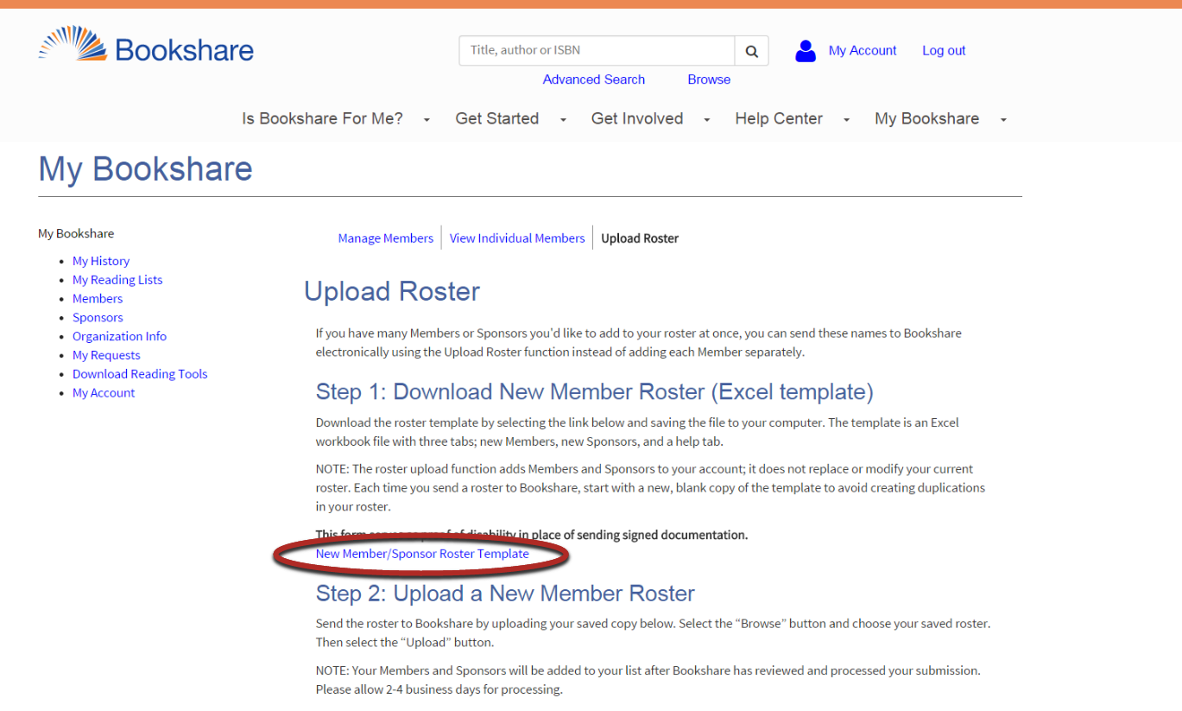
- The Template has three tabs: “Members”, “Sponsors”, and a “Help” tab. Select “Sponsor Roster” and enter names and information.
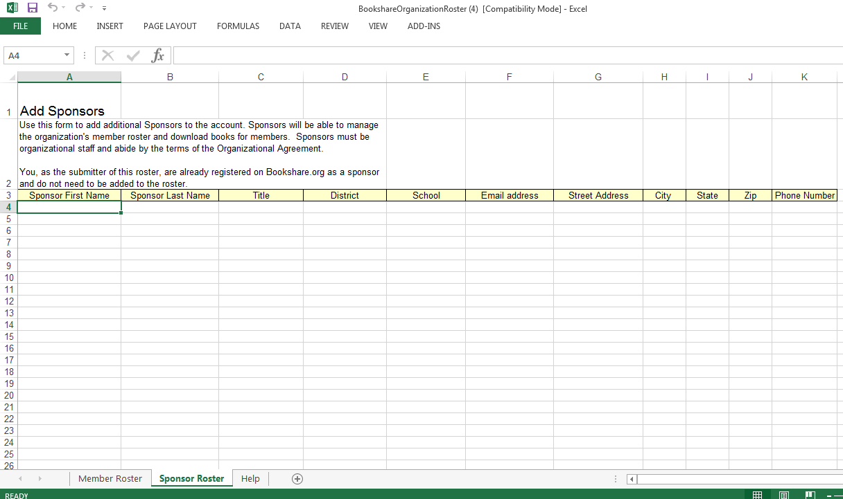
- Save and upload the file.
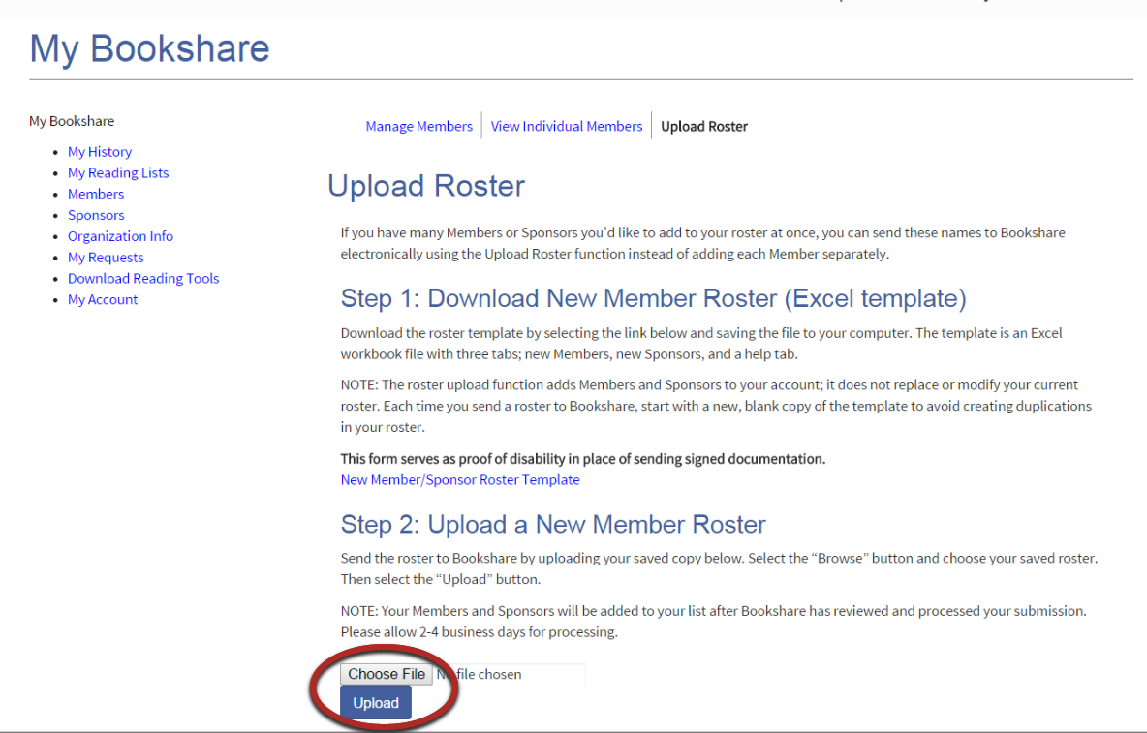
Note: Sponsors will be added to your roster in 2-4 business days.

