Add Several Students

- Select "Members" on the "My Bookshare" page, then select the "Upload Roster" icon.
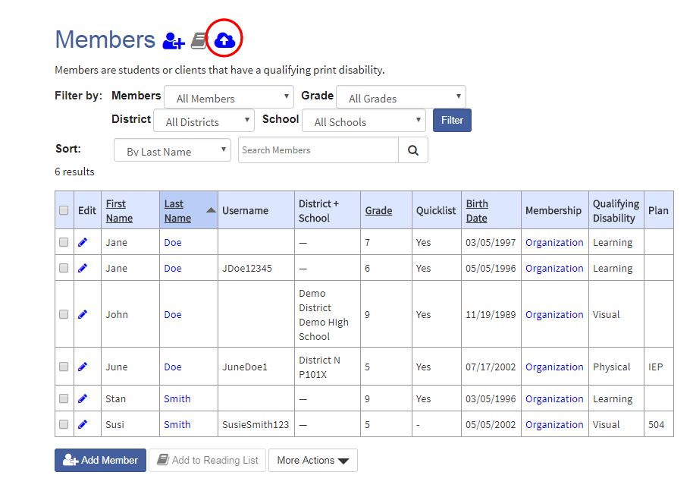
- Download the “New Member Roster Template”.
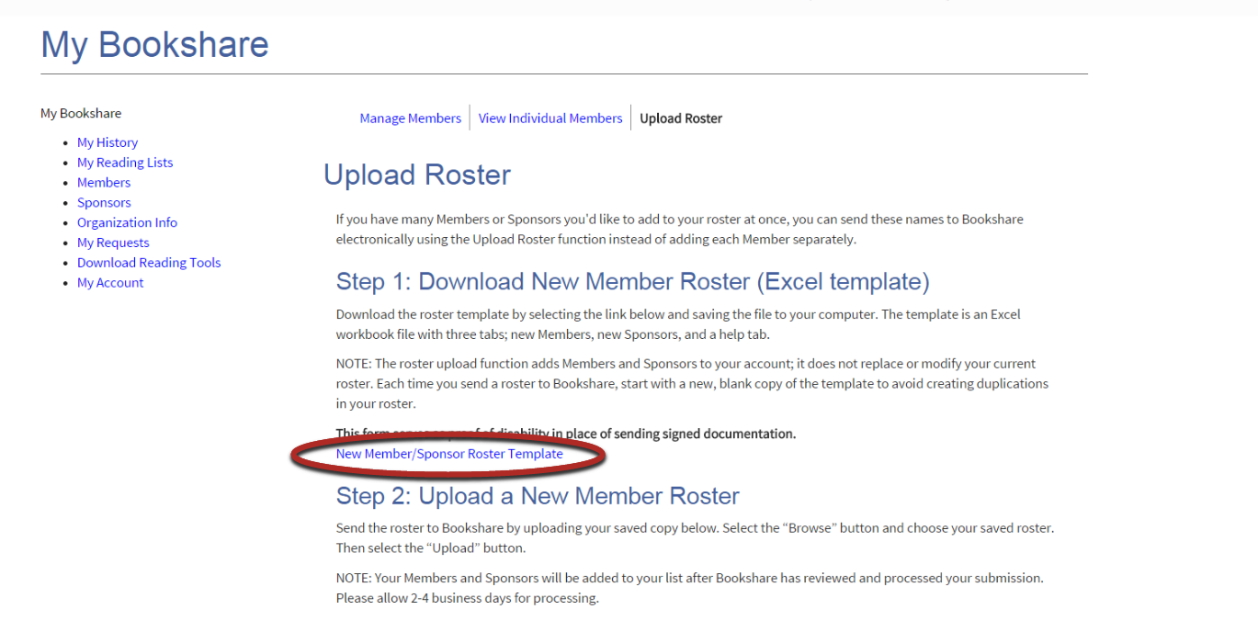
- The Template has three tabs: “Members”, “Sponsors”, and a “Help” tab. Select “Members” and enter names and information.
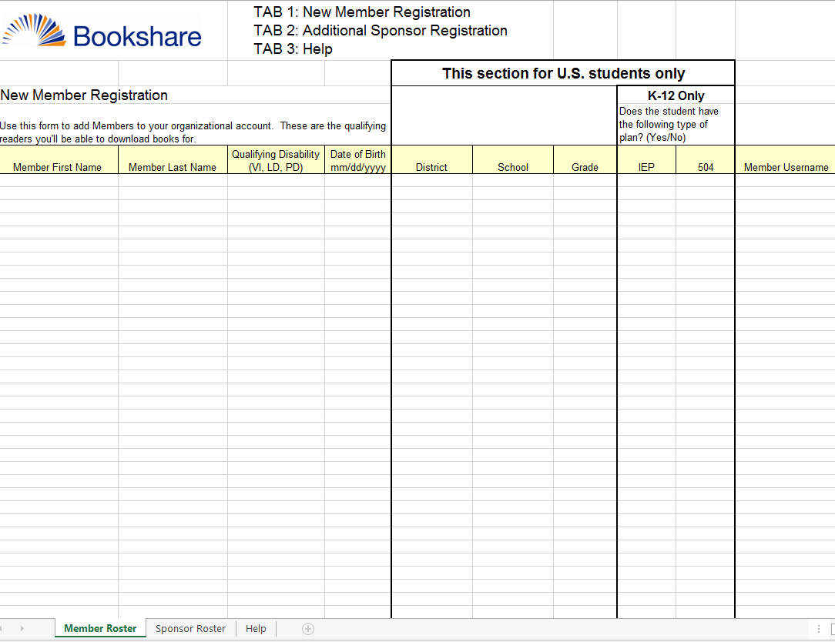
- Save and upload the file. Students will be added to your roster in 2-4 business days.
