How to Guide:

Add Qualified Students and Sponsors to your Bookshare Roster

Sign up Students:

Log into www.Bookshare.org with your username and password.

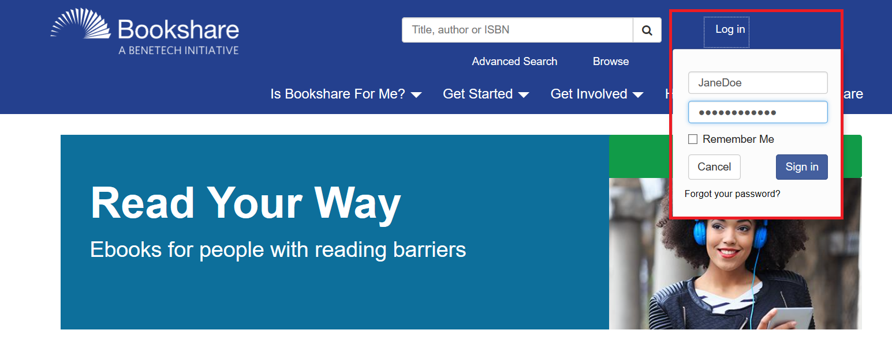

You will be directed to the “My Bookshare” page, or you can select the “My Bookshare” link in the main navigation. From there, select the "Members" link.
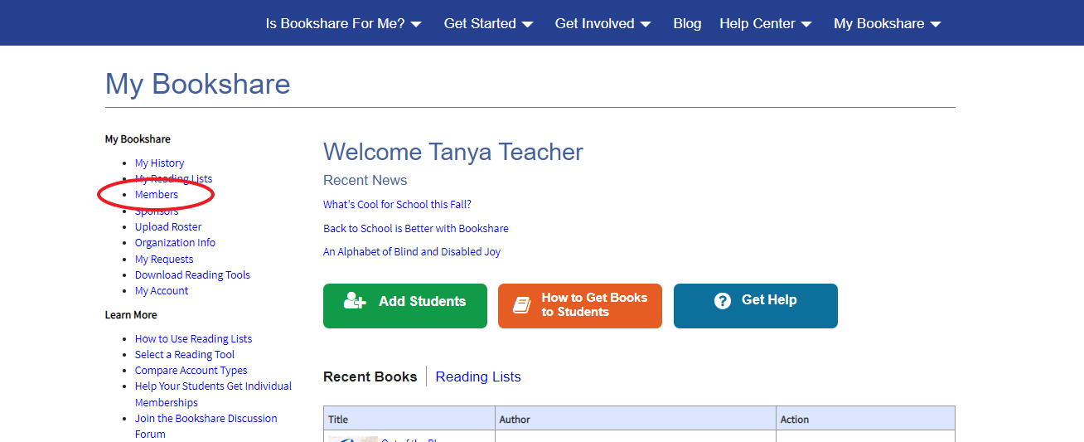

Select the blue "Add a Member" button.
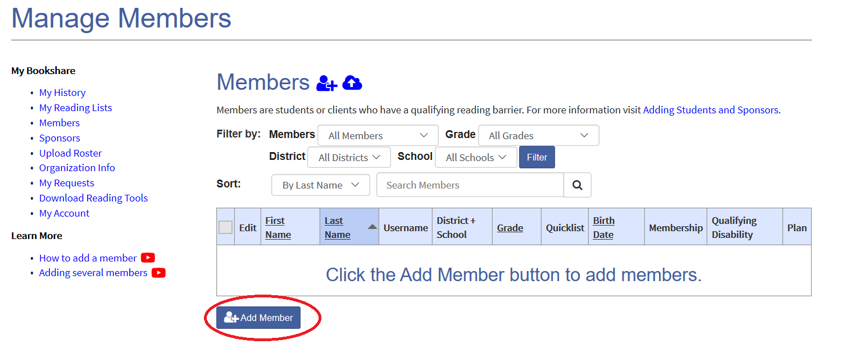

Complete the New Member form. NOTE: Be sure to set a username and password for the student. Usernames can be anything including email addresses or student IDs. Select "Save."
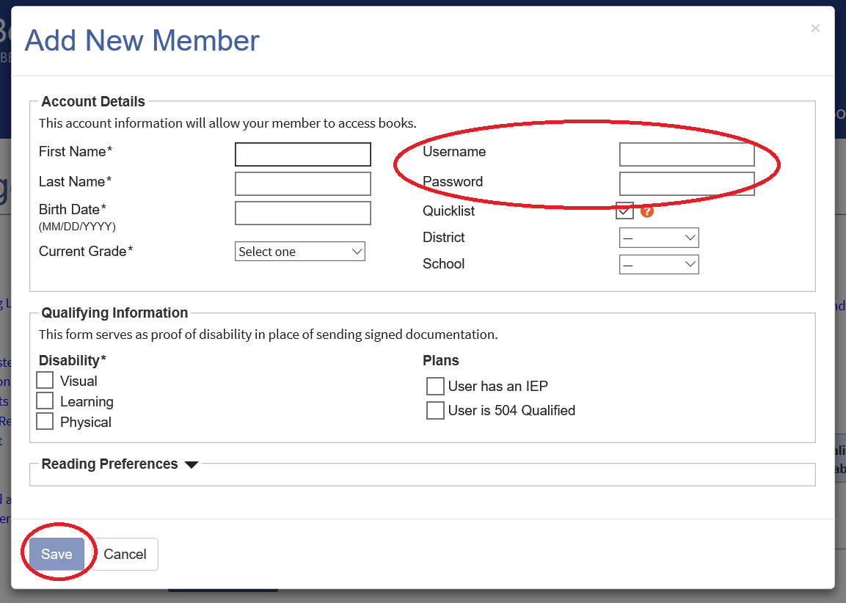

After you add the member, you will be prompted to “Assign Books.” For now, select “Not Now.”
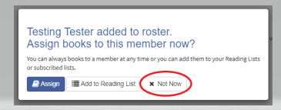

Sign Up Sponsors or Teachers:

Next, add Sponsors or Teachers by selecting the “Sponsors” link on your “My Bookshare” page.

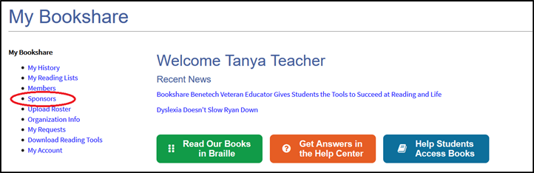

Select the “Add Sponsor” button, or the icon to add a new Sponsor.
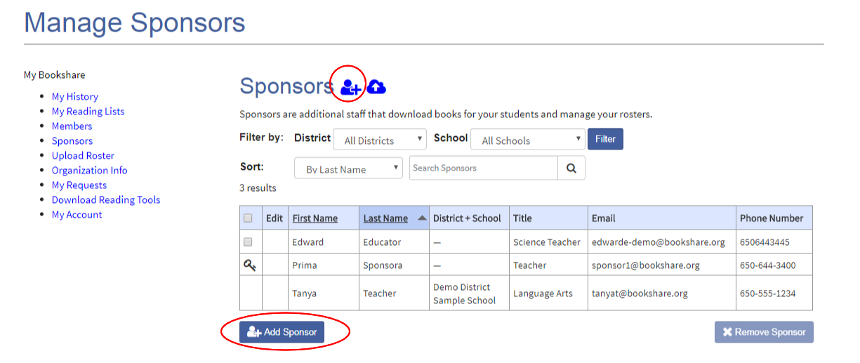

Complete the “Add New Sponsor” form and select the “Save” button.

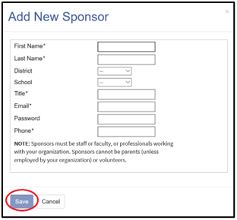

Congratulations! Thank you for choosing Bookshare to support your students!
If you would like to learn more, please visit our
Training and Learning Center!!!

