**Three zoned graphic. On the far left is a boy sitting against a tree, smiling, and looking at the screen of a laptop. His arms are raised.
The middle graphic is the Bookshare logo in a orange box.
on the far right is a man wearing glasses, looking intently at a tablet screen.**

# How to Guide

# Educators: Sign up Your School or District and Get Started with Bookshare!

Sign up at <https://www.bookshare.org/cms/get-started/sign> Select **“Sign up Organization”**.

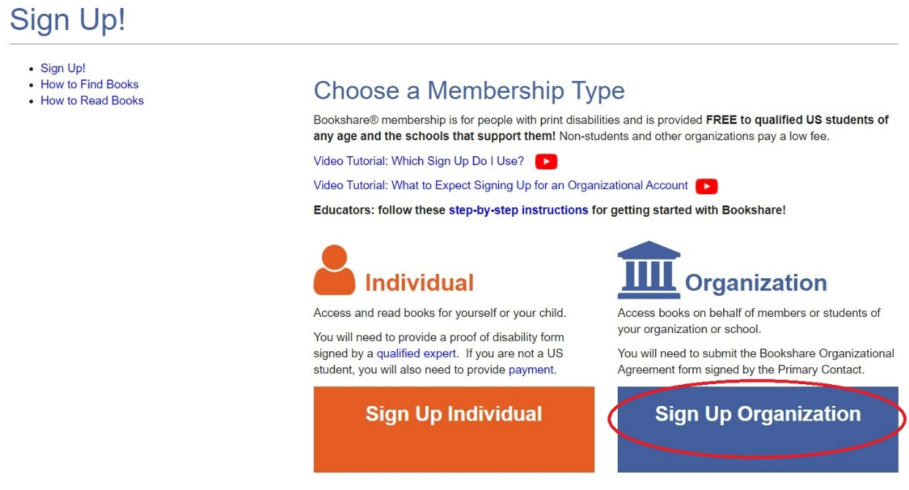

Select **“US School” for all US K-12 schools and districts**. Select other options for non-school organizations.

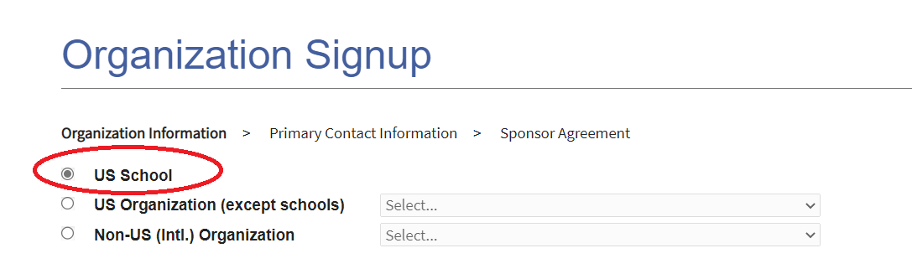

Enter your school’s information and select the **“Find My School” button. NOTE: If you school already has an account, we ask that you do not sign up for a new one, but rather use the existing account. If you do not know who manages your school account, please email** [**findmyschool@bookshare.org**](mailto:findmyschool@bookshare.org) **or contact our** [**Customer Support team.**](https://www.bookshare.org/contactUs)

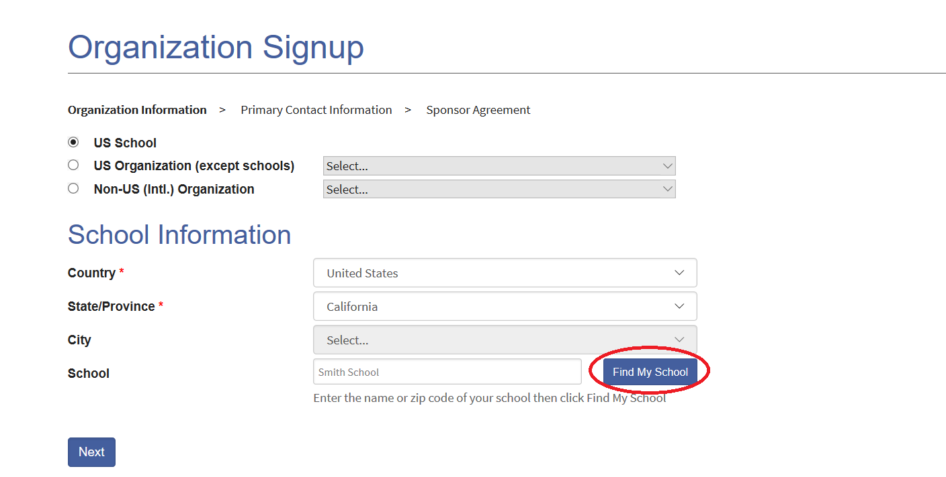

Select your school on the list and select **the “Done” button, then “Next.”** If your school is not on the list, select **“I cannot find my school listed” and** select the **“Done”** button. Fill in the required school information and select **“Next”** to continue.

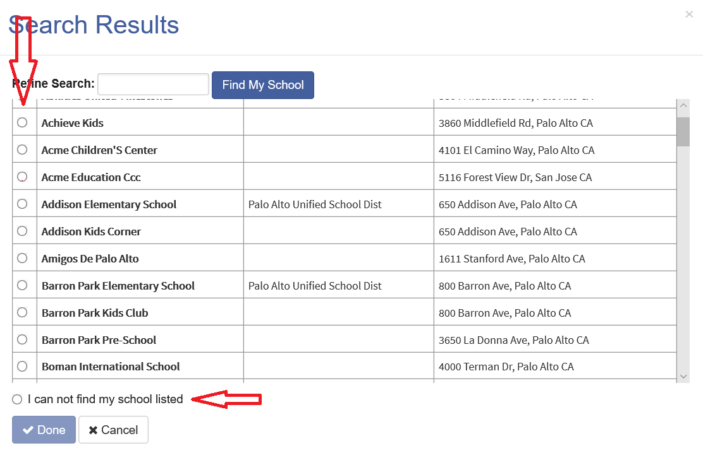

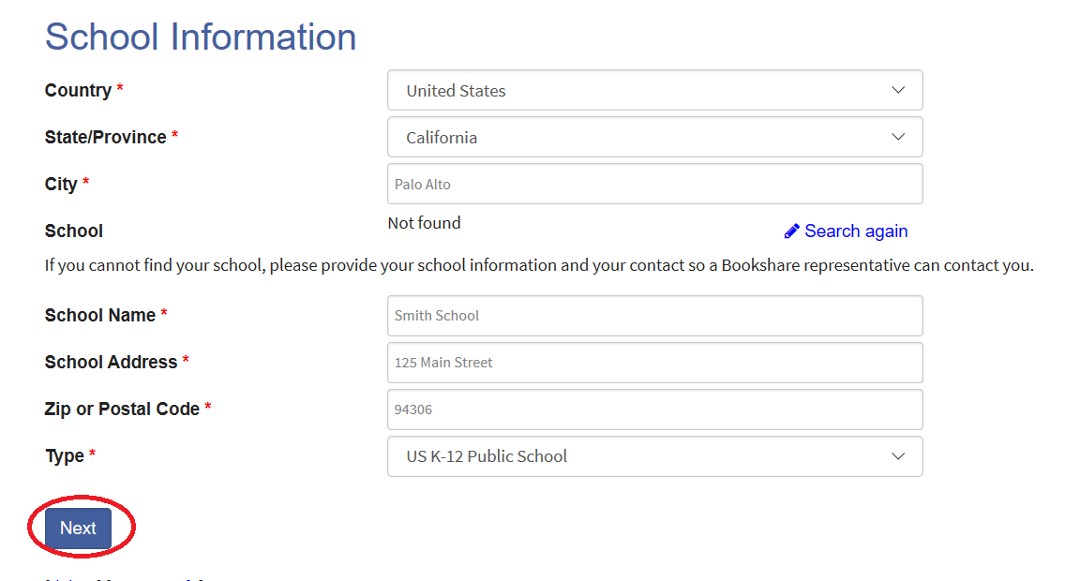

Confirm your school’s information or if the information is incorrect, select **“None of the above this is a new organization**” and select **“Continue.”**

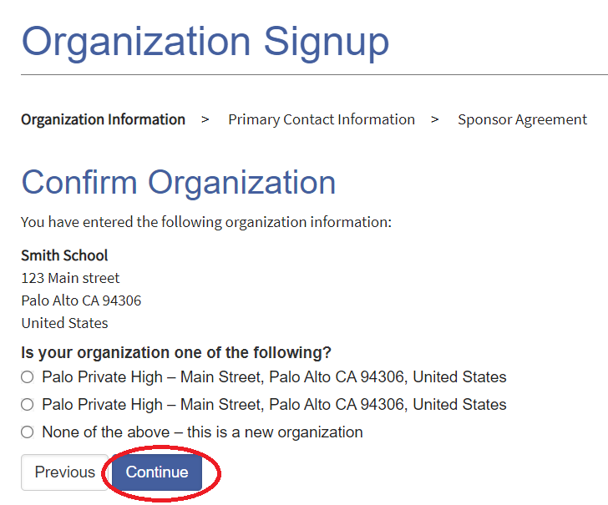

Enter Primary Contact information and select **“Continue.” NOTE: This will be the primary person responsible for the organizational account.**

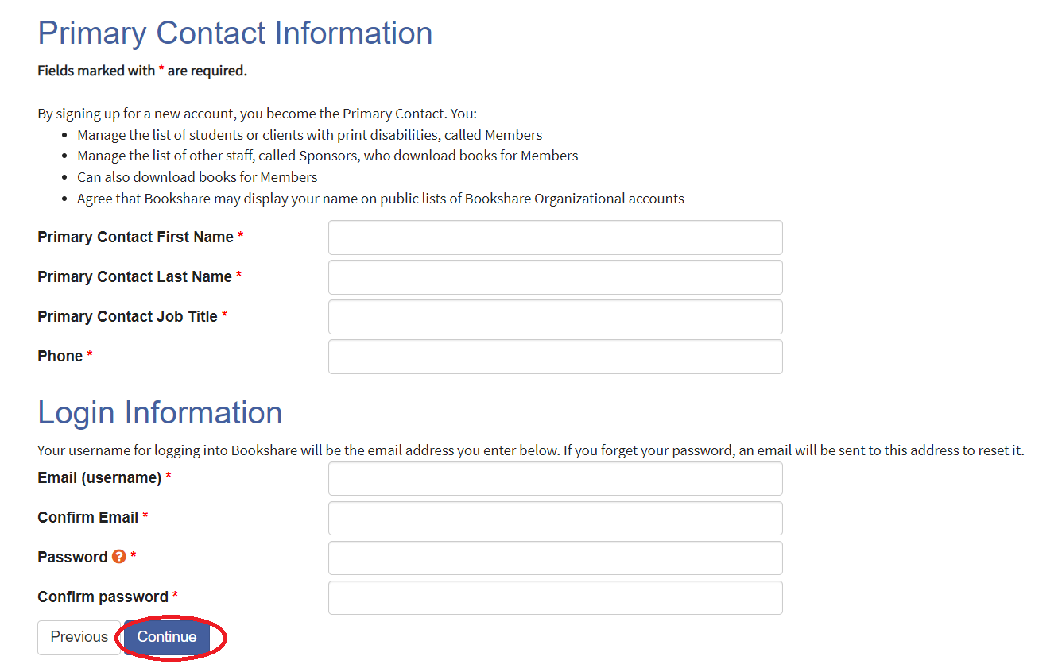

Read and agree to the Sponsor Agreement terms online and select **“Submit.” NOTE: THIS IS THE LAST ONLINE PART OF THE SIGN-UP PROCESS.**

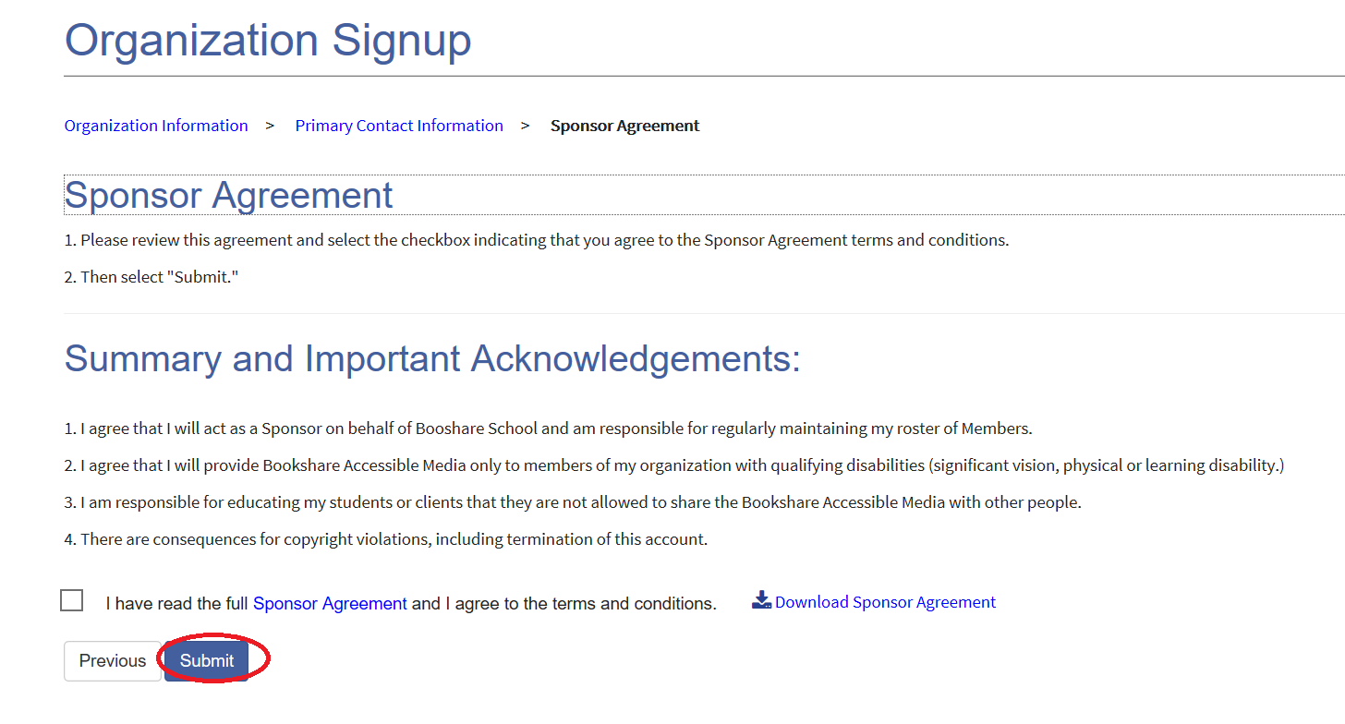

You will be taken to your **“My Bookshare”** page, which will indicate that organization status is Incomplete. Select the Incomplete link to review instructions for completing and submitting the Organization Agreement form.

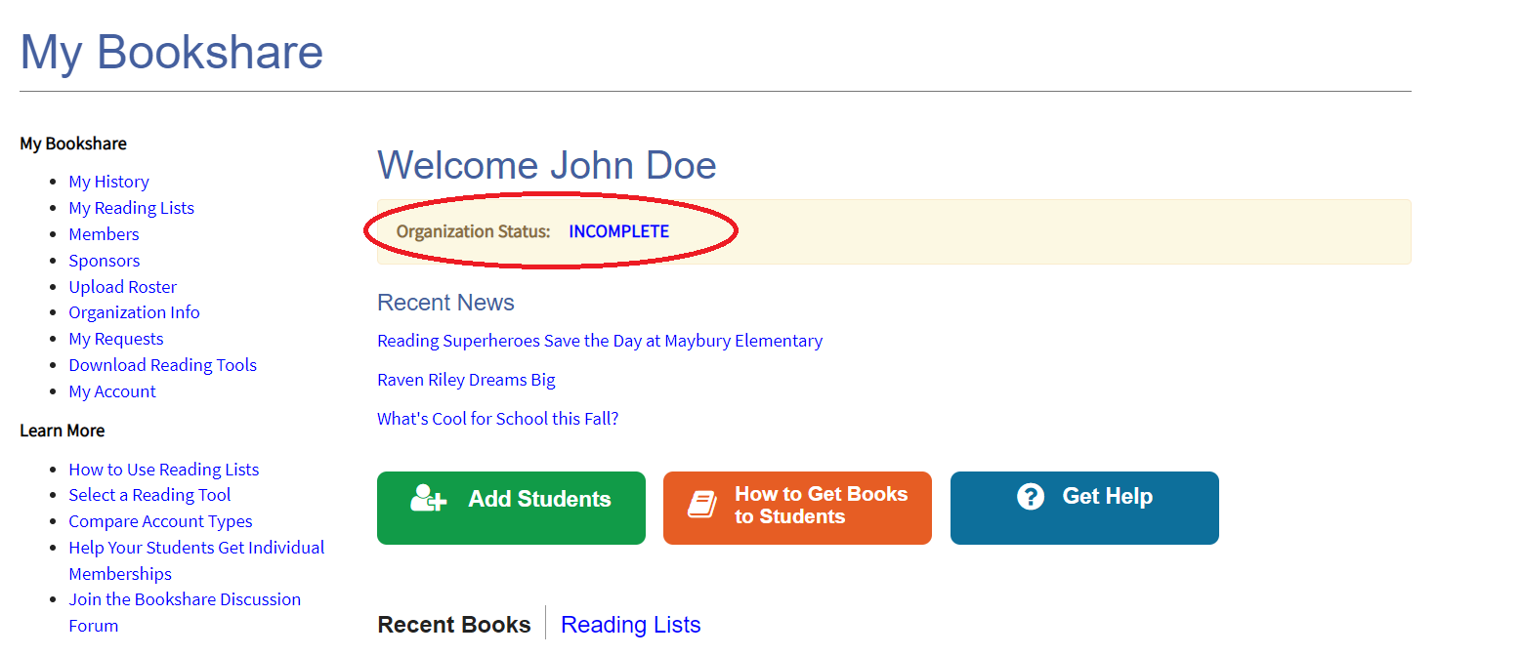

**Thank you for using Bookshare for your students! You will get an email from Bookshare in a few days confirming your Organization’s Account has been successfully set up.**

**If you have any additional questions, please contact our Customer Service Team**

[**membership@bookshare.org**](mailto:membership@bookshare.org) **or call 650-352-0198**

**Monday – Friday 5am – 5pm PST**