**Image 1 - A boy is sitting against a tree, smiling, and looking at the screen of a laptop. His arms are raised.

Graphic - Bookshare logo in a orange box.

Image 2 - A man is looking intently at a tablet screen.**

How-to Guide   
for Beta Testers

## Download and Read Bookshare Titles in Microsoft Word

## Image 3 - A boy and woman are smiling as they look at a computer screen. A open book is in the foreground. Graphic - Blue box. Image 4 - A woman is smiling as she looks at a tablet screen.

# Step 1: Activate the Beta Test Option for Word as a Download Format

**We are excited that you are interested in helping us prepare to offer Word as a download format for Bookshare titles! Beta users should be able to provide feedback to us in a timely manner. As such, we recommend that teachers should assist younger students in looking over a book downloaded for them. For questions, please contact beta@bookshare.org**

1. Log into [Bookshare](http://www.bookshare.org), using whichever browser you normally use to get to Bookshare   
   (e.g. Chrome or IE on a laptop, Safari on an iPad, etc.).
2. Go to the ‘[Help us “Beta Test” new features!](https://www.bookshare.org/cms/help-center/beta-test-new-features)’ page   
   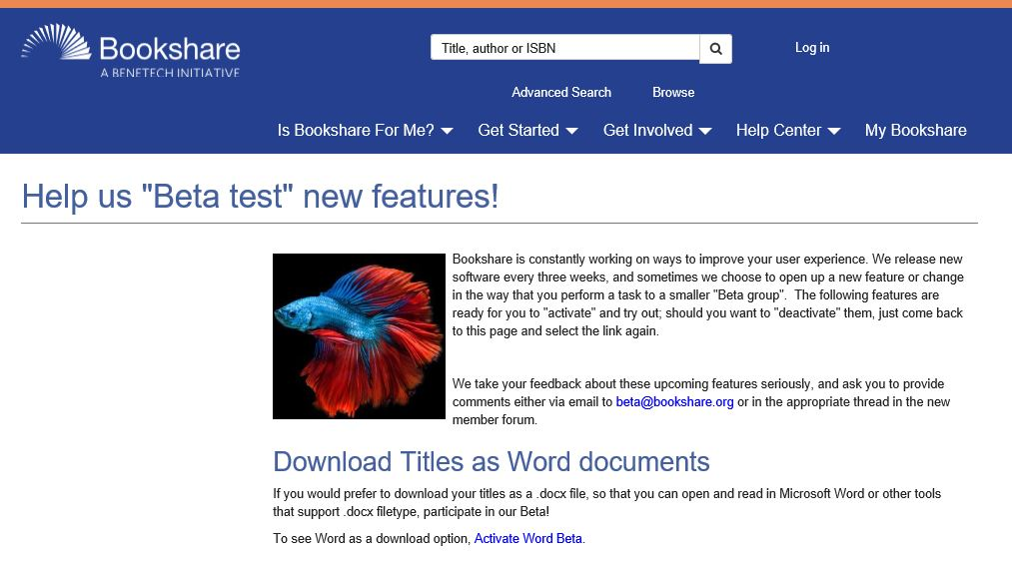
3. Choose the [Activate Word Beta](https://www.bookshare.org/activateBetaFeature?key=fffcf6e27e1c11e7b488efa5ece1b7cc) link  
   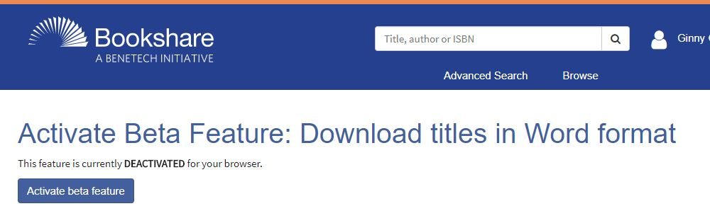

*Note: if you are going to just download a few titles in Word from one computer or tablet, you are done with the setup!*

* *If you will be testing on multiple devices, such as both a school Chromebook and an iPad, or from a home computer, you will need to perform this activation step on every different device you plan on testing from.*
* *If you are a teacher who wants to have your older students assist with the testing, they will need to perform this activation step on the computer or tablets that they are using to download or read books.*

**Step 2: Download a Book that is available in Word format**

1. Go to the [Word Beta Test Reading List](https://www.bookshare.org/browse/collection/201701) page ([www.bookshare.org/browse/collection/201701](http://www.bookshare.org/browse/collection/201701)).   
   *This list does contain some titles that are available only to U.S. School Students who have an IEP because they are available from the NIMAC.*  
   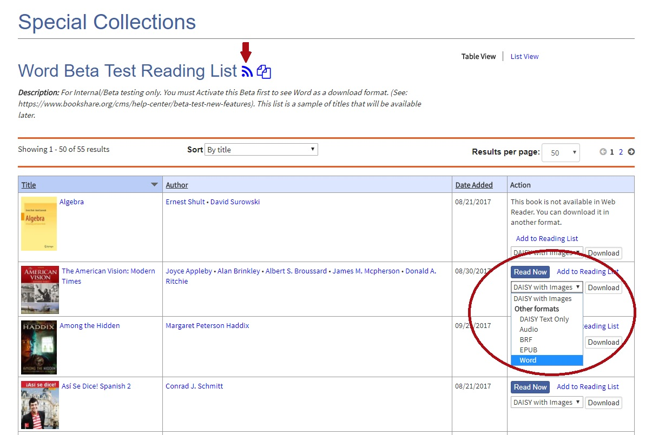
2. Subscribe to the list using the icon at the top of the page (or button at the bottom). *This subscribe action will make it easier for you to find the list later, as it will appear on your “*[*My Bookshare*](https://www.bookshare.org/myHome)*” and “*[*My Reading Lists*](https://www.bookshare.org/myReadingLists)*” pages.*
3. You can download any of these titles as “Word”.

*Something to note is that titles like the Algebra book that is included on this list are too-complex for our Web Reader, but can be downloaded in Word!*



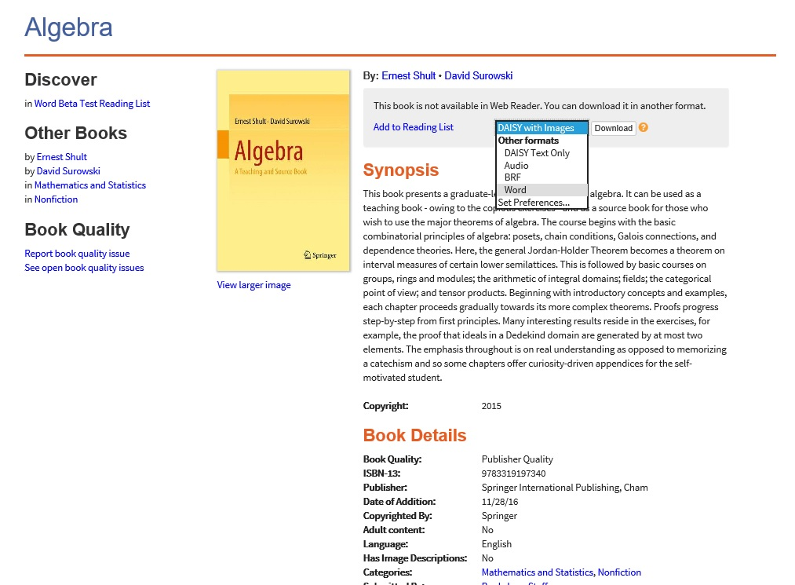

1. When you download the file that has been prepared for the Bookshare Individual Member or Student Member, you will see that the title is zipped into a folder (similar to all of our other Bookshare downloads).   
    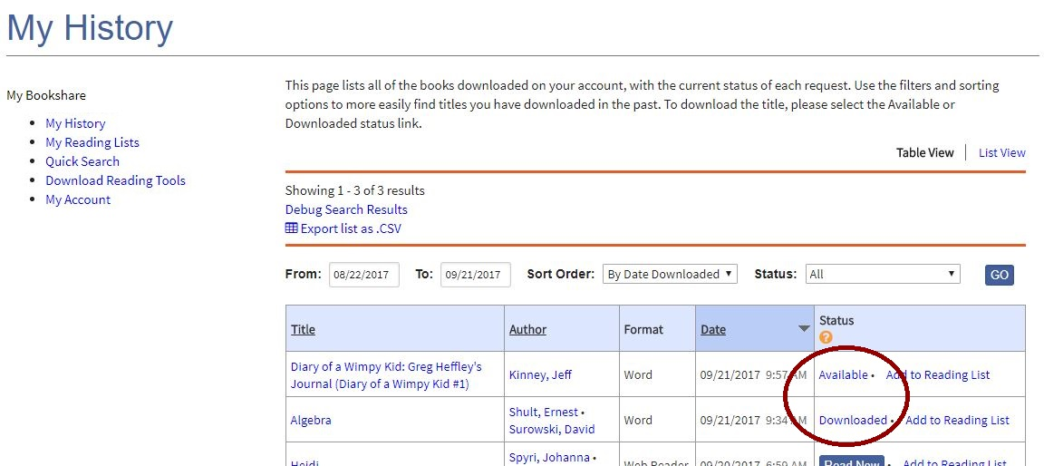 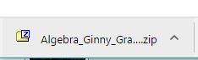
2. Save the folder to wherever you normally save your Bookshare downloads, and then open the zipped folder. You will see one or more .docx files that contain the content of the whole Bookshare title. Shorter books will contain just a single .docx file, but more-complex ones like this Algebra title will have multiple files.  
   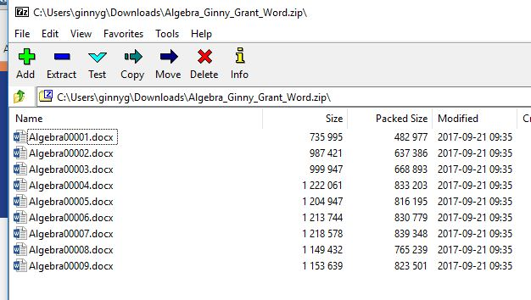
3. Open a .docx file from the folder and view it in Microsoft Word (or other tool that opens .docx files). All navigation elements like chapters or sections, bullets and tables, that are available in our DAISY version are going to be available in this Word format.  
   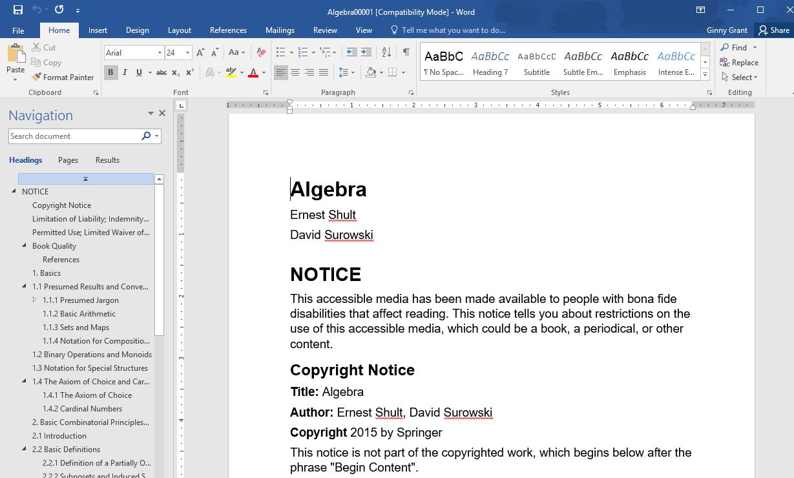
4. For those who use Google Docs or other tools, you may also open these .docx files there, with the reminder that this Word format needs to be considered the same as any other Bookshare book, and **is for the sole use by the Bookshare member for whom it was prepared**.
5. Please send feedback to [beta@bookshare.org](mailto:beta@bookshare.org). Please include the title of the book you downloaded into Word, how you were reading it, and, when applicable, indicate specifically what part of the book’s content were problematic. Constructive criticism as well as concerns are welcome!

**Questions?**

*Q: Can I change the size, font or color of the text?*

*A: Yes, of course. Bookshare has set a default for all Word documents that we generate, but if a particular style or spacing works better for a particular Bookshare member, please change the styles on your downloaded version.*

*Q:? I am a Bookshare Sponsor, and have some students who would be really great at testing their books in Word. I think that they are able to provide feedback on the quality and/or usefulness of being able to open their books in Word. What do I need to do to get them into the Beta?*

*A: After you have subscribed to the Word Beta Test Reading List, you can assign to one or more of your students so that they may have access to these same titles. Remember that they will also need to follow Step 1 above, so that they see “Word” in the download format list.*

*Q: ?*

*A:.*

For answers to other questions, please visit [https://www.Bookshare.com/cms/help-center](https://www.bookshare.com/cms/help-center).