**Image 1 - A boy is sitting against a tree, smiling, and looking at the screen of a laptop. His arms are raised.

Graphic - Bookshare logo in a orange box.

Image 2 - A man is looking intently at a tablet screen.**

**How to Guide**Add Members to an Organizational Account

**Image 3 - A boy and woman are smiling as they look at a computer screen. A open book is in the foreground.

Graphic - Blue box.

Image 4 - A woman is smiling as she looks at a tablet screen.**

Members can be added one by one or in a group using a downloadable spreadsheet.

**Add Members One by One**

1. Select the “Members” link from your “My Bookshare” page.

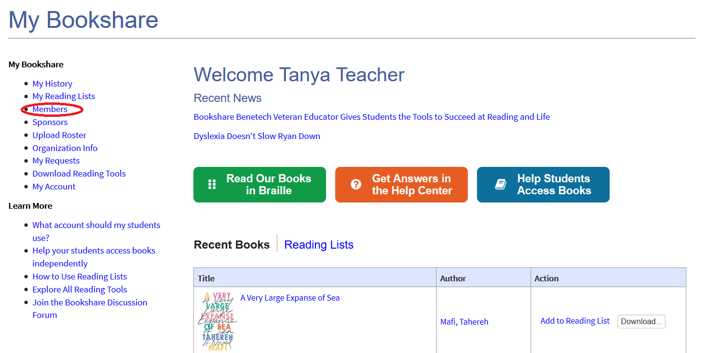

1. Select “Add a Member”.

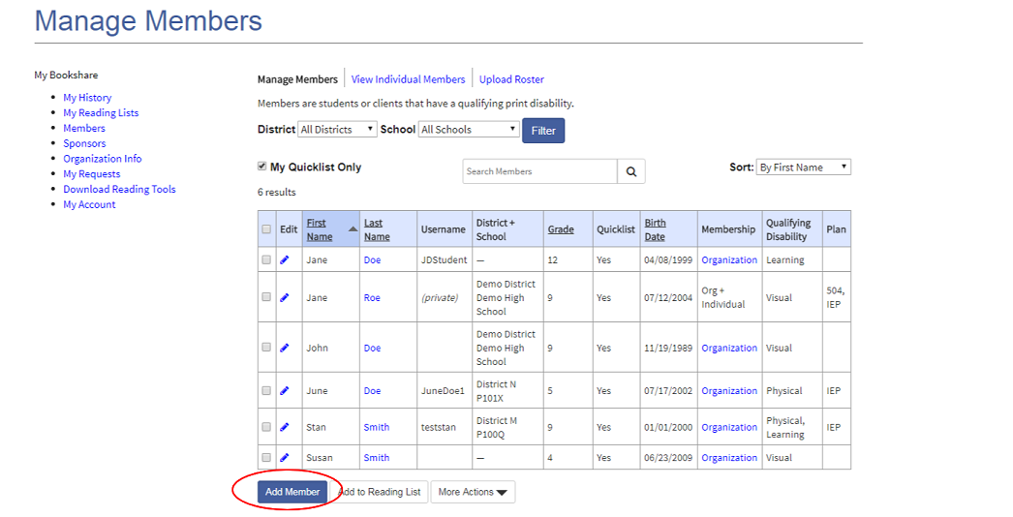

1. Enter student information. Be sure to set a username and password. Select “Save”.

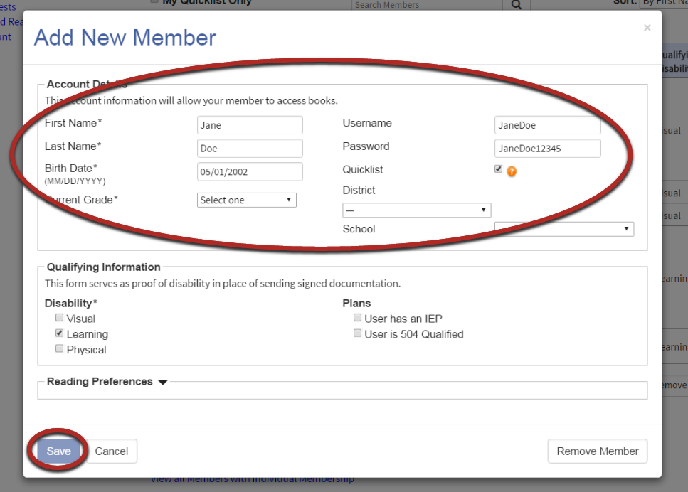

# Add a Group of Members

1. On the "Sponsors" or "Members" page, select the cloud icon to access the “Upload Roster” page.

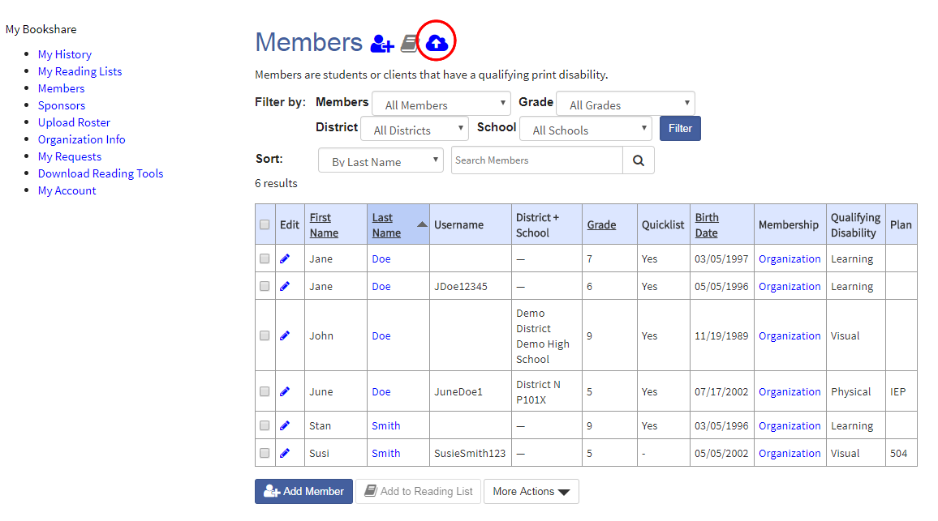

1. Download the “New Member Roster Template”.

Upload Roster page with link to roster template circled.


1. The Template has three tabs: “Members”, “Sponsors”, and a “Help” tab. Select “Members” and enter names and required information.

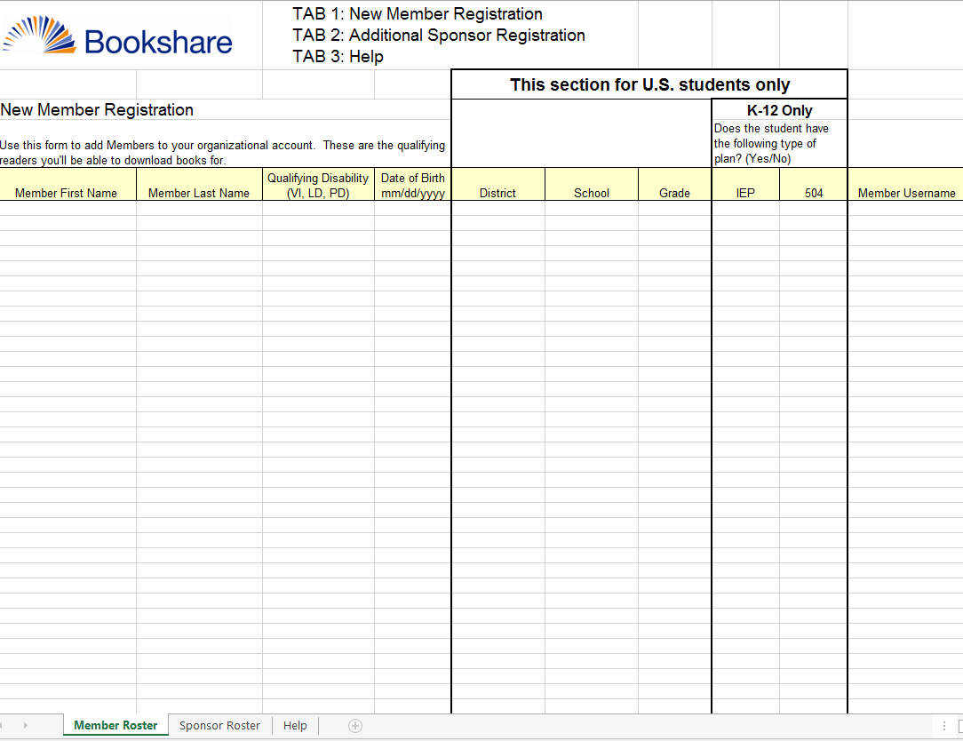

1. Save and upload the file. Members will be added to your roster in 2-4 business days.

Screenshot of the Upload Roster page with the button to upload the roster highlighted.
