**Image 1 - A boy is sitting against a tree, smiling, and looking at the screen of a laptop. His arms are raised.

Graphic - Bookshare logo in a orange box.

Image 2 - A man is looking intently at a tablet screen.**

**How to Guide**Add Sponsors to an Organizational Account

**Image 3 - A boy and woman are smiling as they look at a computer screen. A open book is in the foreground.

Graphic - Blue box.

Image 4 - A woman is smiling as she looks at a tablet screen.**

The Primary Contact can add additional teachers, or Sponsors, who can download books for students and members. Sponsors can also add additional educators as Sponsors.

Sponsors and members can be added one by one or in a group using a downloadable spreadsheet.

**Add Sponsors One by One**

1. Select the "Sponsors" link on the "My Bookshare" page.

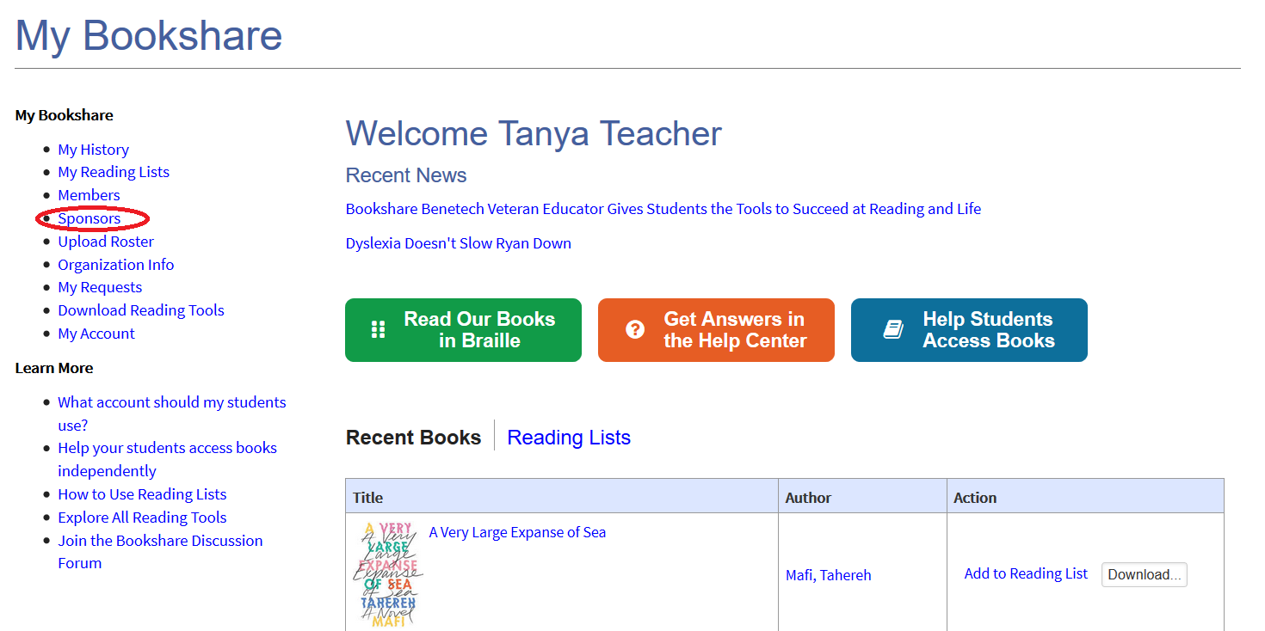

1. Select “Add a Sponsor”.

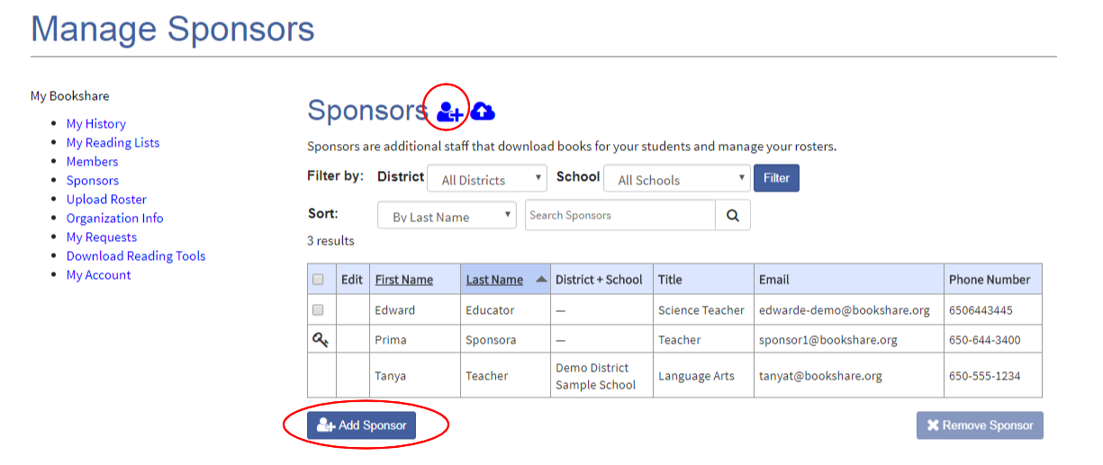

1. Enter the information and select "Save." The new Sponsor will get an email prompting him/her to agree to Bookshare’s membership terms and to create a password.

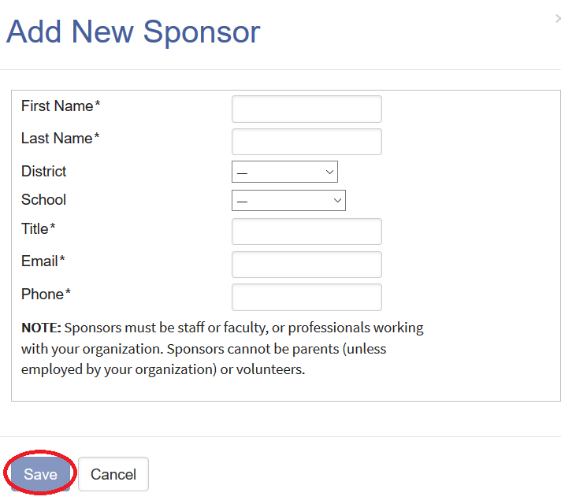

# Add a Group of Sponsors

1. On the "Sponsors" page, select the cloud icon to access the “Upload Roster” page.

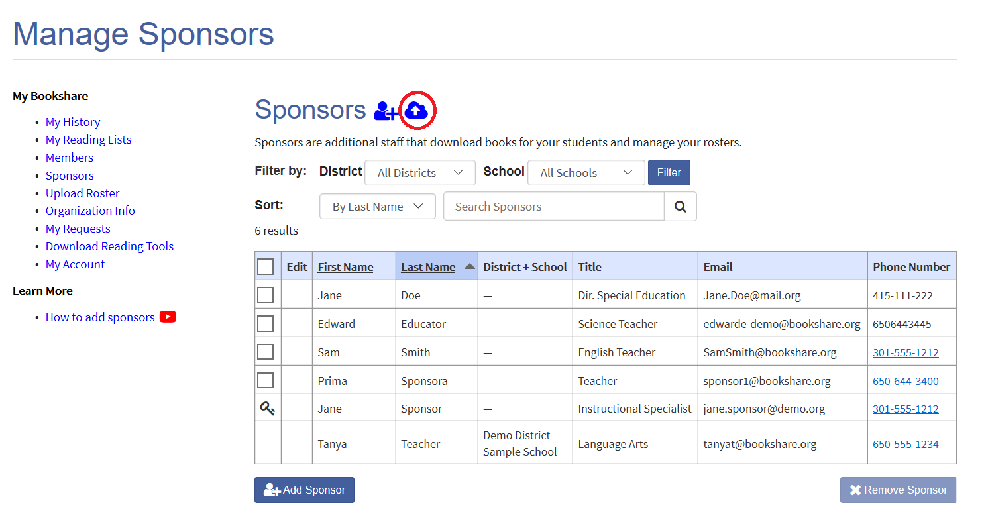

1. Download the “New Member Roster Template”.

Upload Roster page with link to roster template circled.


1. The Template has three tabs: “Members”, “Sponsors”, and a “Help” tab. Select “Sponsors” and enter names and information.

Screenshot of the roster spreadhseet showing the fields to complete such as Sponsor name, title, email, and phone.


1. Save the file to your computer, then and upload the file on the Upload Roster Page. Sponsors will be added to your roster in 2-4 business days.

Screenshot of the Upload Roster page with the button to upload the roster highlighted.
