**Image 1 - A boy is sitting against a tree, smiling, and looking at the screen of a laptop. His arms are raised.

Graphic - Bookshare logo in a orange box.

Image 2 - A man is looking intently at a tablet screen.**

**How to Guide**

Read with Bookshare

Web Reader!

**Image 3 - A boy and woman are smiling as they look at a computer screen. A open book is in the foreground.

Graphic - Blue box.

Image 4 - A woman is smiling as she looks at a tablet screen.**

# Read with Bookshare Web Reader

The easiest way to read Bookshare books is with the Bookshare Web Reader. Features include text-to-speech, word highlighting and options for large print. The Web Reader includes self-voicing with word highlighting on the following browsers:

* Google Chrome version 33+
* Safari version 6.1+
* Google Chrome version 14-32 ([Bookshare Chrome Extension installation required](https://chrome.google.com/webstore/detail/bookshare-web-reader/bkfmjmjngglphchhiemnghidpnddofmo?hl=en))
* Chromebooks version 14+ ([Bookshare Chrome Extension installation required](https://chrome.google.com/webstore/detail/bookshare-web-reader/bkfmjmjngglphchhiemnghidpnddofmo?hl=en))

The Web Reader displays the books on the following browsers without the text to speech and highlighting:

* Mozilla Firefox version 6+
* Safari version 6.0+
* Internet Explorer 9, 10 and 11
* iPad with iOS 7+
* The Web Reader is not supported on other mobile devices.

## Bookshare Web Reader

1. Log into your Bookshare account.
2. Search for a book.



1. Select “Read Now”

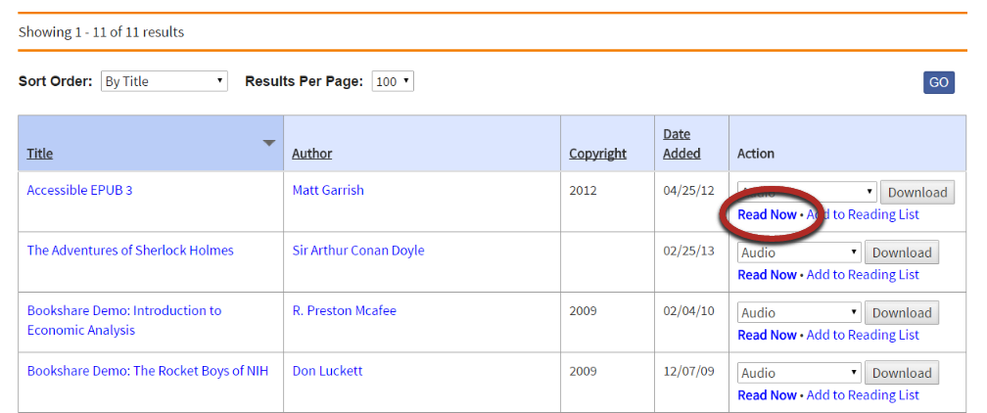

1. Next, Bookshare packages the book and prepares it for reading in your browser.

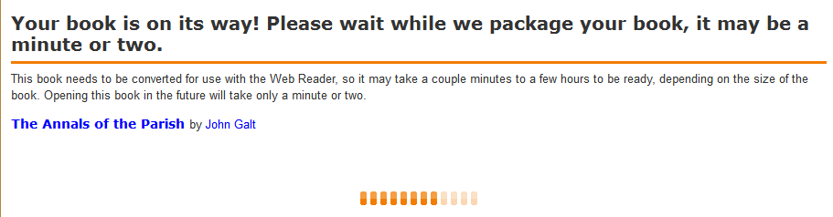

1. Now your book is ready to be viewed – and heard – in the Web Reader.
2. To hear the book read aloud, select “Play”. Speaker Icon
3. Use the settings button to change font size and text and background color.

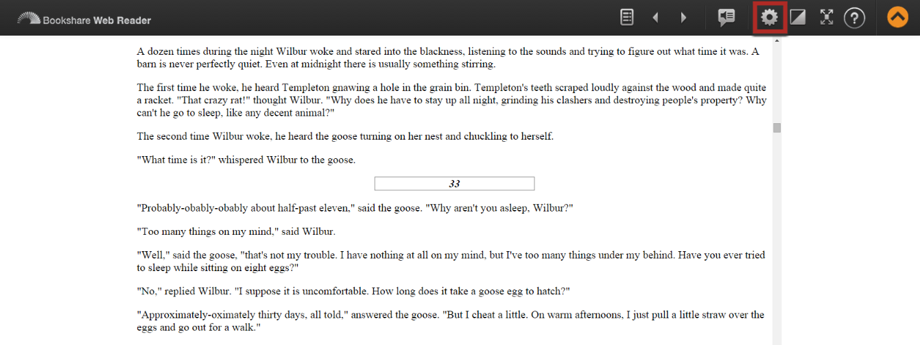

Settings for changing font and appearance of book in Web Reader.
