**Three zoned graphic. To the far left is a boy is sitting against a tree, smiling, and looking at the screen of a laptop. His arms are raised. In the middle is the Bookshare logo in a orange box. To the far left is a man looking intently at a tablet screen.**

# **How-To Guide**

# **Find and Request Books**

## How to Search, Utilize Advanced Search Features, Browse for Books and Request Books:

Log into your Bookshare account at [www.bookshare.org](http://www.bookshare.org)

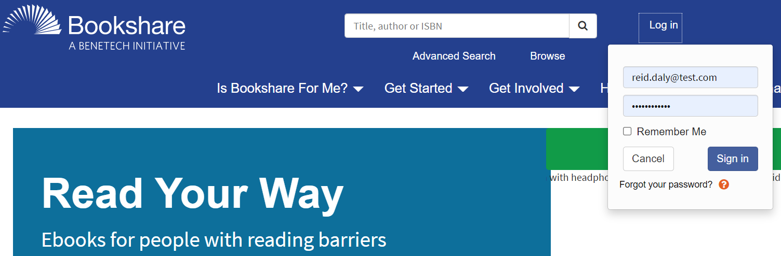

Enter a search term in the **Search Text Box** located at the top of every page. You can search by title, author, or ISBN. This searches all text, including the title, author and contents of every book in the library.



Select the **“Browse link”** to browse our special collections.

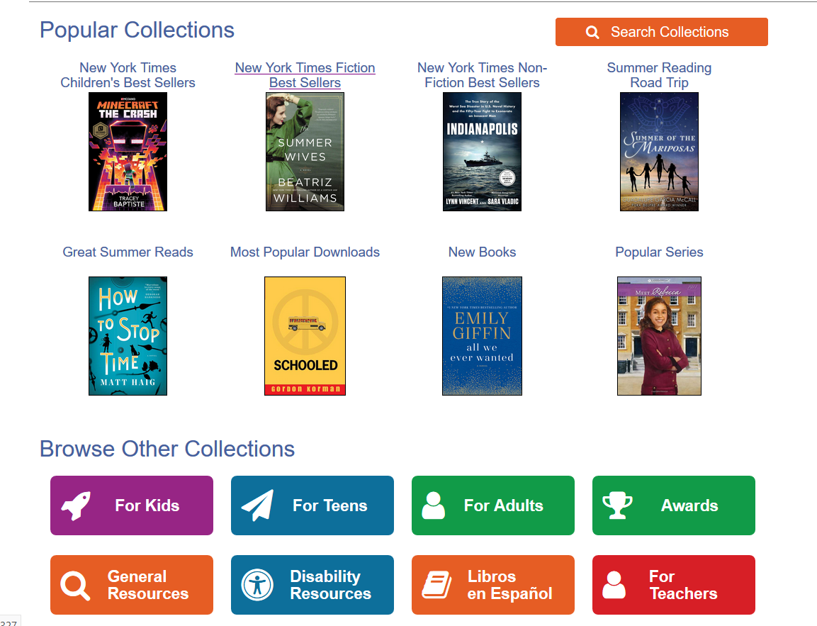

For a narrower search, select the “**Advanced Search**” link and fill in as many details as possible.



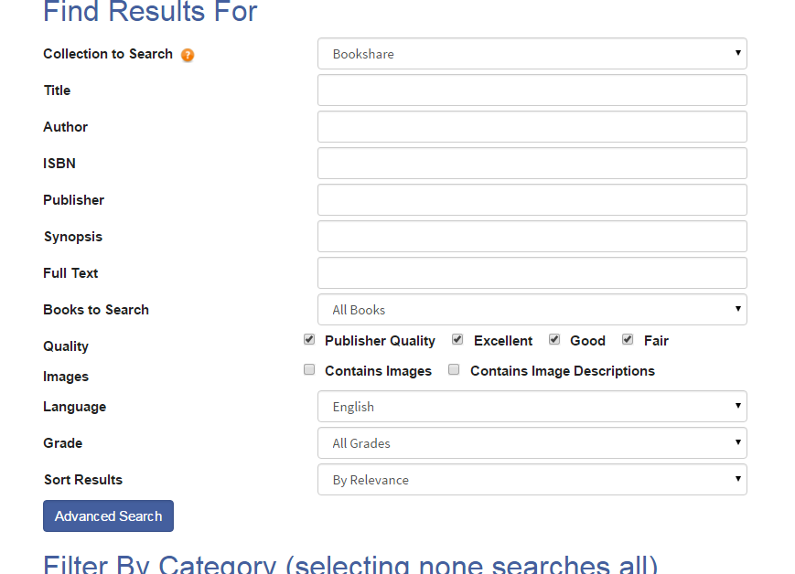

## Request Books

You can request to have books added to the Bookshare collection. Instructions can be found on the Help Center [Request a Book Page](https://www.bookshare.org/cms/help-center/request-book).

Select the **“**[Book Request Form link](https://www.bookshare.org/bookRequest)”

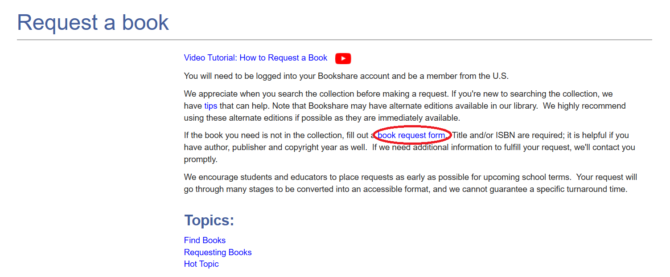

Provide as much information as possible, **specifically if the title is required reading for school** as well as **the ISBN number.** After you fill in the form and select the **Next** button, you will be brought to a confirmation page to review the information you entered. You must select **Submit.** After you submit your request, you will receive an automated confirmation email with a **case number to use for further reference.**

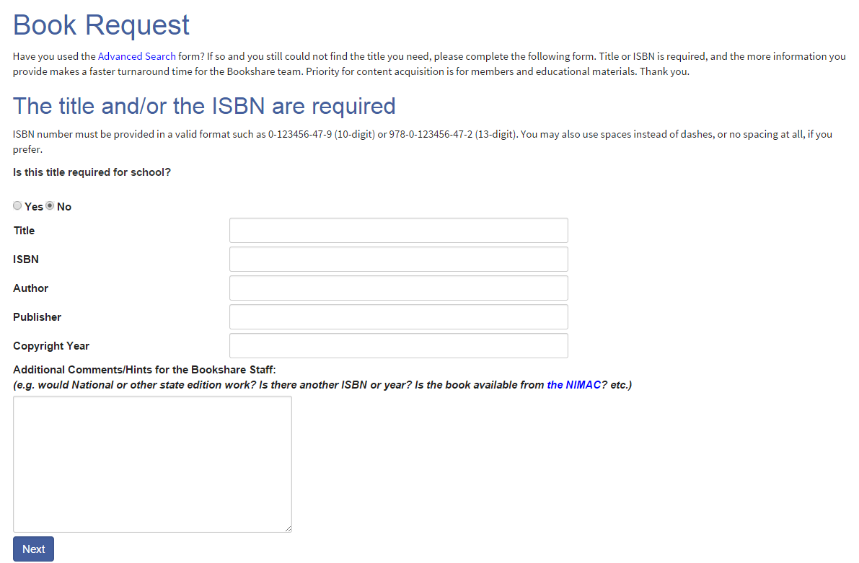

The Bookshare team will reply to your email within three business days with the status of your request. **You can also track the status on your “My Bookshare” page by selecting the “My Requests” link**.

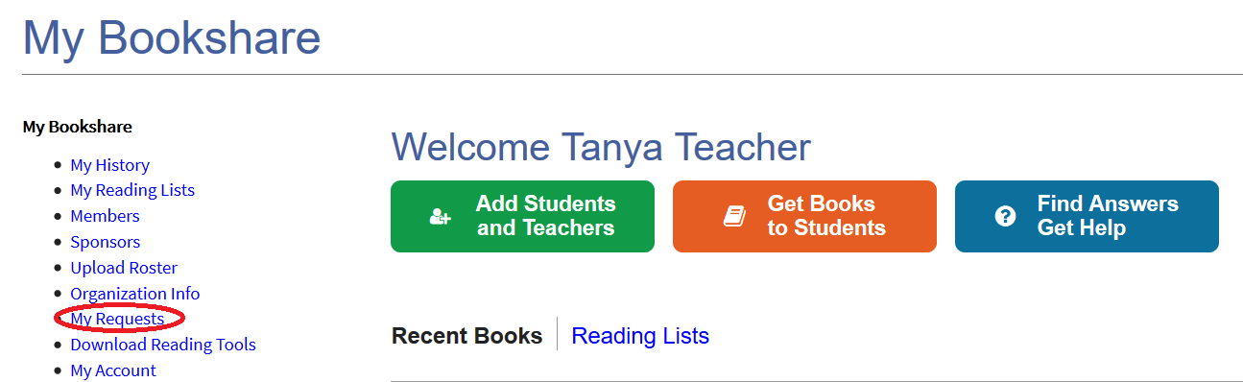

**Thank you for choosing Bookshare! To learn more, please visit our**

[**Training and Learning Center.**](https://www.bookshare.org/cms/help-center/learning-center)