**Image 1 - A boy is sitting against a tree, smiling, and looking at the screen of a laptop. His arms are raised.

Graphic - Bookshare logo in a orange box.

Image 2 - A man is looking intently at a tablet screen.**

**How-To Guide**

Find and Request Books

**Image 3 - A boy and woman are smiling as they look at a computer screen. A open book is in the foreground.

Graphic - Blue box.

Image 4 - A woman is smiling as she looks at a tablet screen.**

There are two ways to find books: Search (Standard and Advanced) and Browse.

# Search

1. Enter a search term in the Search Text Box located at the top of every page. This searches all text, including the title, author and contents of every book in the library



## Advanced Search

1. For a narrower search, select “Advanced Search” next to the Browse link.



1. You can search specifically by title, author, ISBN, publisher, images, or you can enter specific phrases in the “full text” field.

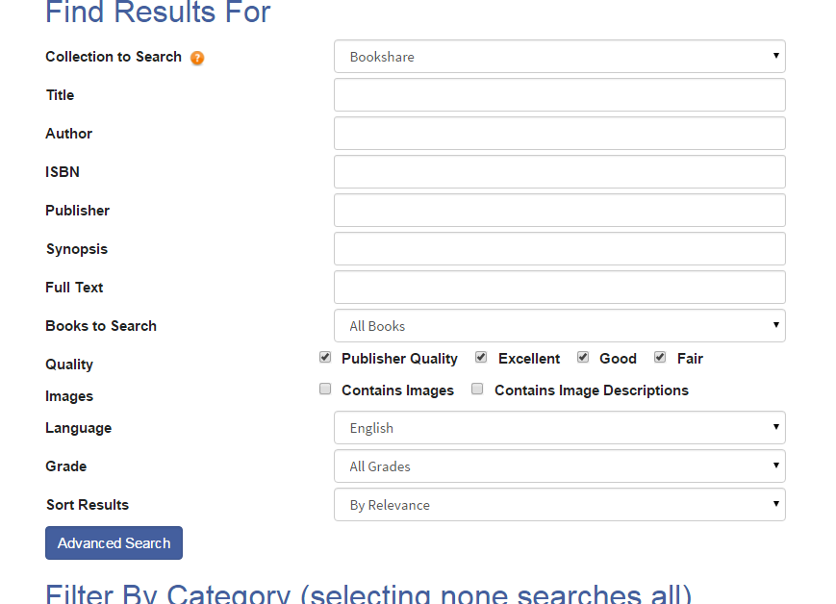

## Browse

1. Select the “Browse” link under the Search Text Box located at top of every page.  
   
2. Browse by a number of options such as “Author”, “Subject categories”, or “Special Collections”.

Screen shot of the Browse page displaying all the options to Browse by such as author, category, language, grade level, new books, most popular, NIMAC Books and newspapers and magazines.


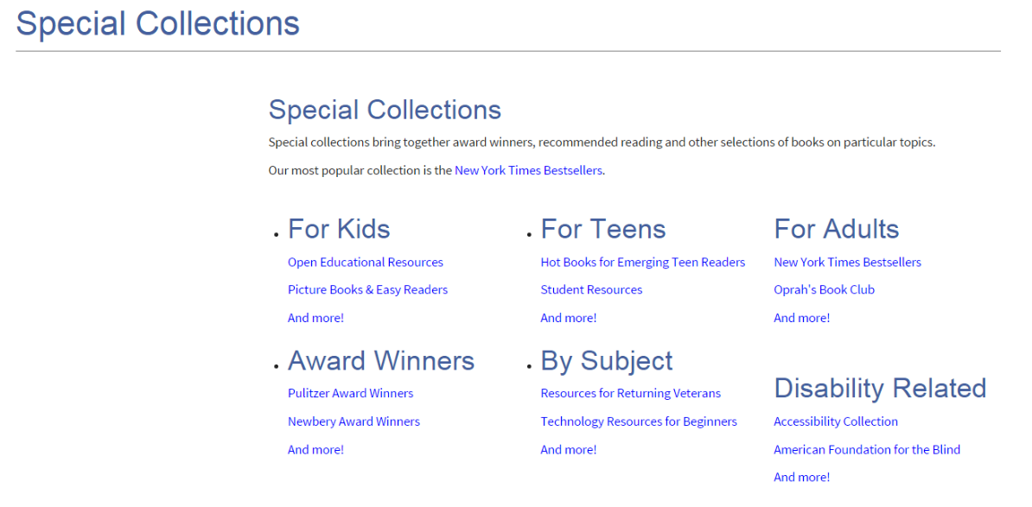

## Request Books

You can request to have books added to the Bookshare collection.

1. Under the “Getting Started” menu, select “How to Find Books”

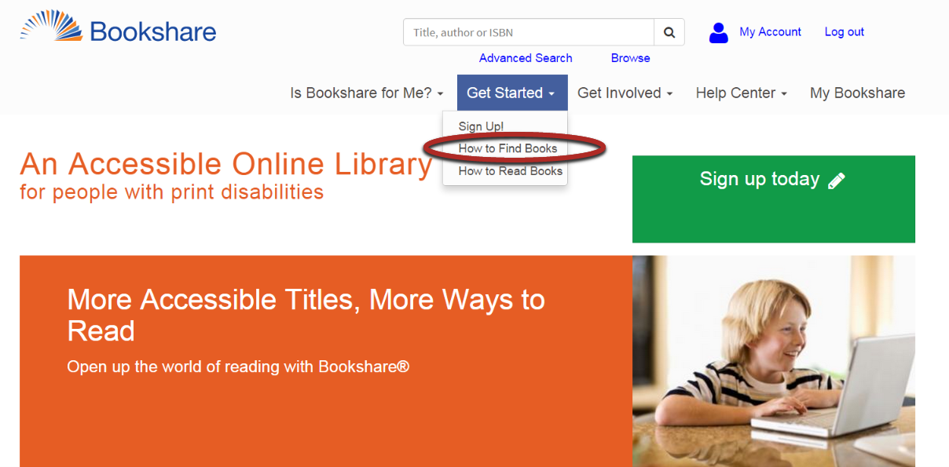

1. Select “Request to Add New Books”.

Screenshot of the "How to Find Books" page with the link for requesting to add books highlighted.


1. Provide as much information as possible. The ISBN is particularly helpful.

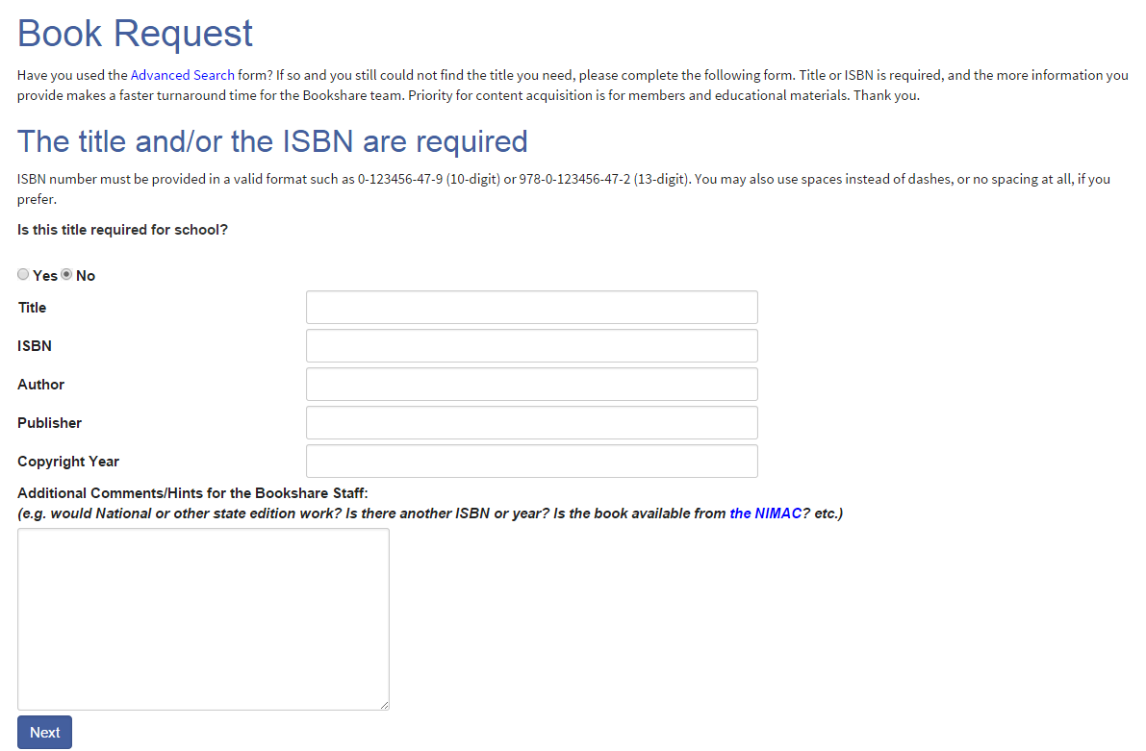

1. The Bookshare team will reply to your email within three business days with the status of your request. You can also track the status in the “My Bookshare” section.

