**Three zoned graphic. To the far left is a boy is sitting against a tree, smiling, and looking at the screen of a laptop. His arms are raised.
In the middle is the Bookshare logo in a orange box.
To the far right is a man is looking intently at a tablet screen.**

How-to Guide: Organize Your Member Roster

Sponsors or teachers can organize their Member Rosters using Quicklists and District and/or School information.

**Adding Members to / Removing Members from Quicklists**

Quicklists make it easier for Sponsors on large organizational accounts to manage the members or students they support. Quicklist members will also appear at the top of the list of Members from whom to choose during the download process, making it easier to find the right member(s). Each Sponsor can set up and manage his/her own Quicklist.

1. On the “My Bookshare” page, select the "Members" link.

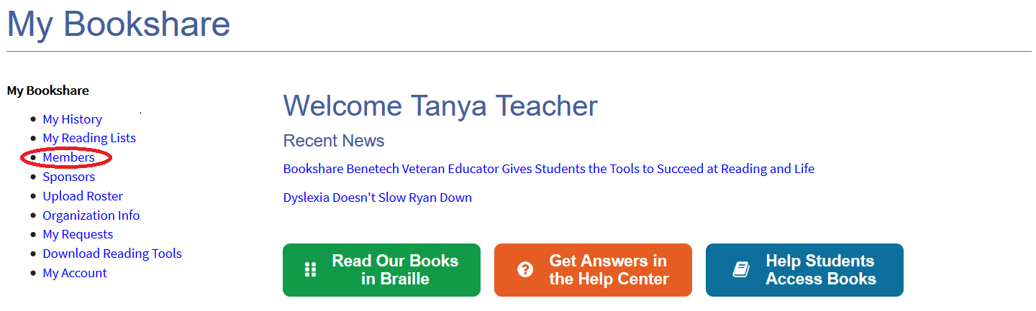

1. Select "Add Member."

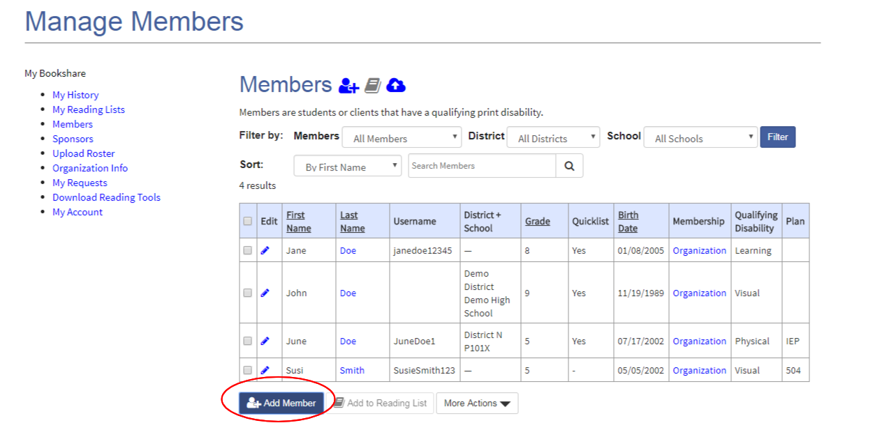

1. Complete member information. The Quicklist box will automatically be checked. To change, simply uncheck the box.

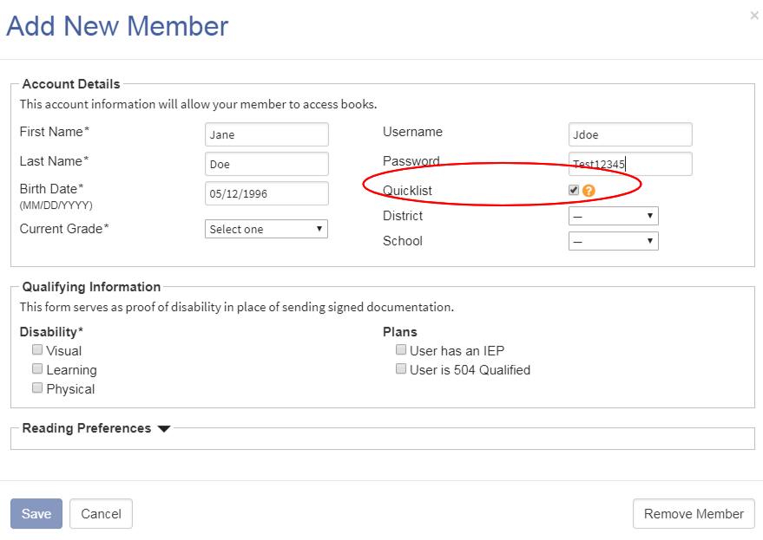

1. To add existing members to your Quicklist, place a check mark next to their names and select the "Add to Quicklist" link under the "More Actions" button.

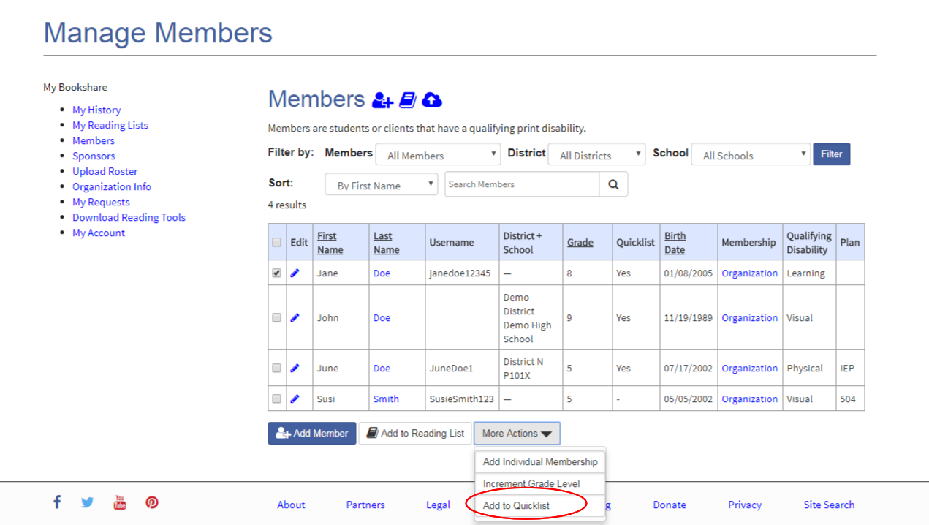

1. To see only the members on your Quicklist, select "My Quicklist" in the dropdown menu next to "Filter by” and select the “filter” button.

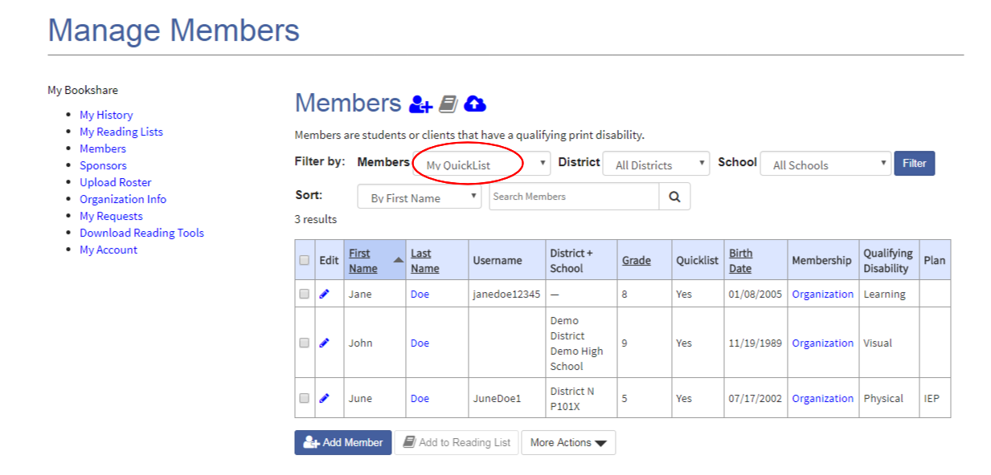

1. To remove members from your Quicklist, place a check mark next to their name and select "Remove from Quicklist" under the "More Actions" button.

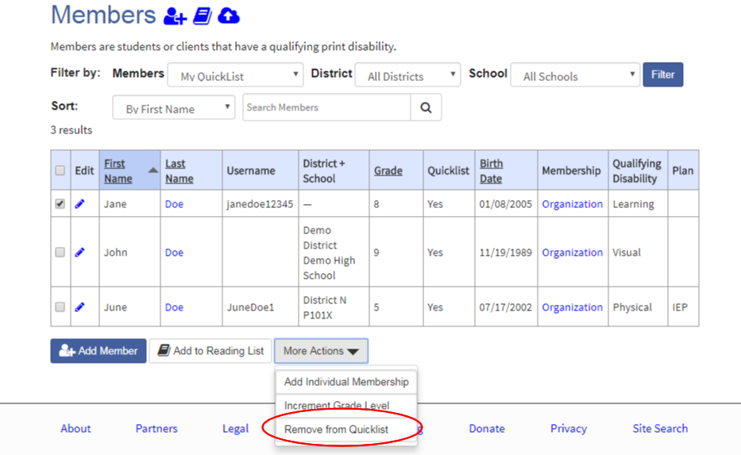

**Adding District and School Information**

Adding District and School information for each student enables Sponsors to filter the member roster to see a list of members for a particular district or school. The roster can also be filtered by grade level.

1. Enter the district and school information when you add a new member and select "Save."

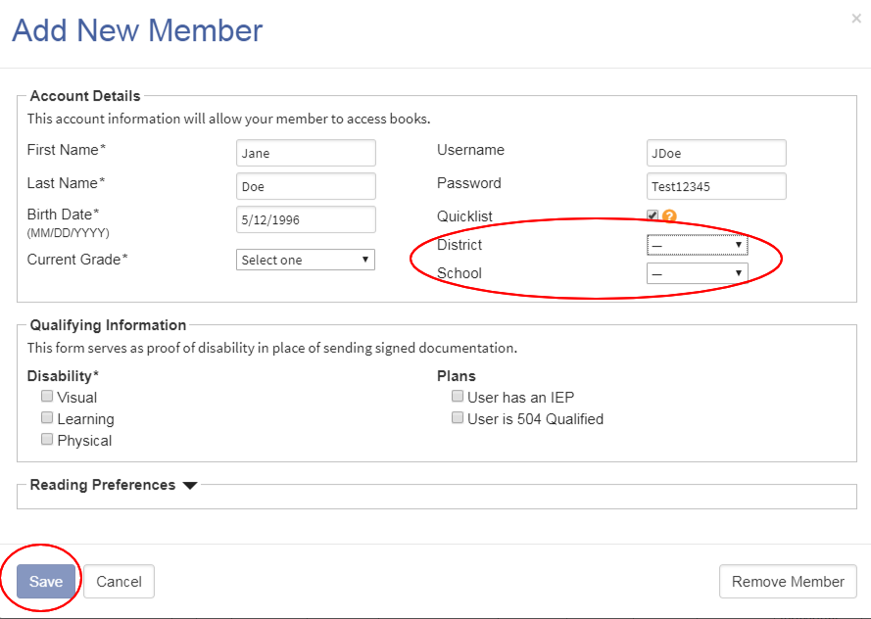

1. To add district and school information to existing members, select the edit icon next to a member's name, Enter the name of District and/or School and select the save button.

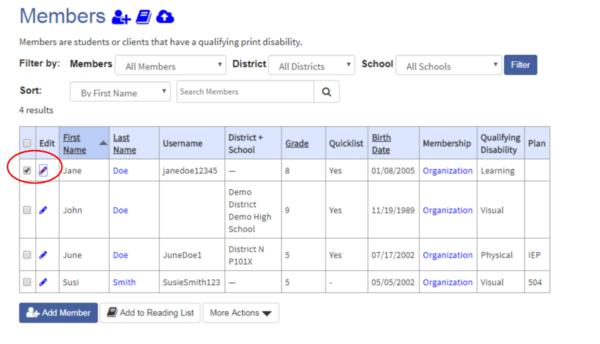

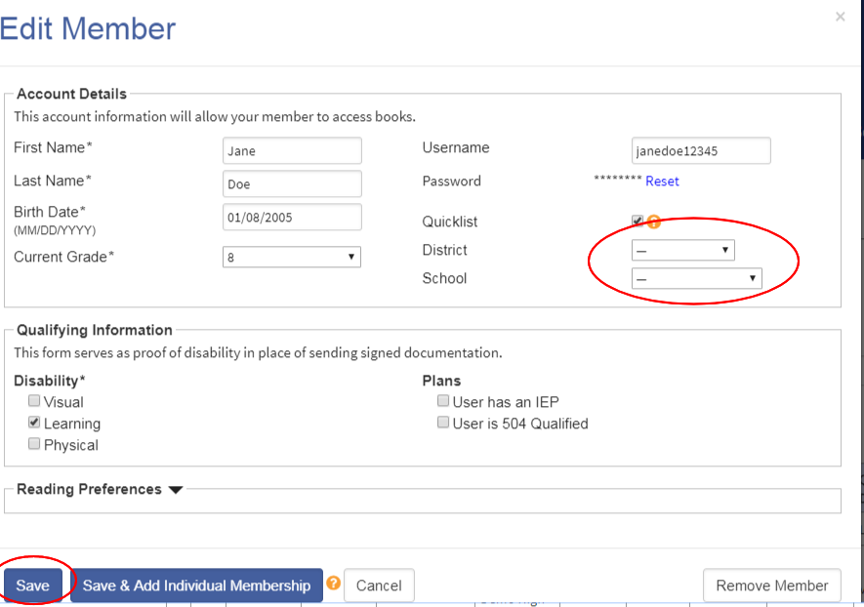

*Note: you can also enter District and School information on the group upload roster. For more information about group uploads see the* [*How to Guide: How to Add Members and Sponsors on an Organizational Account*](https://www.bookshare.org/cms/sites/default/files/how_to_guide_add_sponsors_and_members.pdf)*.*

1. To filter by District or School, choose the appropriate district or school name from the drop down menu and select the "Filter" button.

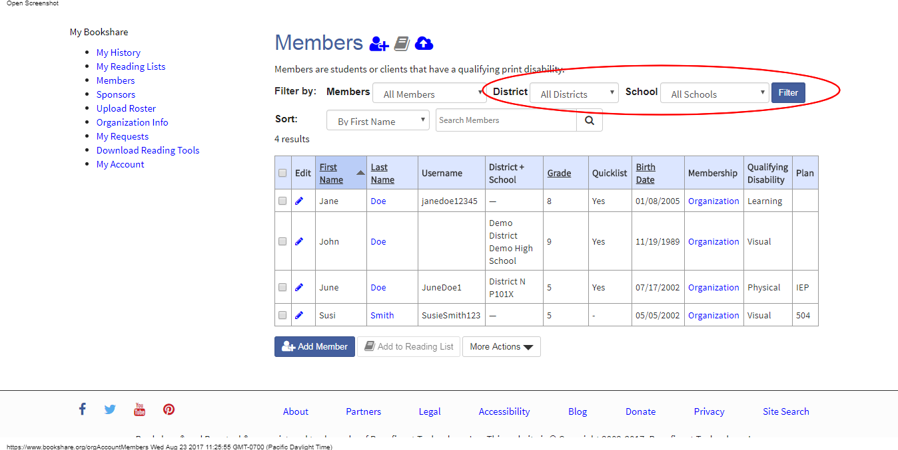

**Removing Members from Organizational Account**

1. Primary Contacts can remove groups of members from an organizational account all at once by placing check marks in the boxes next to the members' names, then selecting "Remove Member".

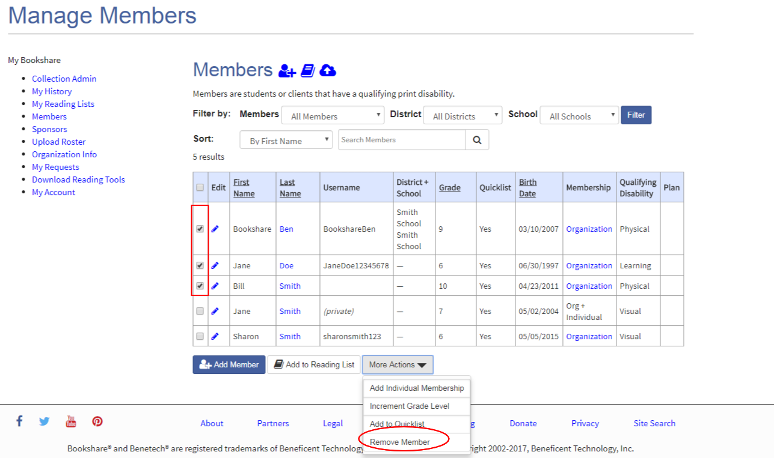

1. Sponsors can remove members from the account one at a time by selecting the edit icon next to the appropriate name in the member roster, then selecting the "Remove member" button.

