**Three zoned graphic. To the far left is a boy is sitting against a tree, smiling, and looking at the screen of a laptop. His arms are raised.
In the middle is the Bookshare logo in a orange box.
To the far right is a man looking intently at a tablet screen.**

**How-to Guide**

Assign Books to Students with Reading Lists

Reading Lists let you select and assign multiple books for students so they can read independently. Create lists by class, student, topic, or interest.

# Create New Reading Lists

# 

1. Select "My Reading Lists" on your "My Bookshare" page.

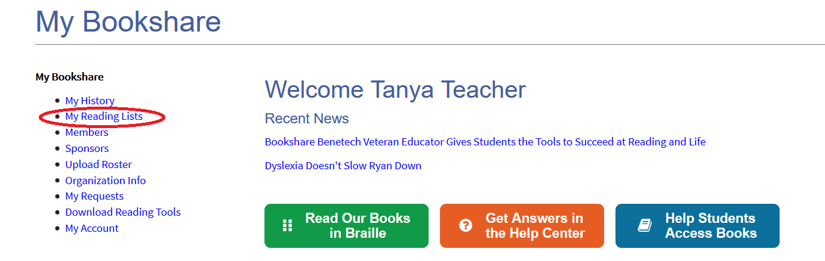

1. Select “Create."

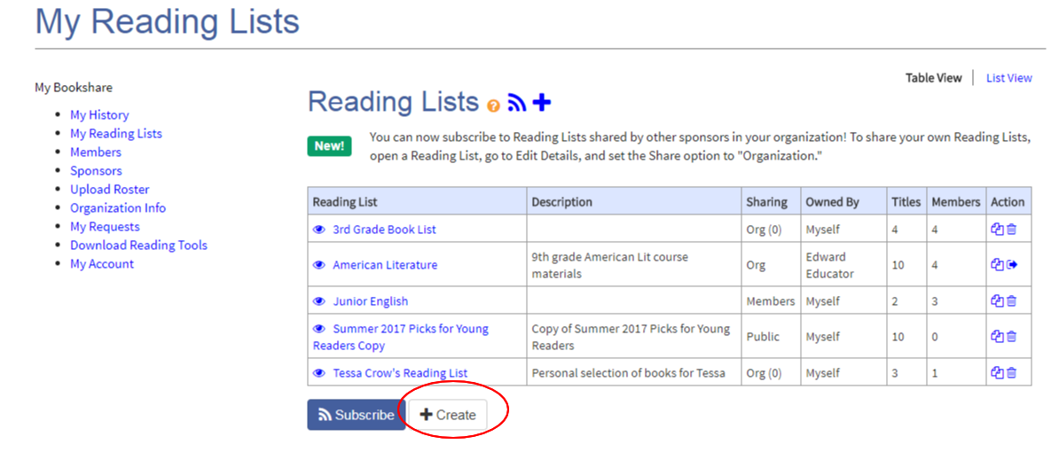

1. Assign a name and description and choose a sharing option. Select "Member" to share the list between you and your student(s) assigned to this Reading List or "Org" to allow other Sponsors to view and add books. Then select “Save."

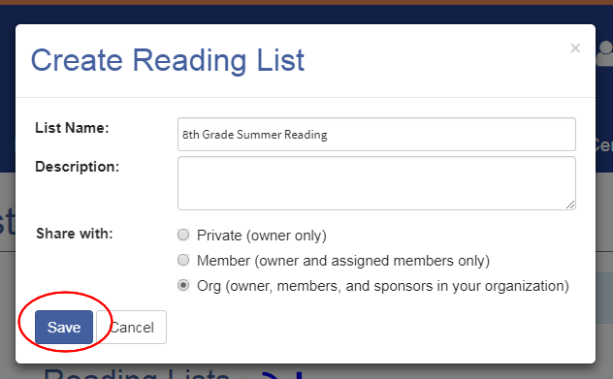

1. Select the “Assigned Members” link, then the “Add Members” button to bring up your list of members.

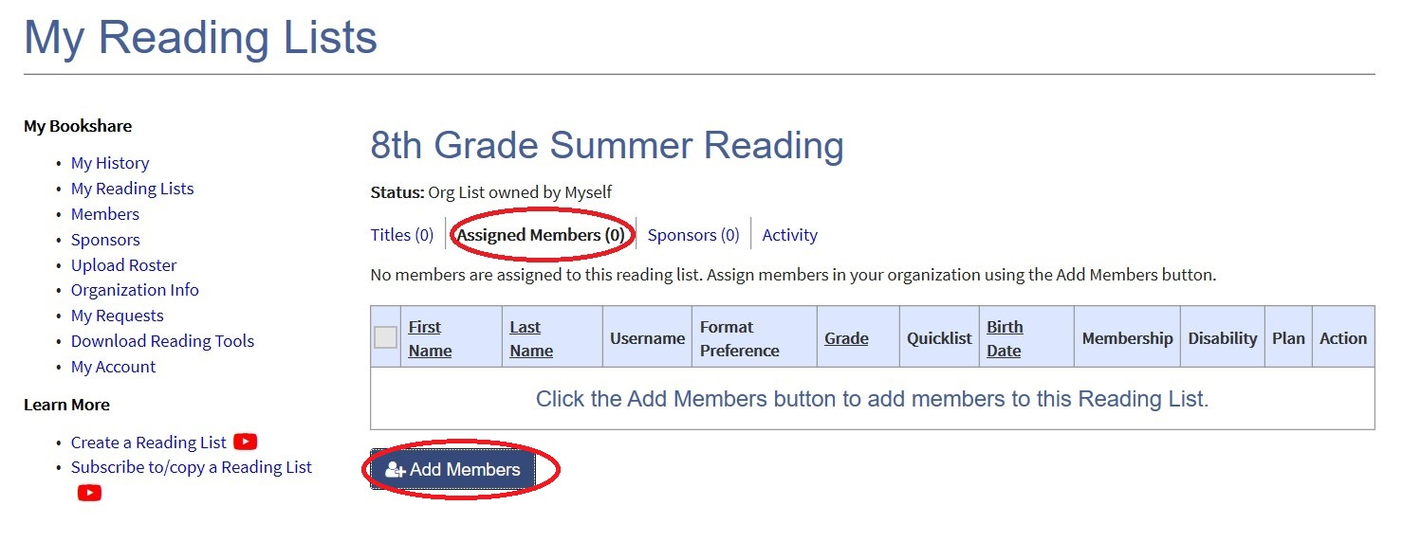

1. Put a check mark next to the names of students you wish to add and select "Add Selected Members."

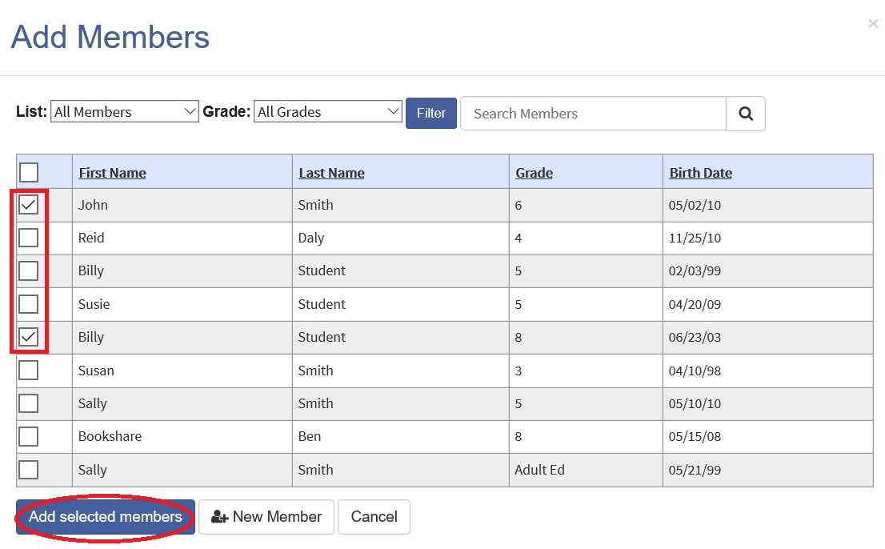

1. Select the "Titles" link, then the “Add Books" button to add books to the Reading List.

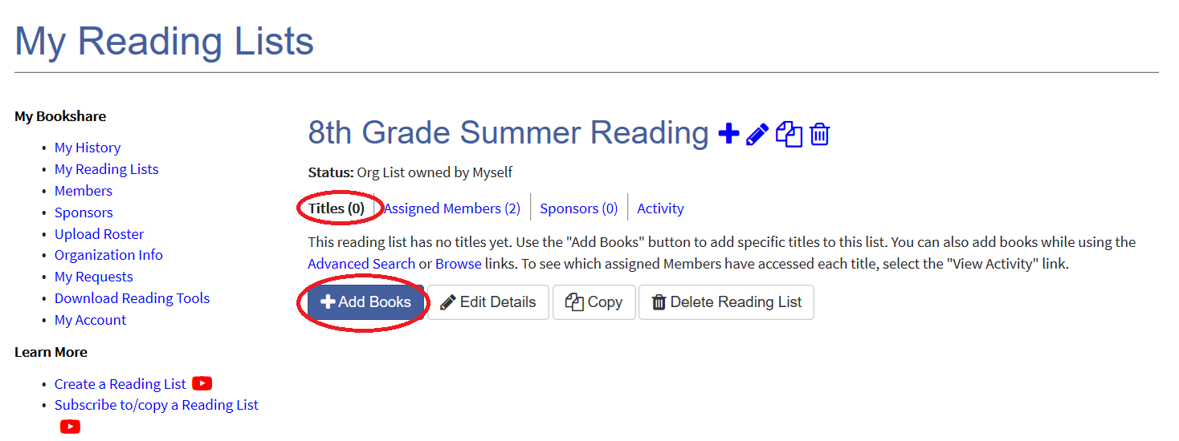

1. Search for books by title, author, or ISBN. When you find a book you want to add, place a check mark next to the title and select "Save and Add More" if you wish to search for and add more titles or “Save and Close” if finished adding book.

Screenshot of book search results pop up box where users search for books to add to reading lists.


1. You can also add other Sponsors to the Reading List so they can share it with the members they support by selecting the “Sponsors” link, then the “Add Sponsors” button.

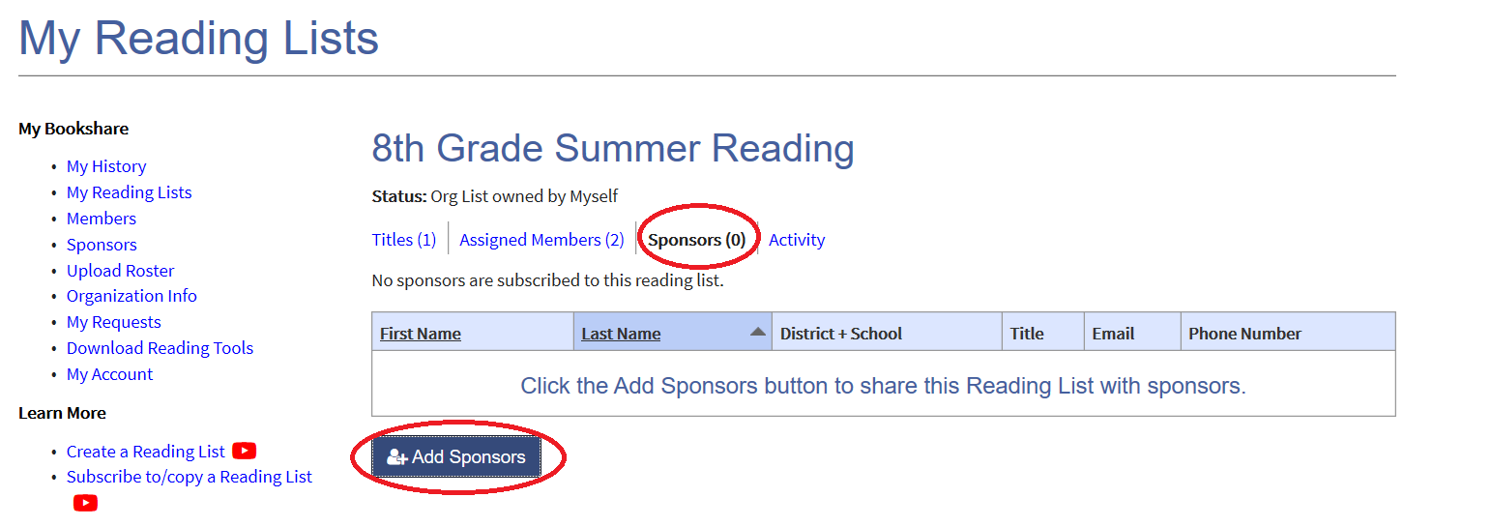

1. Put a check mark next to the name(s) of Sponsors you wish to add to the Reading List and select the “Add Selected Sponsors” button.

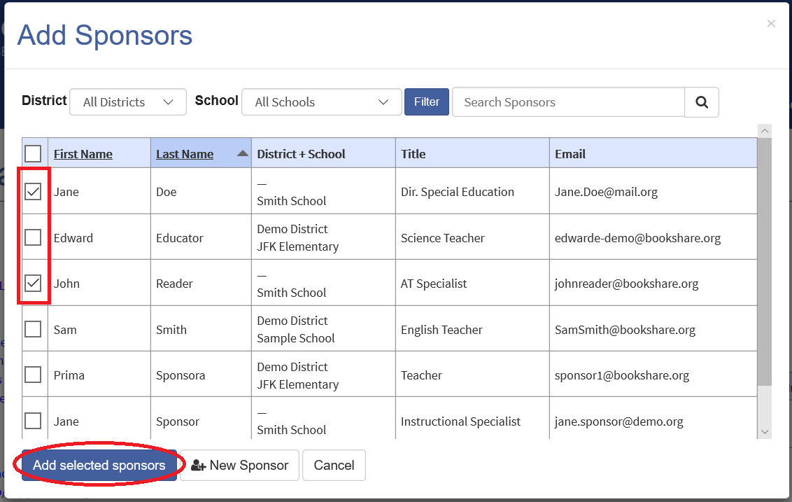

1. You can review Reading List activity by selecting the “Activity” link to see which members have accessed a book(s) from the list.

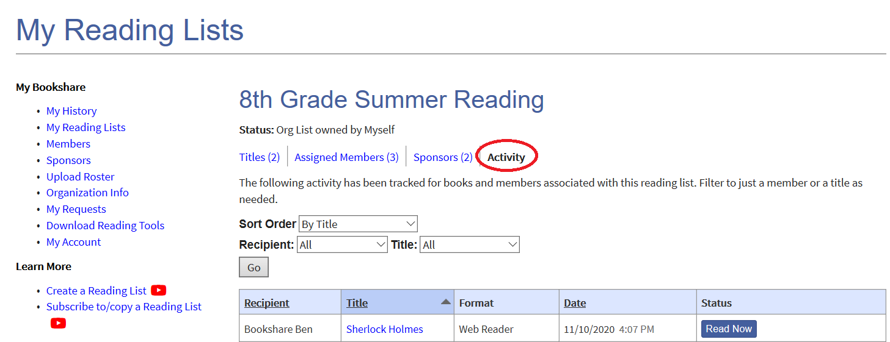

Thank you for choosing Bookshare!

You have now assigned books to your students by creating at least one Reading List and learned how to share Reading Lists with other Sponsors in your organization. Your students are ready to read! Remind your students to log in with their username and password to view their assigned Reading Lists.

If you would like to learn more, please visit our [Training and Learning Center!!](https://www.bookshare.org/cms/help-center/learning-center)