**Image 1 - A boy is sitting against a tree, smiling, and looking at the screen of a laptop. His arms are raised.

Graphic - Bookshare logo in a orange box.

Image 2 - A man is looking intently at a tablet screen.**

**How-to Guide:**Parents: Sign Your Child up for an Individual Membership

**Image 3 - A boy and woman are smiling as they look at a computer screen. A open book is in the foreground.

Graphic - Blue box.

Image 4 - A woman is smiling as she looks at a tablet screen.**

Parents can either upgrade their child's school (Organizational) account to include an Individual Membership or create a new account with Bookshare if their child is not on an Organizational Account. All memberships for qualified U.S. students are free through an award from the U.S. Department of Education, Office of Special Education Programs (OSEP).

**Upgrade an Organizational Account**

1. Log in to [the Bookshare Website](http://www.bookshare.org/) using your child’s username and password. You will be taken to their My Bookshare page.
2. Select the “Upgrade to an Individual Membership” link under the “Learn More” heading.

Screenshot of the My Bookshare page with the upgrade to an individual membership link circled.


1. Review the instructions and select the link to sign up.

Screenshot of the page with instructions for signing up for the individual membership for members already on a school account


1. Complete the required information on the sign up form.

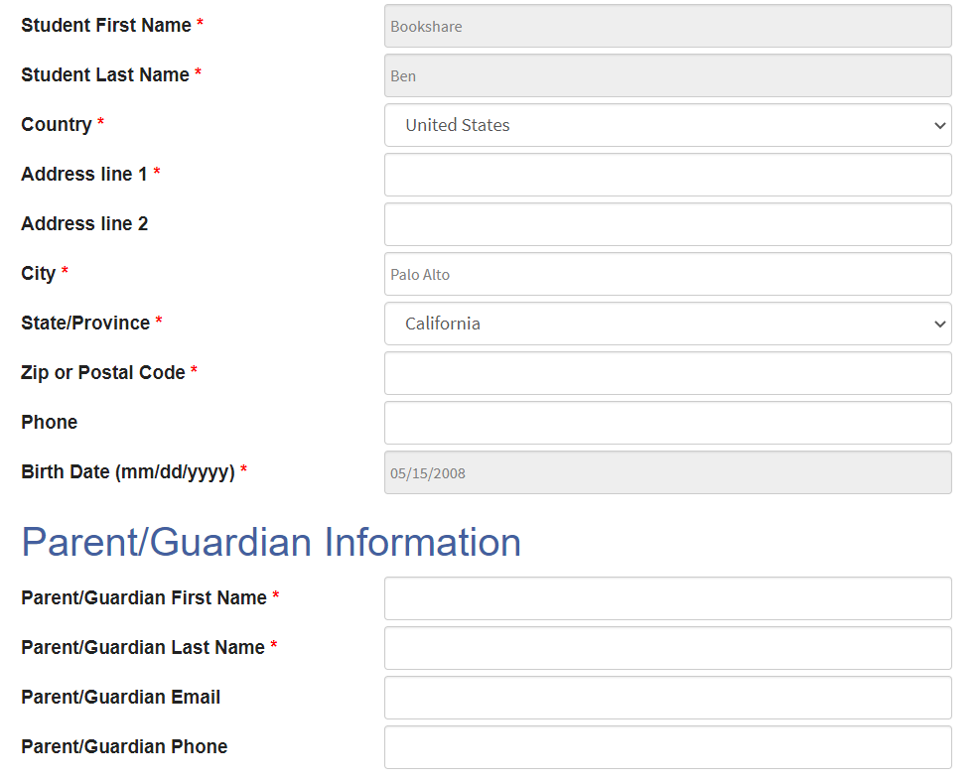

1. Enter an email address and password and select the “Next” button. Your child will now use this email address and password to log in to Bookshare.

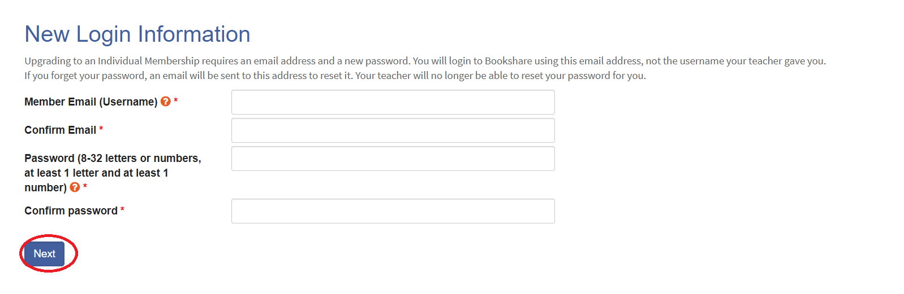

1. Under the “Account Management” heading you can opt to allow teachers to manage the account. This is helpful for account maintenance and resetting passwords if necessary. Agree to the terms, provide a digital signature and select the “Create Account” button.

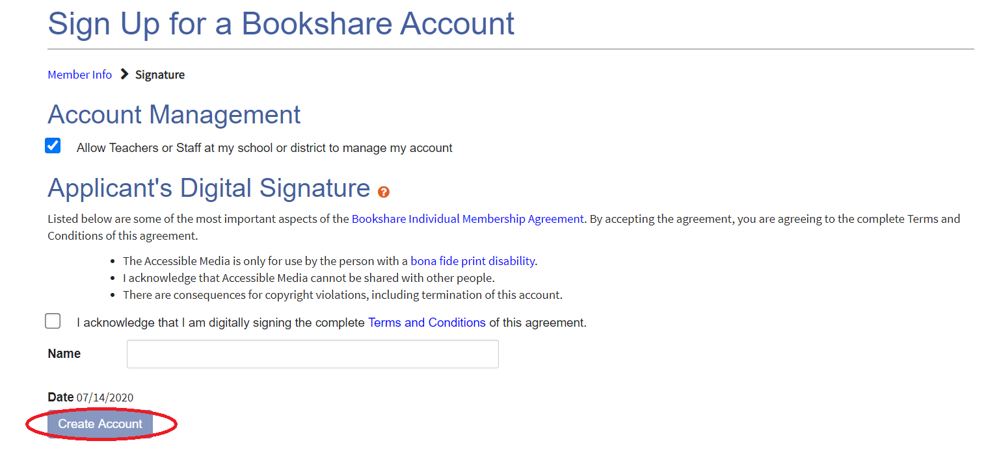

Your child can now read books from the entire Bookshare collection, as well as those assigned by his/her teacher.

**Sign up for a New Bookshare Account**

1. Go to [the Bookshare Website](http://www.bookshare.org/) and select the "Sign up Today" button.

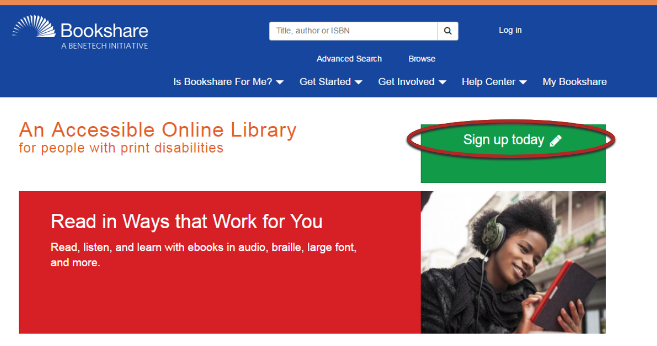

1. Select "Sign Up Individual."

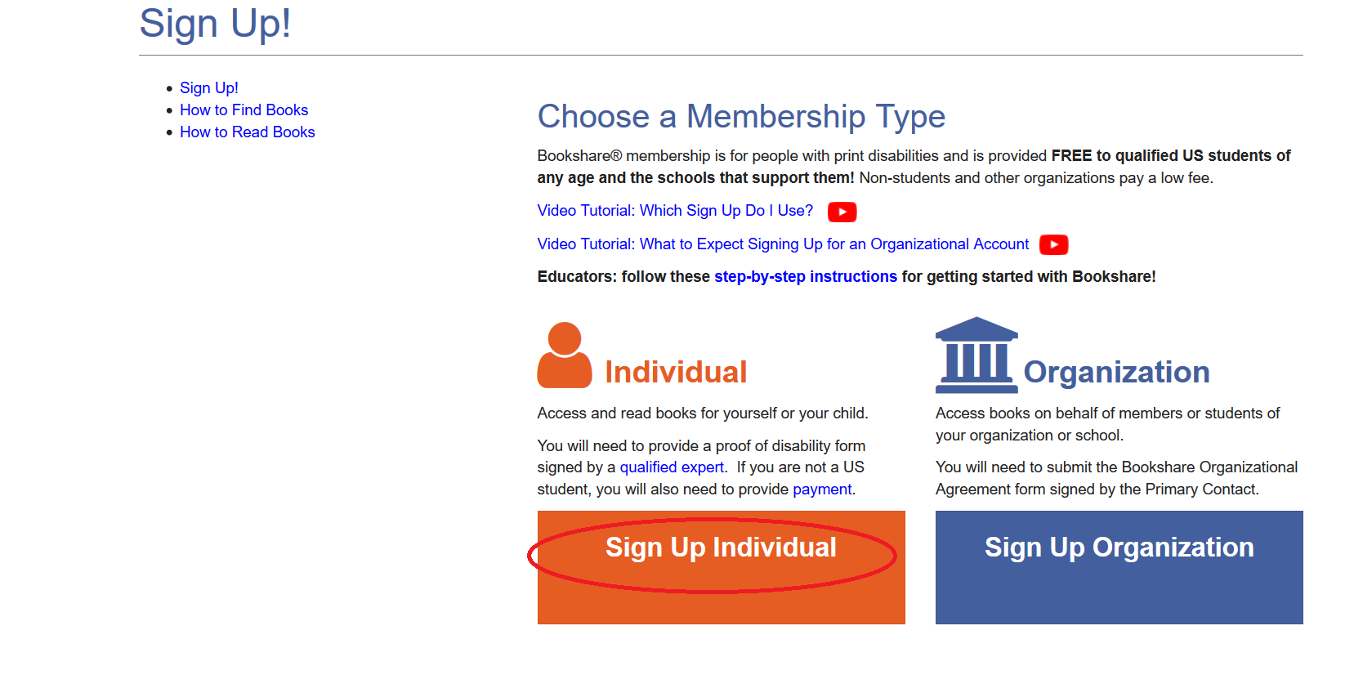

1. Select the "yes" radio button to confirm the account is for a person with a print disability.

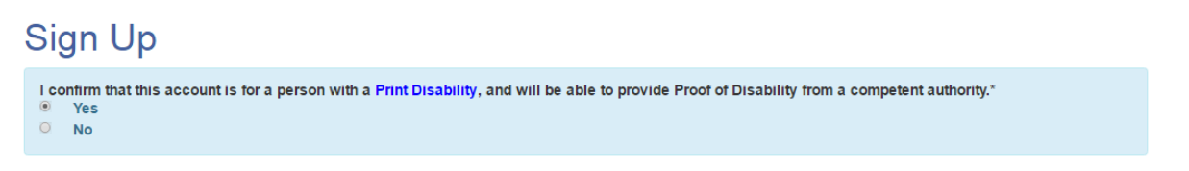

1. Select the "yes" radio button to confirm the account is for a U.S. student.

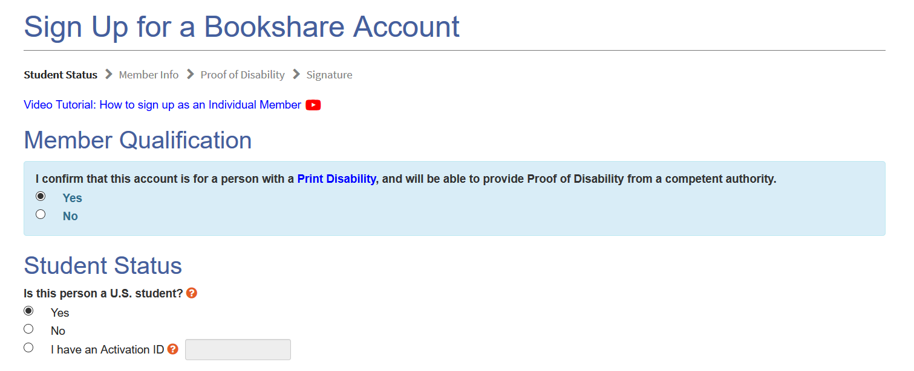

1. Enter your State, City and the name or zip code of your child’s school and select the “Find My School” button.

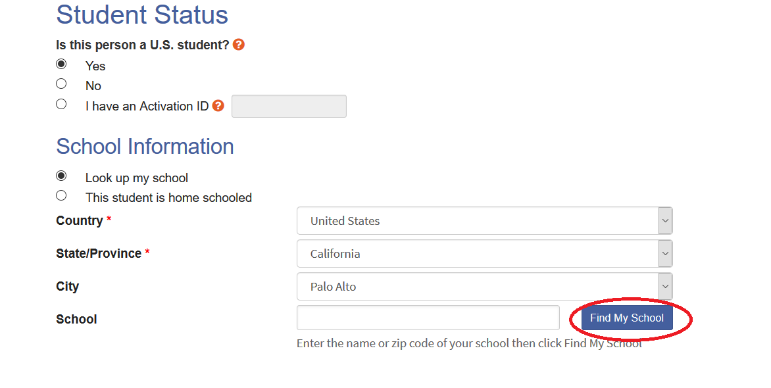

1. Select your child’s school from the list. If you cannot find the school check the box “I can not find my school.” Select the “Done” button.

.Screenshot of an example of a search for school but city.


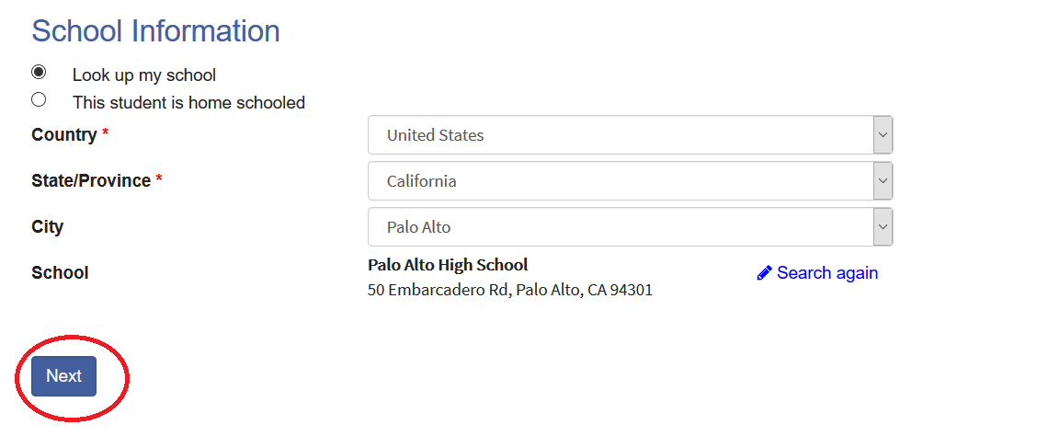

1. Enter all required information about the student and set a user name (email address) and password. Select the “Next” button.

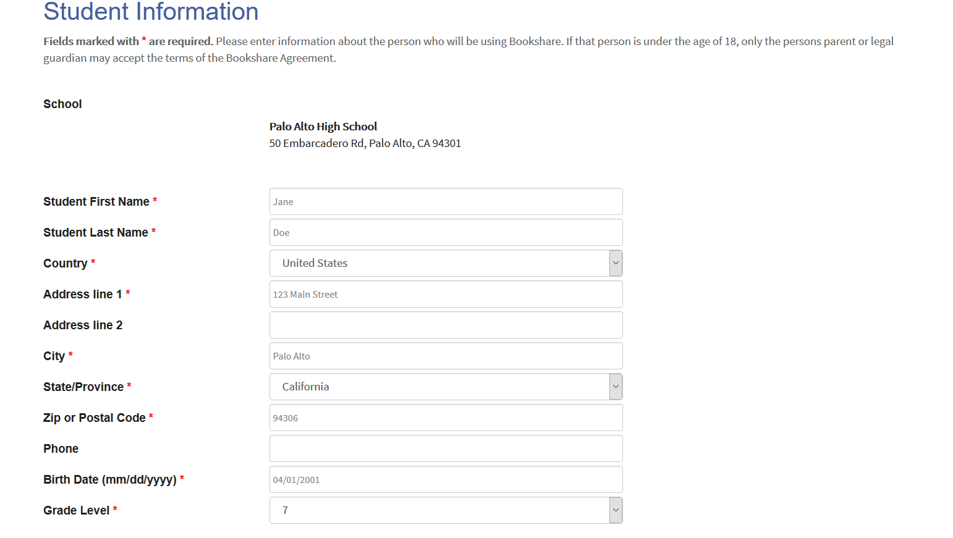

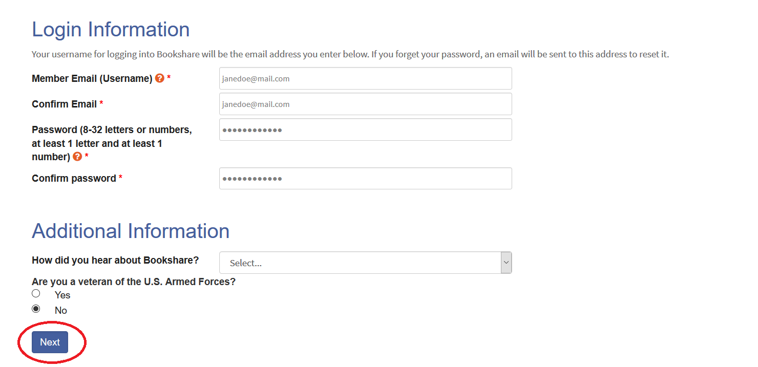

1. Proof of Disability is required. Select how you want to provide Proof of Disability, or select the last option to “Skip this step.” Select the “Next” button.

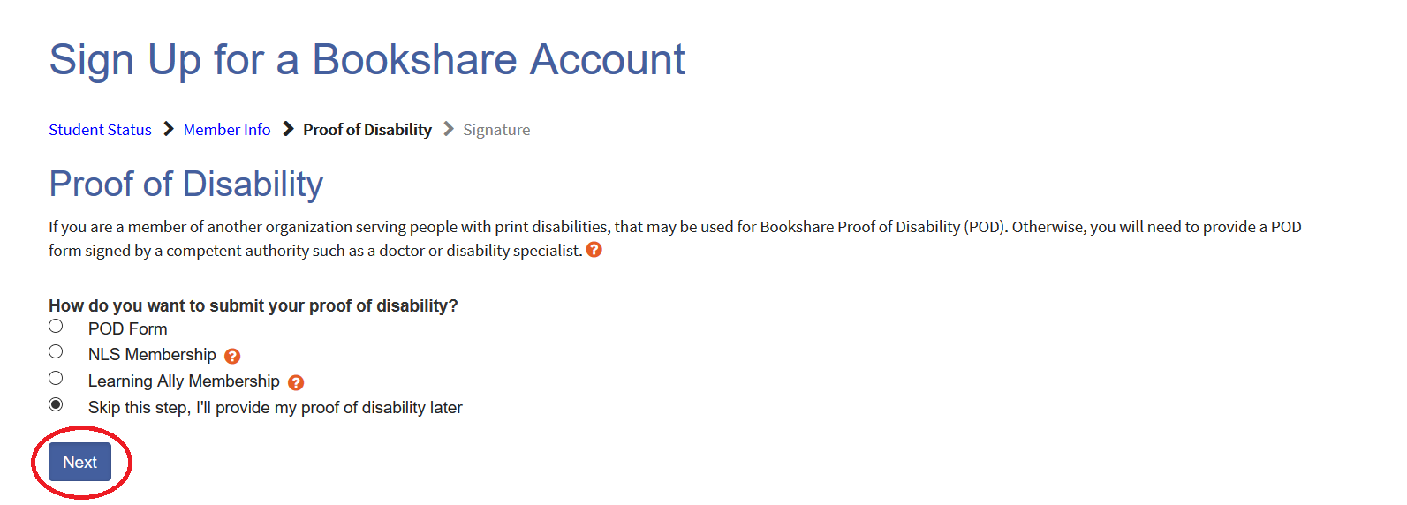

1. Select that the account is for a U.S. Student, provide a digital signiature and select the “Create Account” button.

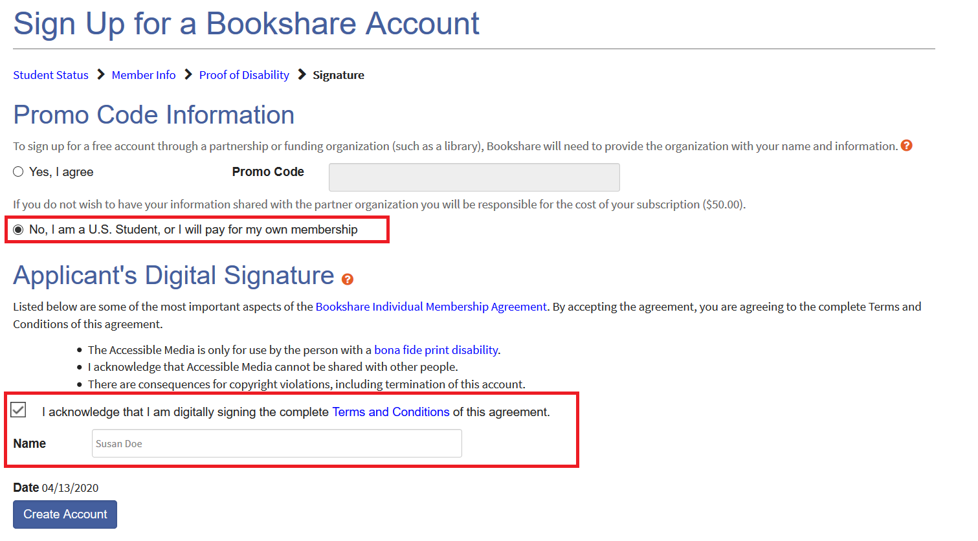

1. You will be taken to the "My Bookshare" page. Select "Submit POD."

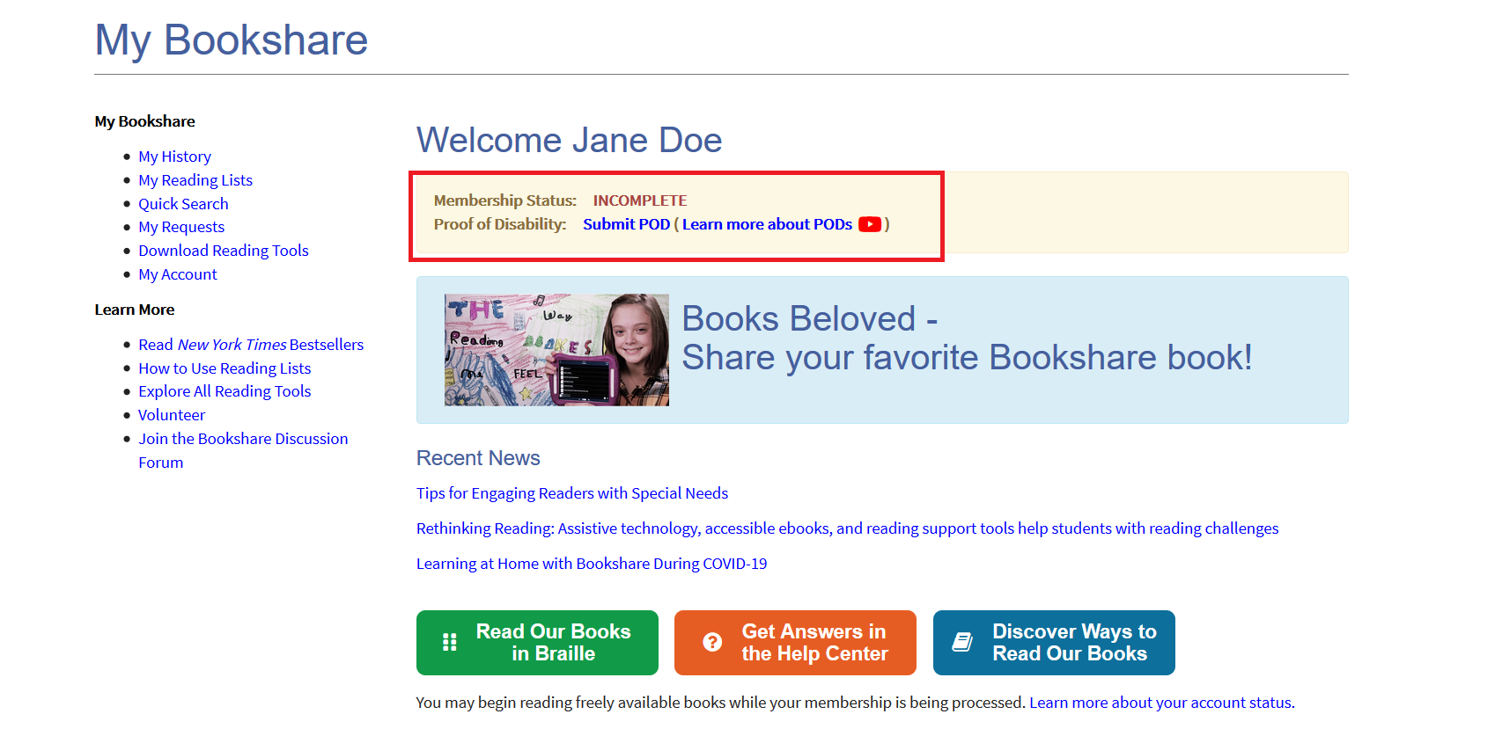

1. Download the Proof of Disability form or submit a copy of your NLS or Learning Ally information.

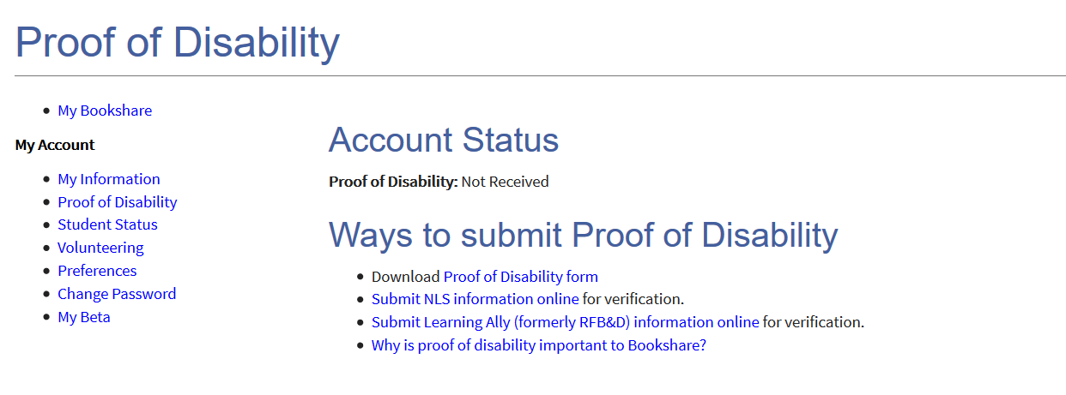

1. If using the Proof of Disability (POD) form, have a Competent Authority select type of disability, provide their information and print and sign the form. (Visit the "[Who Qualifies](https://www.bookshare.org/cms/bookshare-me/who-qualifies)" page for examples of Competent Authorities.) Email the completed POD form as an attachment to [membership@bookshare.org](mailto:membership@bookshare.org) or mail to the address on the form.

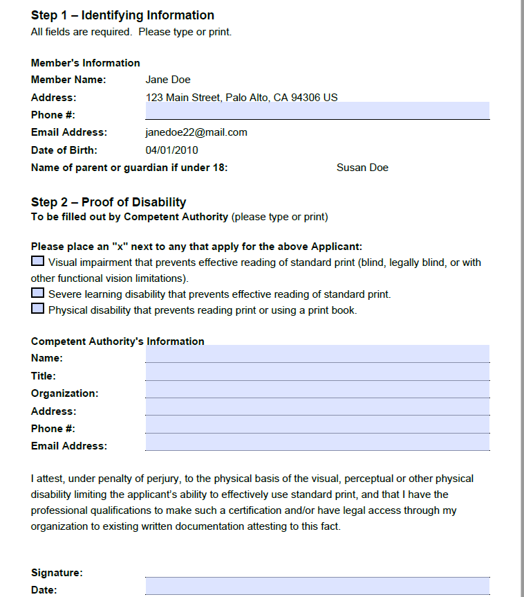

*Note:* We understand that during the Covid-19 it might not be possible to print and have the form signed therefore we are allowing the Competent Authority to “sign” the completed form by sending it to us by email along by following the process outlined below:

1. Download a copy of the Proof of Disability form from your Bookshare account. It is highlighted on your My Bookshare page after you login.
2. Either you or the Competent Authority needs to fill out all of the required fields on your Proof of Disability form digitally and save the electronic file.
3. IMPORTANT – Please ask the competent authority to email that completed digital form to [membership@bookshare.org](mailto:membership@bookshare.org) and include the following in their email:

*I attest, under penalty of perjury, to the physical basis of the visual, perceptual or other physical disability limiting the applicant’s ability to effectively use standard print, and that I have the professional qualifications to make such a certification and/or have legal access through my organization to existing written documentation attesting to this fact.*

Competent Authority Name:

Competent Authority Title:

Please be sure that the completed Proof of Disability form is included as an attachment to the email, even though it will not be signed*.*Your child is now ready to read! View our [Reading Tools Wizard](https://www.bookshare.org/cms/reading-tool-wizard) to learn more about reading Bookshare books on a computer or Chromebook, mobile phone or tablet, or an assistive technology device.