# Image 1 - A boy is sitting against a tree, smiling, and looking at the screen of a laptop. His arms are raised. Graphic - Bookshare logo in a orange box. Image 2 - A man is looking intently at a tablet screen.How to Guide

# Read with the Bookshare

# Reader Mobile app

**Welcome to Bookshare Reader, a free app that allows members to read quickly and easily on Android or Apple smartphones.**

## Download the app

The Bookshare app is available in both the Apple App Store and the Google Play Store. Search for Bookshare Reader. Download the app onto your device, and launch it.

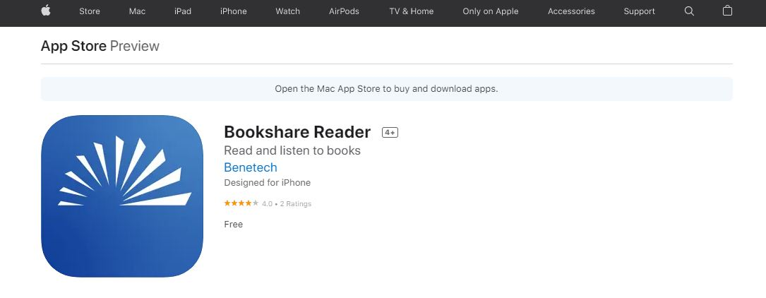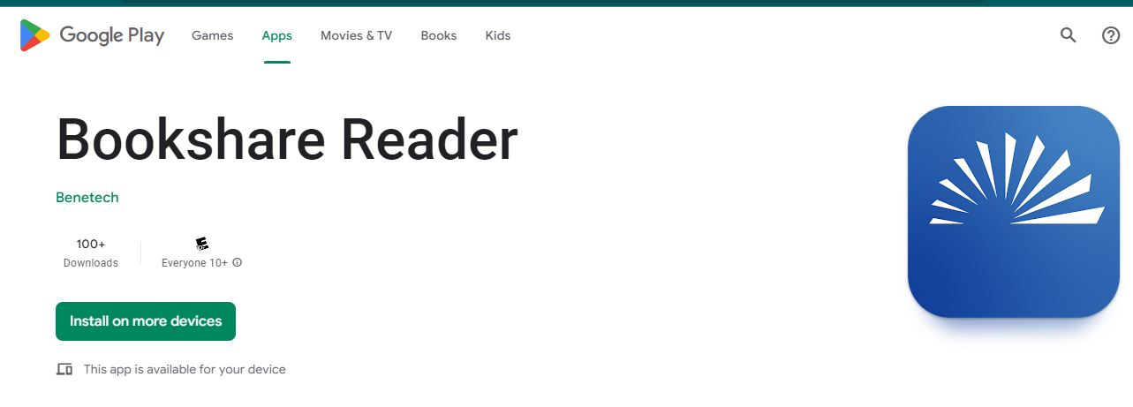

## Read with Bookshare Reader

**Log into the app** with your Bookshare username and pasword.

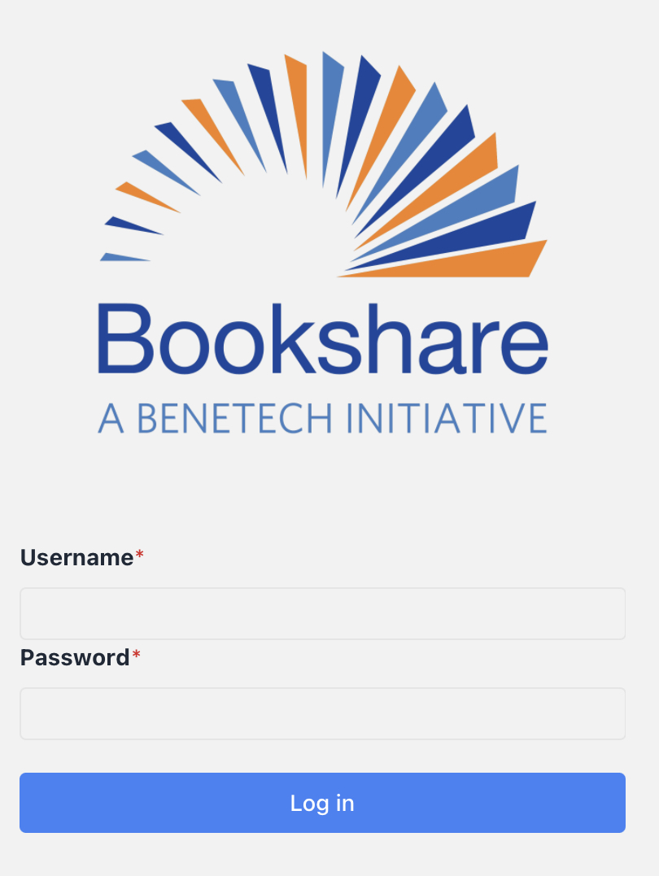

**Find a book to read!** Search for a book using the search box located in the heading region of the app.



**Select the book** you want to read from the search results, and you will be brought to the book information page. This page will give you a synopsis of the book, as well as the option to download the book for offline reading or read now.

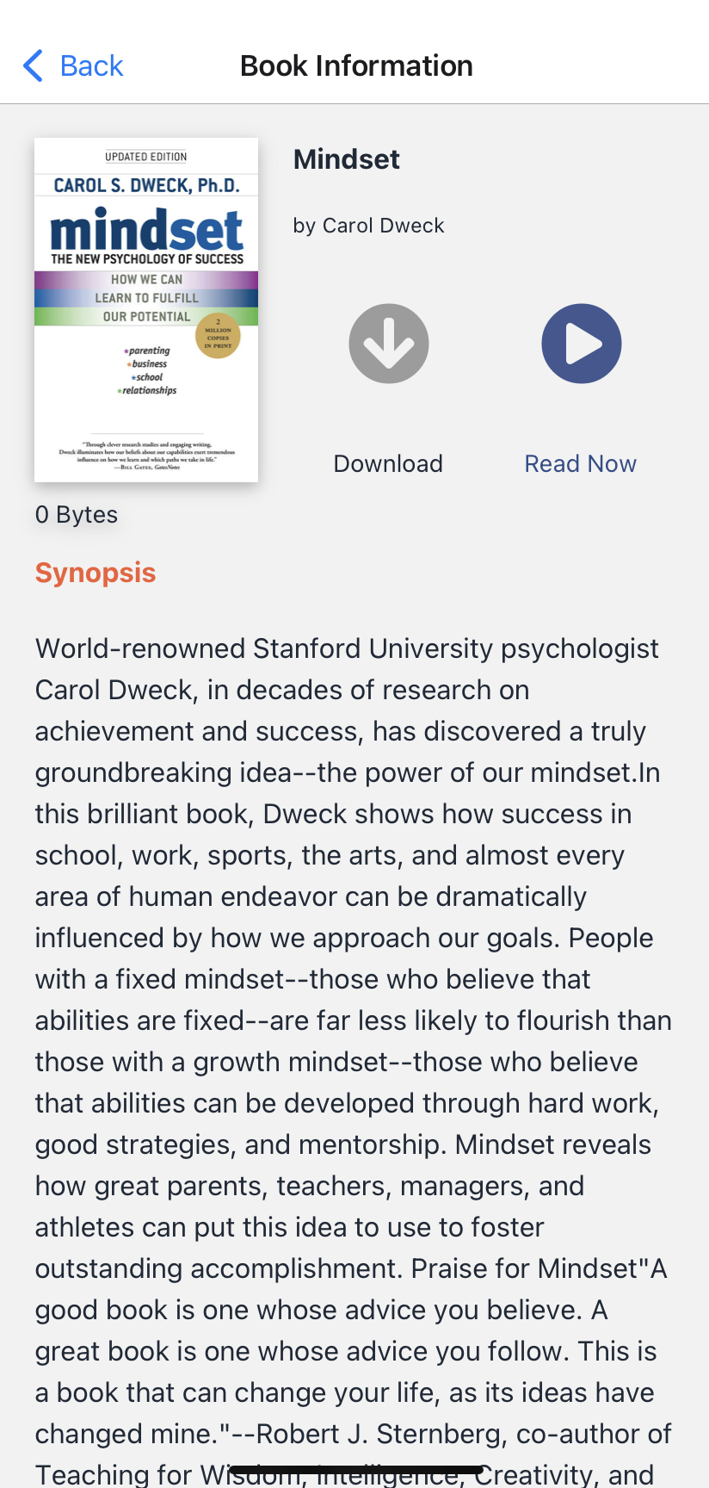

If you select the grey **download button**, the button will change and provide you with the download status. Once the download is complete, the download button disappears, and you can select the **Read Now button** to launch the Bookshare Reader.

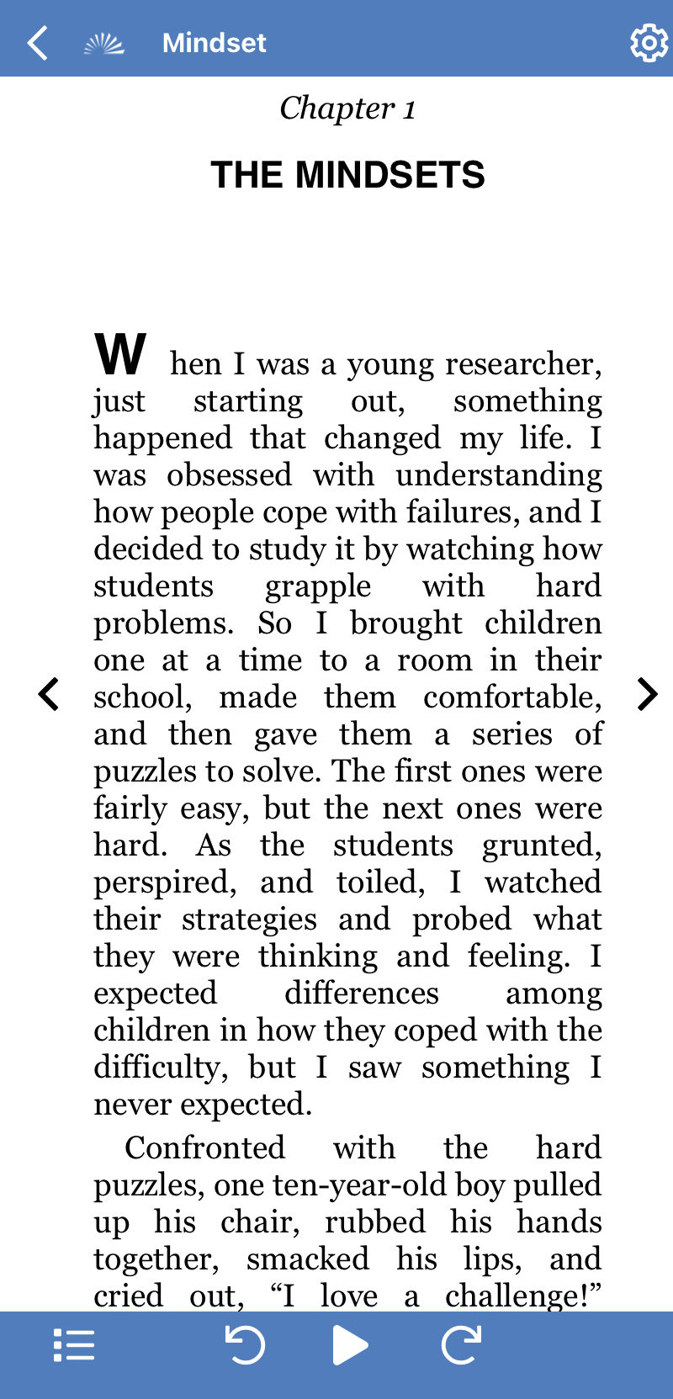

## Customization:

Use the **settings button (gear icon)** to customize audio, text, page, and color settings to your reading style and preference.



Choose **“Quick Set”** to customize key settings in real time. You can revert to default settings by selecting the **“Reset to Defaults”** button.

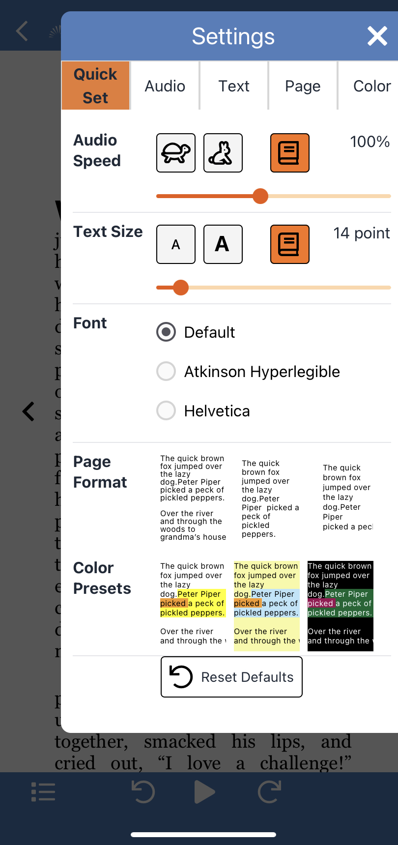

Under the **“Audio”** tab you can select a voice using the drop-down menu and adjust speed and chose voicing options. The voices available to you depend on the browser and device you are using.

Under the **“Text”** tab you can select font size, a variety of fonts and character spacing.

Under the “**Page”** tab you can select display format, margins and line spacing.

Under the **“Color**” tab you can select from a variety of preset color and contrast options or customize your own by selecting background, text, sentence highlight, and word highlight colors. **This is the last customizable category in settings**.

Get Reading!

The Play icon  allows you to hear the book read out loud. The arrows move the cursor back or forward one sentence. You can begin reading anywhere on the page. Simply double click where you want to start!



The “**Table of Contents”** icon Icon for the table of contents icon, bulleted list.  allows you to navigate through the book. Select the chapter you want to move to and Bookshare Reader will immediately bring you to that point in the text.

**Thank you for choosing Bookshare Reader! If you would like to learn more, please visit** **our** [**Training and Learning Center**](https://www.bookshare.org/cms/help-center/learning-center)