**Image 1 - A boy is sitting against a tree, smiling, and looking at the screen of a laptop. His arms are raised.

Graphic - Bookshare logo in a orange box.

Image 2 - A man is looking intently at a tablet screen.**

**How to Guide**

Read with Go Read

**Image 3 - A boy and woman are smiling as they look at a computer screen. A open book is in the foreground.

Graphic - Blue box.

Image 4 - A woman is smiling as she looks at a tablet screen.**

# Read with Go Read

Go Read is a free, open source ebook reader for Android devices. Go Read is optimized for visually-impaired readers and usable by anyone. The app connects directly to Bookshare, and allows you to download and listen to accessible ebooks in seconds.

**Install Go Read**

1. Go to [Google Play](https://play.google.com/store) [Google Play Store Icon](http://play.google.com/store/apps/details?id=org.benetech.android)
2. Search for Go Read or Bookshare.
3. Select Go Read and “Install”.

**Opening Go Read's Menus**

There are two separate menus in Go Read—the Drawer menu and the More Options menu. Within the Drawer menu you can open your downloaded books and search and download titles within Bookshare’s library. Within in the More Options menu you can adjust settings.

1. Open Go Read on the device and select the Drawer menu button on the left side of the header bar.

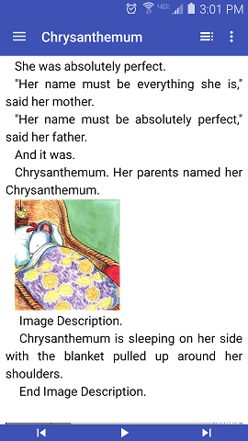

*Drawer Menu*

1. Here you find options to read downloaded books or search for new books. You can view books by author, title, recent downloads, etc.

Screenshot showing  the options under the Drawer menu such as search Bookshare, seach text, sccreen orientation, and delete book.


Items under the My Books section include favorites, recent,  by author, title, or search.


3) Within the “More Options” menu you can access Go Read’s settings, including both visual and font settings.



*More Options*

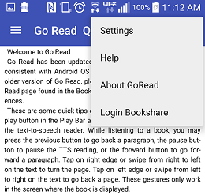

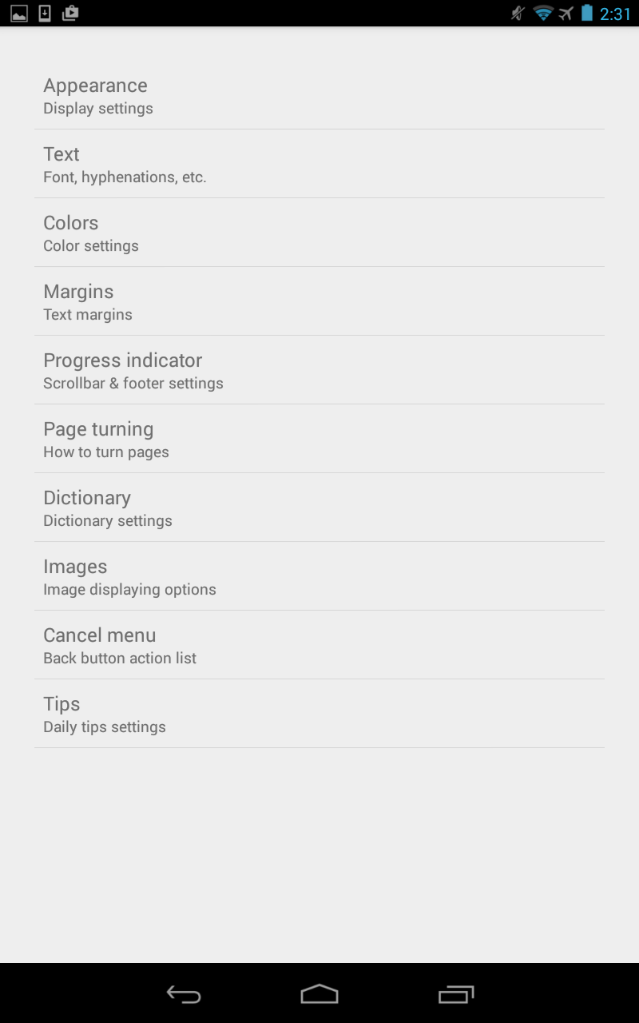

**Downloading Bookshare Books:**

1. Launch the Go Read app.
2. Select the Drawer menu button.
3. Select the Search Bookshare button.

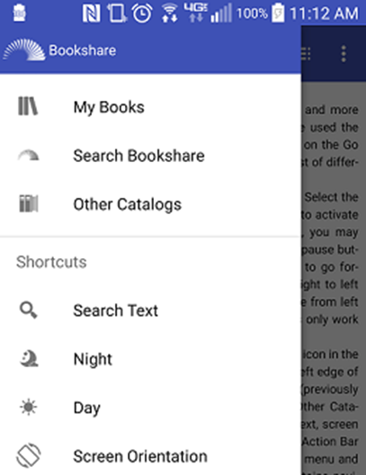

1. If you're not already logged in, you will be prompted here to enter in your Bookshare log in and password, then select the Log In button.
2. Select a search option, you can search for your book by Title, Author, ISBN, or browse our categories.
3. When you locate a book select the book’s title, then select the Download button.

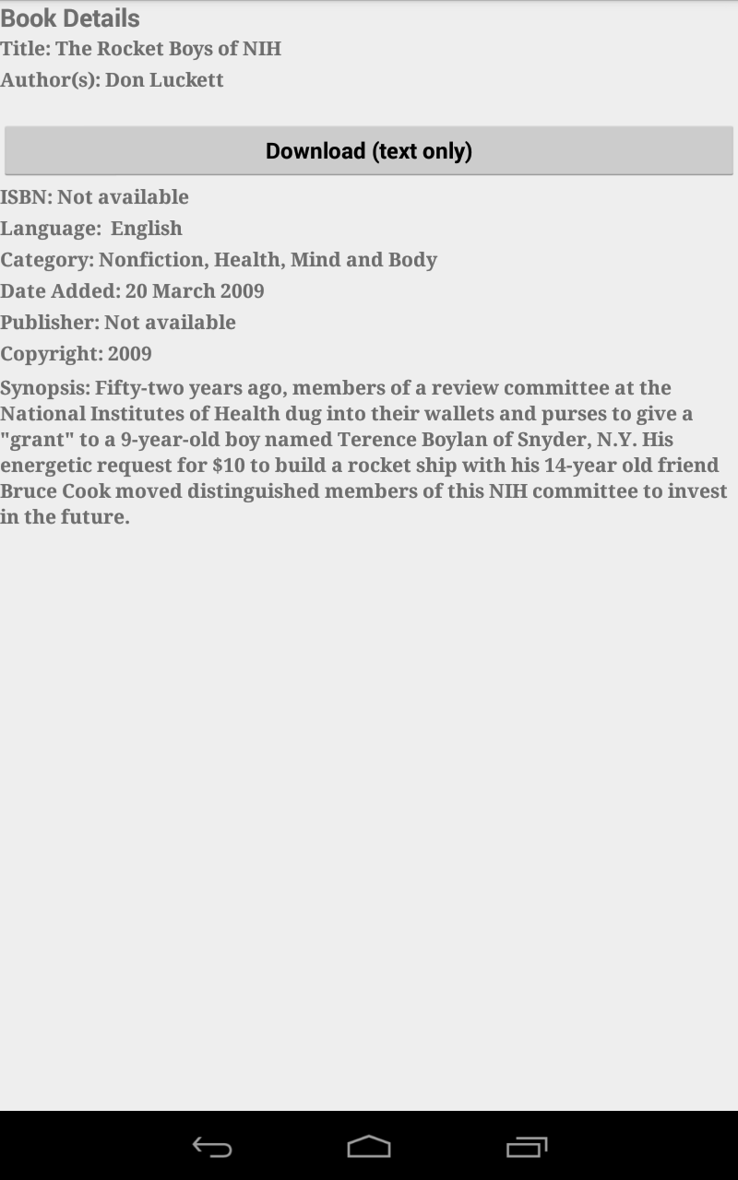

1. Once the book has downloaded, select the “Book Downloaded! Read Book” button.

