**Image 1 - A boy is sitting against a tree, smiling, and looking at the screen of a laptop. His arms are raised.

Graphic - Bookshare logo in a orange box.

Image 2 - A man is looking intently at a tablet screen.**

**How-To Guide**

How to Set Up Student Logins

**Image 3 - A boy and woman are smiling as they look at a computer screen. A open book is in the foreground.

Graphic - Blue box.

Image 4 - A woman is smiling as she looks at a tablet screen.**

# Set Up Student Logins

# Students can read books assigned by teachers independently with student logins. Follow these steps to help your members read.

## Step 1 - Set up your Student’s Login:

1. Log in to your Bookshare account.
2. Select “Members”
3. Select a student with an organizational membership and select their last name to edit.

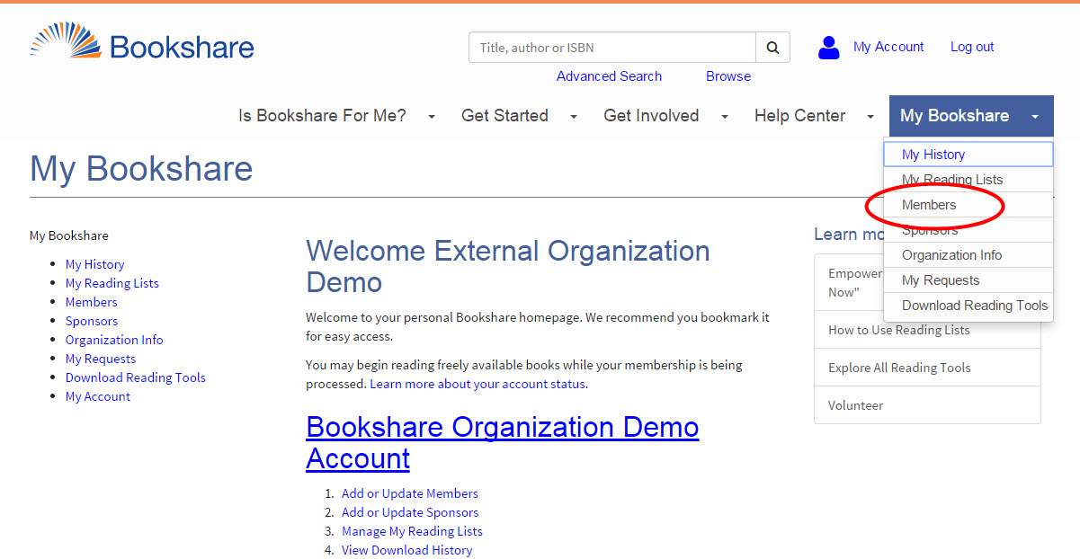

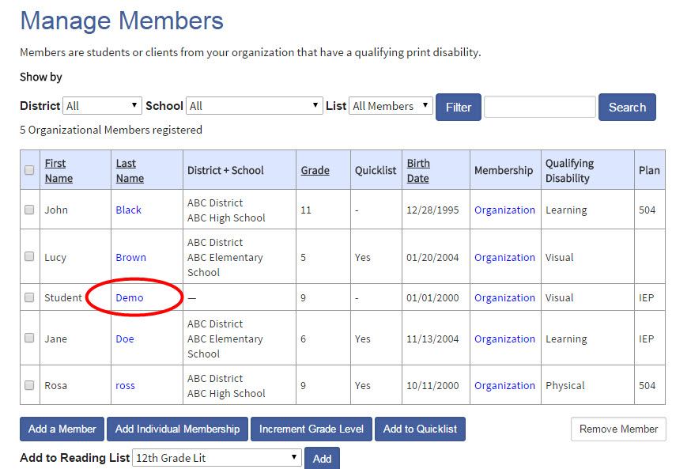

1. Set a username and password for your student. Usernames can be an email, nickname, or student ID, and must be unique and a minimum of 6 characters long.

**Tip:** Write down the username and password on a useful form found in the “Help Center" under “Training and Resources > Brochures and How-To Guides.”

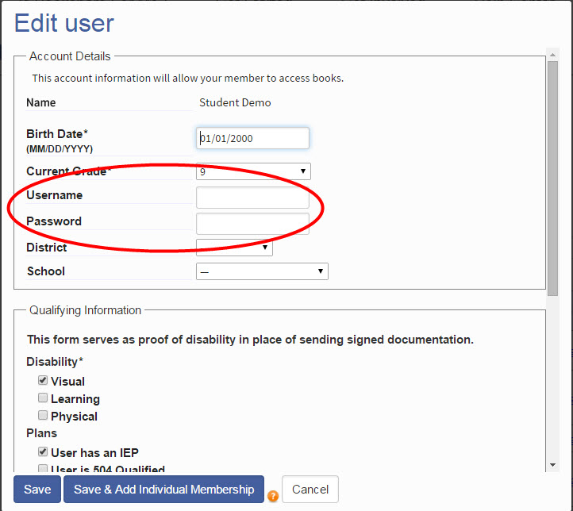

1. Save the student information and repeat these steps for other students.

**Step 2 - Assign Books to Students on a Shared Reading List:**

1. To get your student members their reading materials we encourage you to set up “Reading Lists” or share Reading Lists that you already created.
2. To create a new “Reading List” go to “My Bookshare.”

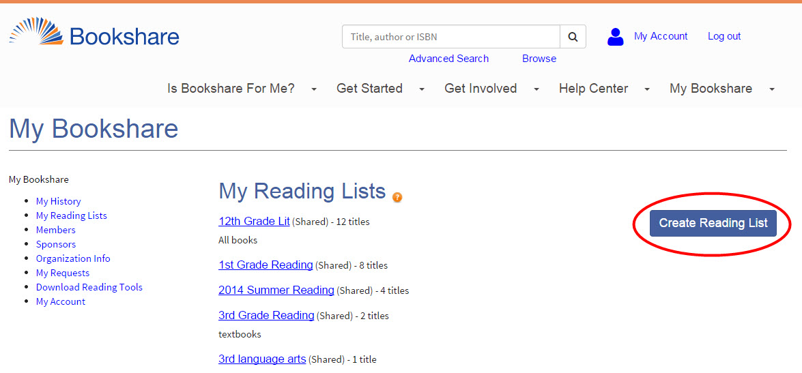

1. Name the reading list something meaningful, and ensure the drop down box indicates the reading list is visible to all reading list members.

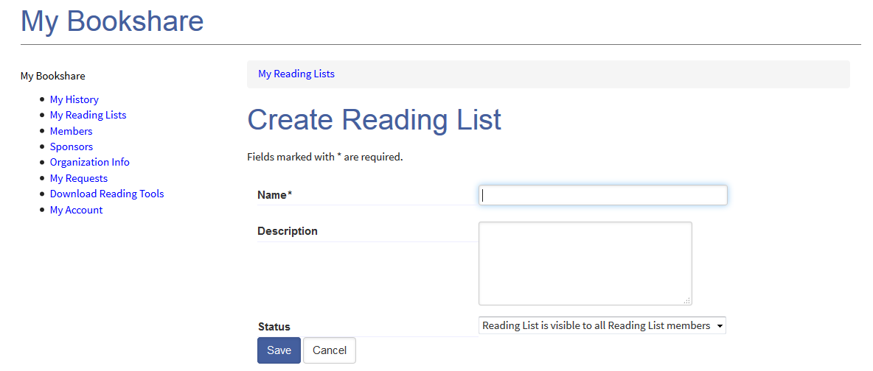

1. Select the “Members” link from the top of the reading list.

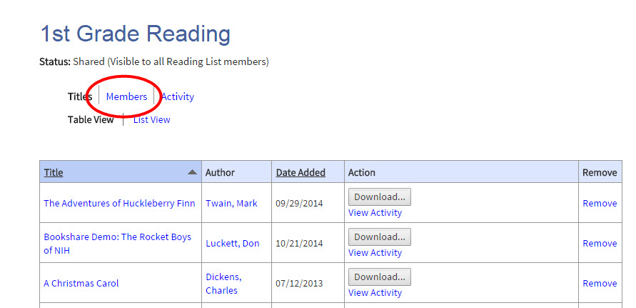

1. Select the “Add Members” button and place a check mark next to the members you wish to assign books.
2. Select the “Add selected members” button.
3. Assign books to the students by searching Bookshare and select the “Add to Reading List” link.
4. Select the newly created reading list from the drop down box and select “Add.”

**Step 3 - Students Read Independently:**

Students log in either through the Bookshare website to use Bookshare Web Reader or a [Bookshare Integrated application](https://www.bookshare.org/cms/help-center/other-reading-tools).

Bookshare Web Reader:

1. Students log in to Bookshare with his/her user name and password as set by the Sponsor.
2. On the “My Bookshare” page, select “My Reading Lists”.

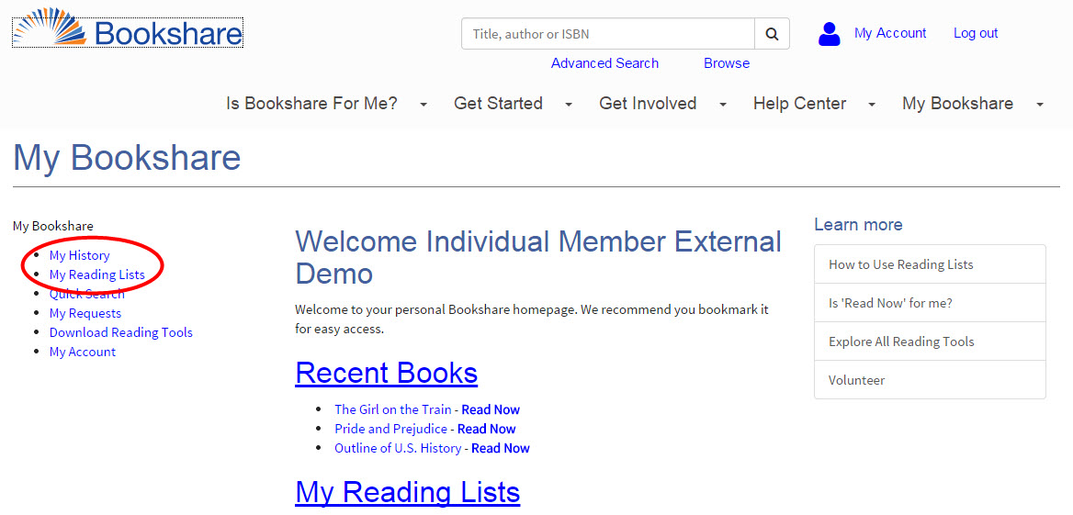

1. Students can open any title that was previously downloaded for them by a Sponsor or shared on a Reading List by selecting “Read Now”.

Bookshare Integrated Application:

1. Student logs into the reading tool.
2. The student searches for the book using the tool’s search function.
3. The book is downloaded through the tool’s download function.