**Three zoned image. To the far left is a boy is sitting against a tree, smiling, and looking at the screen of a laptop. His arms are raised.
In the middle is the Bookshare logo in a orange box.
To the far right is a man looking intently at a tablet screen.**

**How-To Guide**

How to Set Up Student Logins

# Set Up Student Logins

Students can read books assigned by teachers independently with Student Logins. These allow students to log in to Bookshare at school or at home and access books you have assigned on Reading Lists. You can set up Student Logins for both new and existing student members.

## Student Logins for Existing Members

1. Select a student with an organizational membership and select the edit icon or their last name to edit. Note: students with Individual Memberships do not get assigned a Student Login.

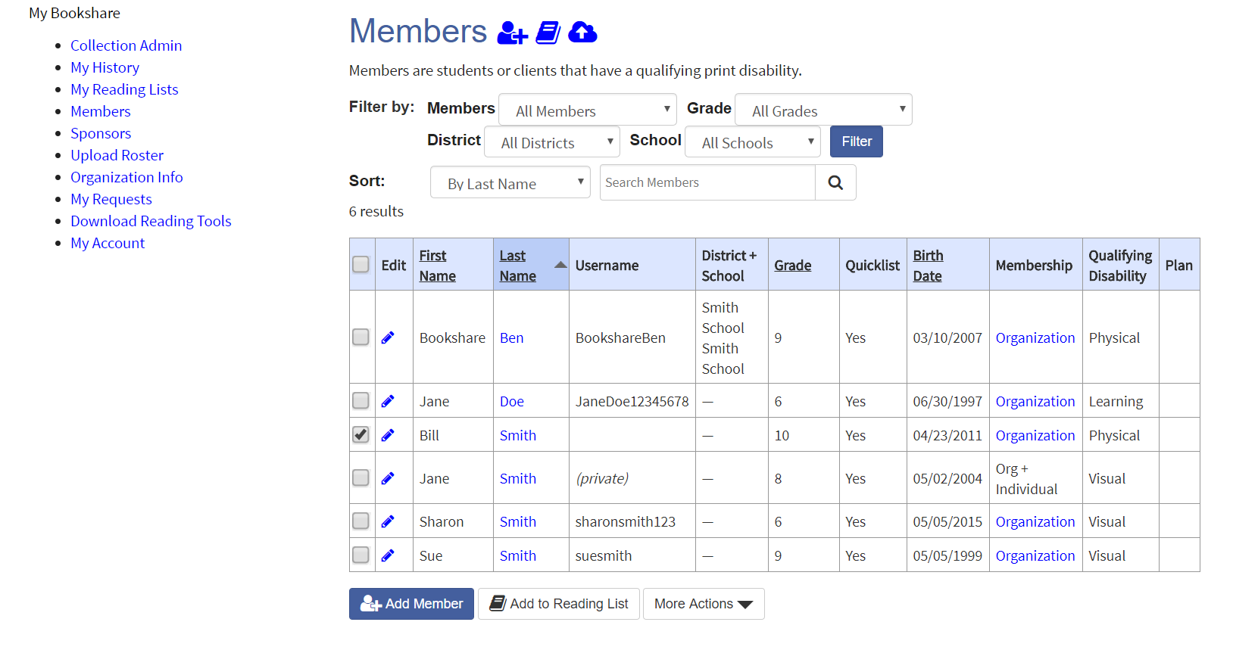

1. Enter username and password and select “Save.”

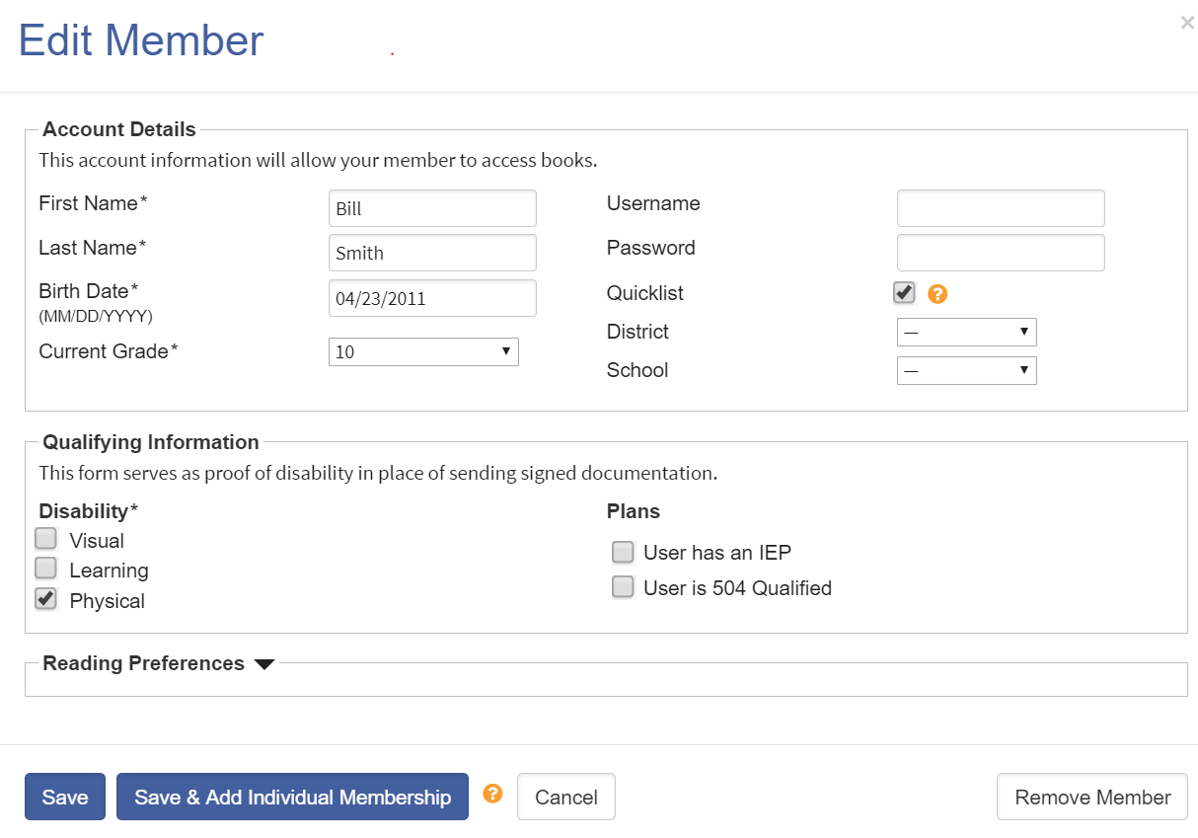

**Tip:** Write down the username and password on a useful form found in the “Help Center" under “Training and Resources > Brochures and How-To Guides > [Student Login Form](https://www.bookshare.org/cms/sites/default/files/bookshare_student_login_information.pdf).”

Students can now read books you have assigned to them on shared Reading Lists. To learn more about using Reading Lists, review the [How to Guide: Use Reading Lists to Assign Books](https://www.bookshare.org/cms/sites/default/files/how_to_guide_how_to_use_reading_lists.pdf).

To learn more about how students read Bookshare books, review [Students: Read Bookshare Books](https://www.bookshare.org/cms/sites/default/files/quick_start_guide_for_students.pdf).

## Student Logins for New Members

1. Log in to your Bookshare account and select “Members” or “Manage Student Roster.”

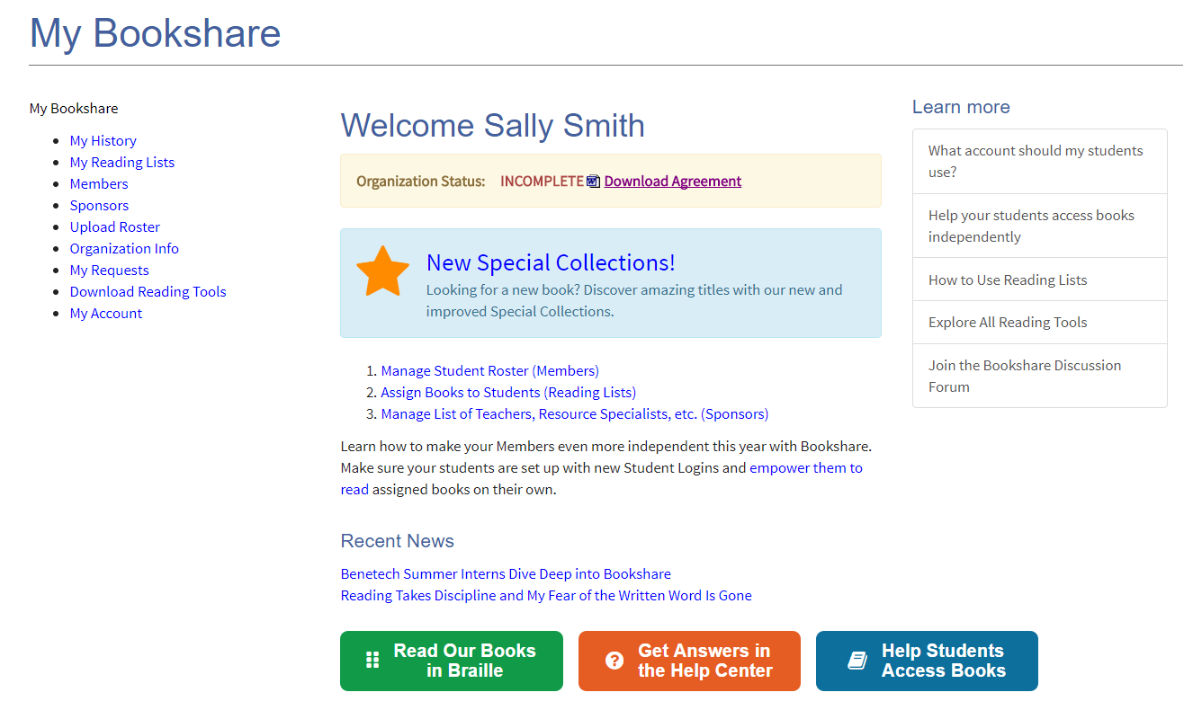

1. Select the “Add Member” button.

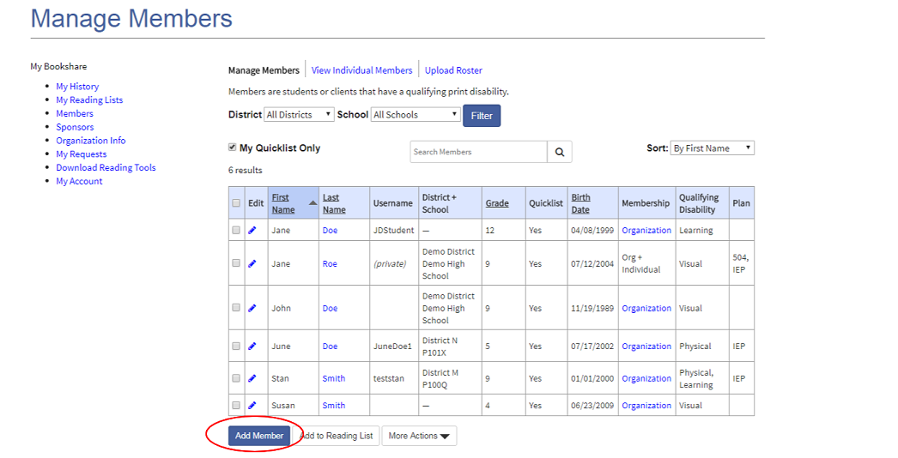

1. Complete the first two sections by entering information on a [qualified student](https://www.bookshare.org/cms/bookshare-me/who-qualifies/qualifications). The username and password fields are for the student’s personal login. Usernames can be anything including: email addresses, nicknames, or student IDs. Select "Save."

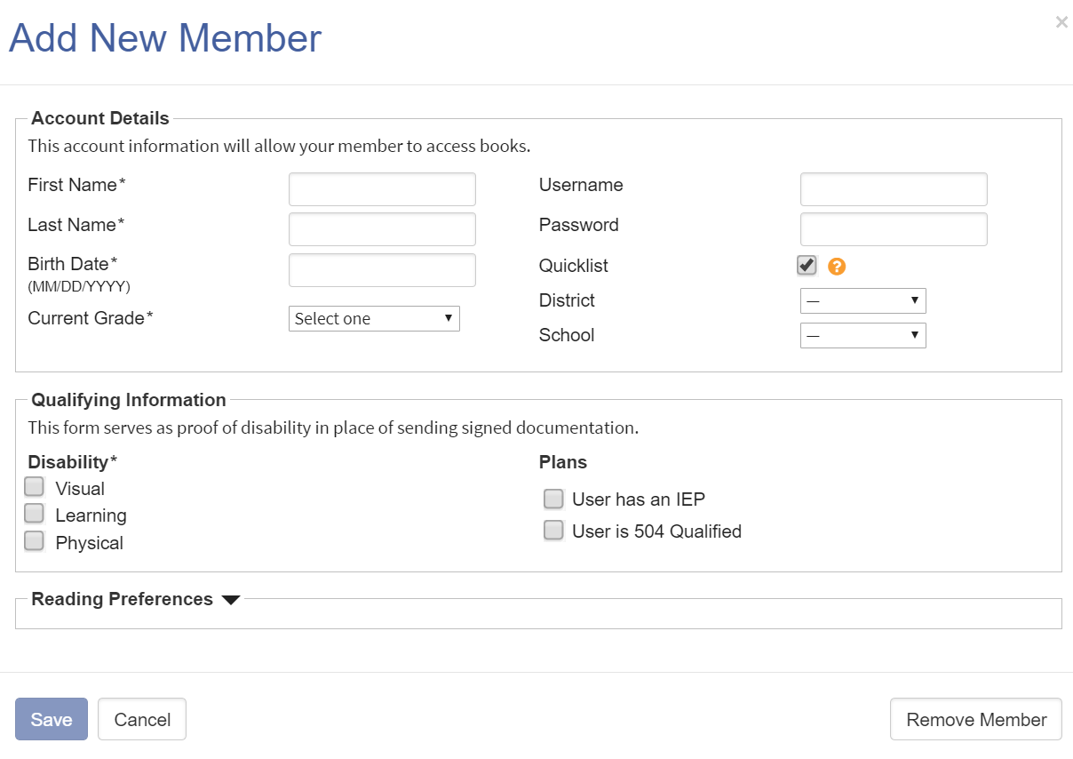

**Tip:** Write down the username and password on a useful form found in the “Help Center" under “Training and Resources > Brochures and How-To Guides > [Student Login Form](https://www.bookshare.org/cms/sites/default/files/bookshare_student_login_information.pdf).”

**Thank you for choosing Bookshare! To learn more, please visit our**

[**Training and Learning Center!!!**](https://www.bookshare.org/cms/help-center/learning-center)