**Image 1 - A boy is sitting against a tree, smiling, and looking at the screen of a laptop. His arms are raised.

Graphic - Bookshare logo in a orange box.

Image 2 - A man is looking intently at a tablet screen.**

**How-to Guide**

Subscribe to Summer with Reading Lists!  
  
**Image 3 - A boy and woman are smiling as they look at a computer screen. A open book is in the foreground.

Graphic - Blue box.

Image 4 - A woman is smiling as she looks at a tablet screen.**

# Step 1: Subscribe to Summer Reading Lists

1. Go to the [Bookshare Summer Reading](http://www.bookshare.org/cms/campaign/summer-2017) page ([www.bookshare.org/cms/campaign/summer-2017](http://www.bookshare.org/cms/campaign/summer-2017))
2. Select one of the Reading Lists that Bookshare has created for its members.
3. Look over the books that are on the list, and then **subscribe** to the list.
4. This Summer Reading List will now appear on your [My Reading Lists](http://www.bookshare.org/myReadingLists) page and on your [My Bookshare](http://www.bookshare.org/home) page
5. You can open or download your books all summer long!

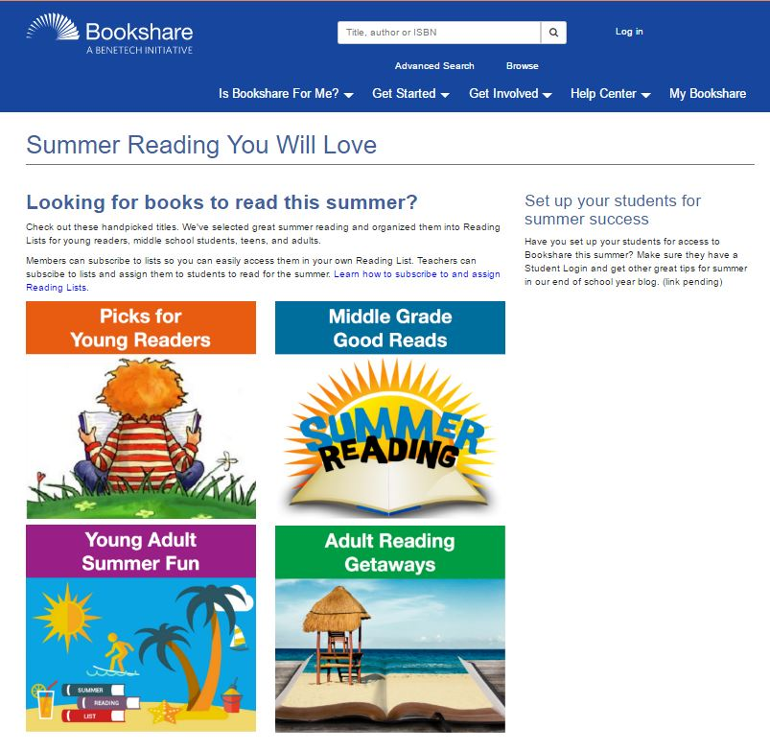 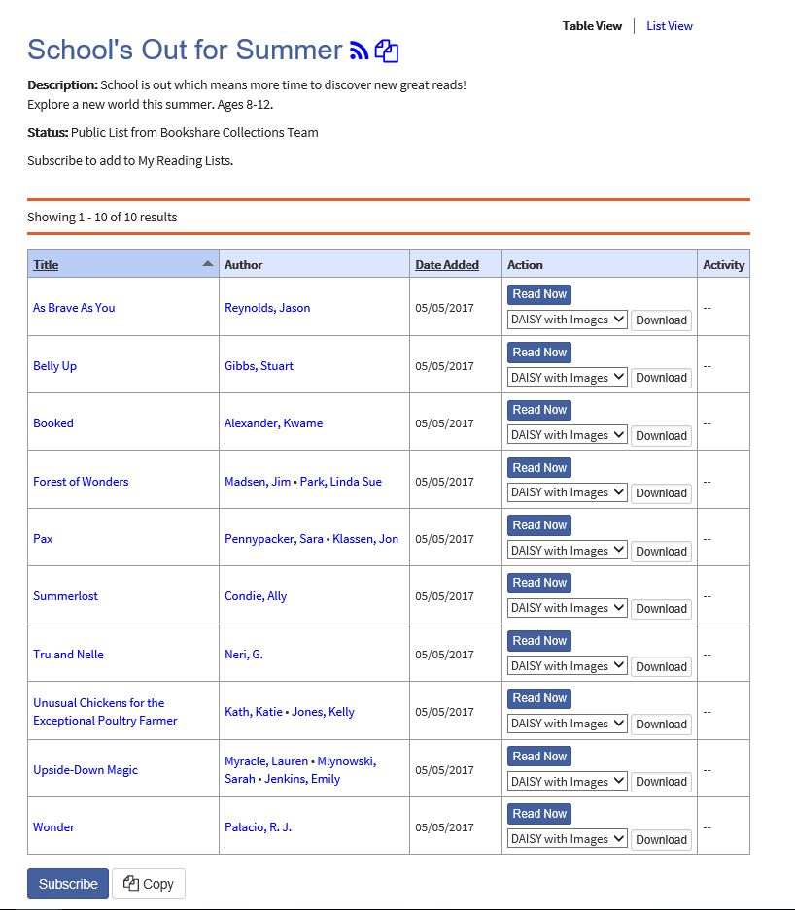

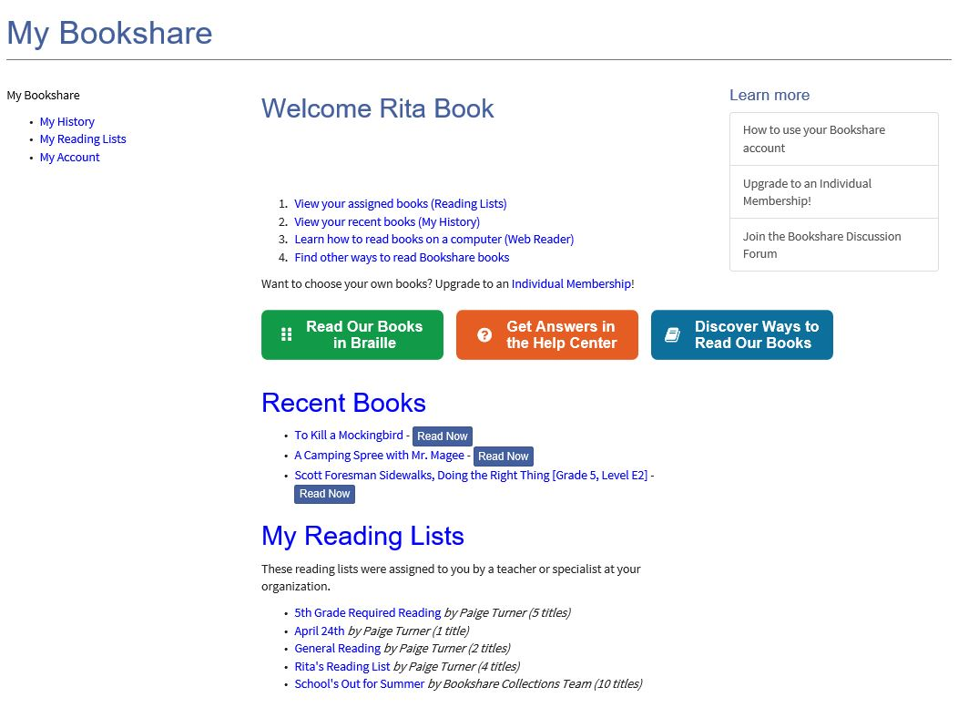 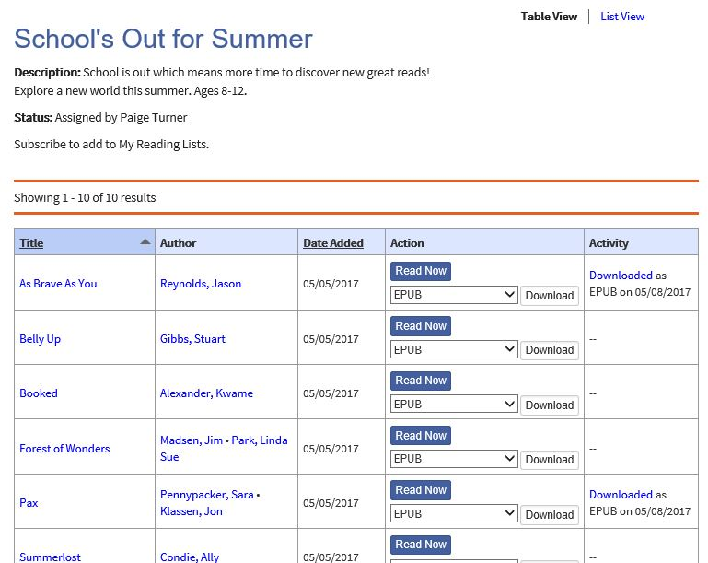

**Questions?**

*Q: Will there be more Reading Lists to which I can subscribe and assign to my students?*

*A: Yes! Bookshare is actively working on adding more Reading Lists that will replace the Special Collections. We hope that you will like these new additions that make it easier to discover books and get them to your students.*

*Q: If my account also is associated with a school account, can my teachers assign me this list*

*A: Yes! As an individual member, you can subscribe to reading lists on your own, just as you can pick your own books to download. However, your teacher might want to assign a specific reading list to you as well, so you may see some other reading lists appear.*

*Q: When would I copy the Reading List instead of subscribe to it?*

*A: If you want to take a “snapshot” of a Reading List that Bookshare is managing, then you might want to copy it, name it as your own, add your own books or remove some. Bookshare may continue to add books to their public Reading List, but your copy of the list is yours.*

For answers to other questions, please visit [https://www.Bookshare.com/cms/help-center](https://www.bookshare.com/cms/help-center).