**Three zoned graphic: On the far left, a boy is sitting against a tree, smiling with his arms raised, looking at the screen of a laptop. Next is the Bookshare logo in a orange box.To the far right is a man is looking intently at a tablet screen.**

# How-To Guide

# How to Read Bookshare Books with Alexa

## Step 1: Enable the Bookshare Reader Skill

Welcome to Bookshare for Alexa! To use the Bookshare Reader for Alexa, you must be a Bookshare Member. To begin using Bookshare Reader for Alexa, you must download, and install the Alexa app onto your mobile device or computer and sign in with your Amazon account. **NOTE: If you have already set up the skill, skip to page 4, Get Reading!**

Find the Bookshare Skill by searching for “Bookshare Reader” within the “Skills and Games” link on the Alexa App, on the [Alexa Skills page](https://www.amazon.com/alexa-skills/b/?ie=UTF8&node=13727921011&ref=_alxhb_tpnv_ftrs) on the Amazon website or by voice command to your Alexa-enabled device. **NOTE**: On the app, select the **“More**” option on the bottom right of the screen. Then select “**Skills and Games.”**

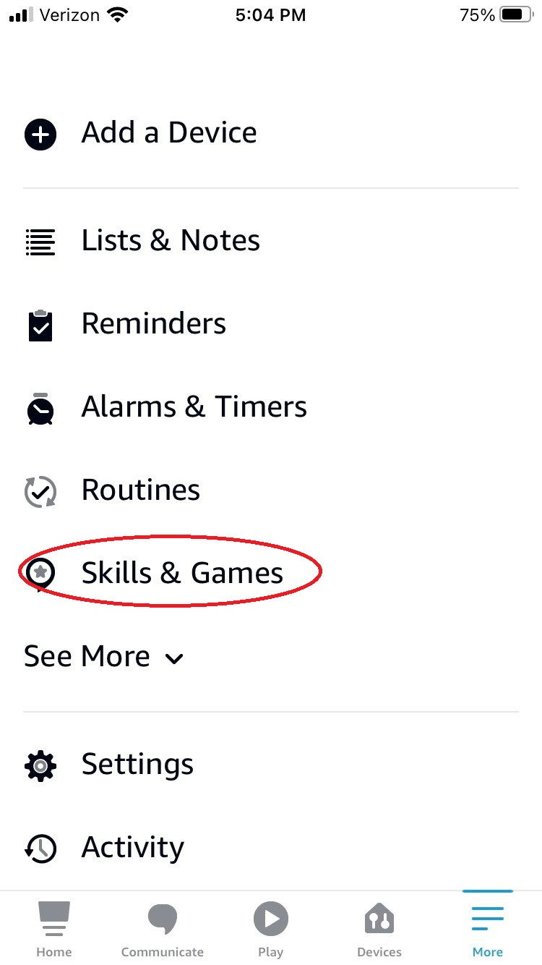

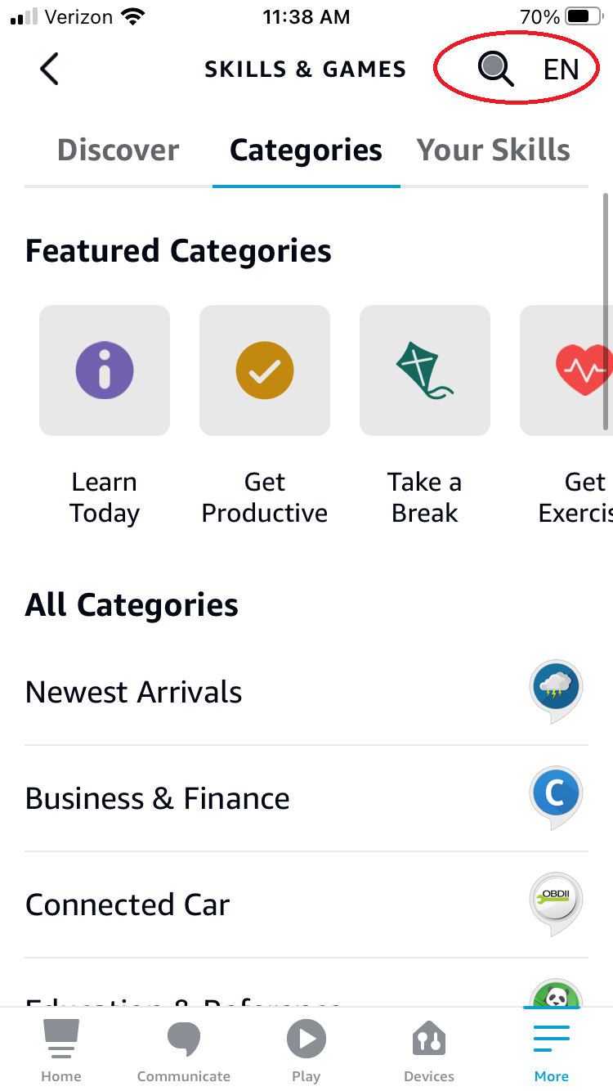

Select the “**Enable to Use”** button.

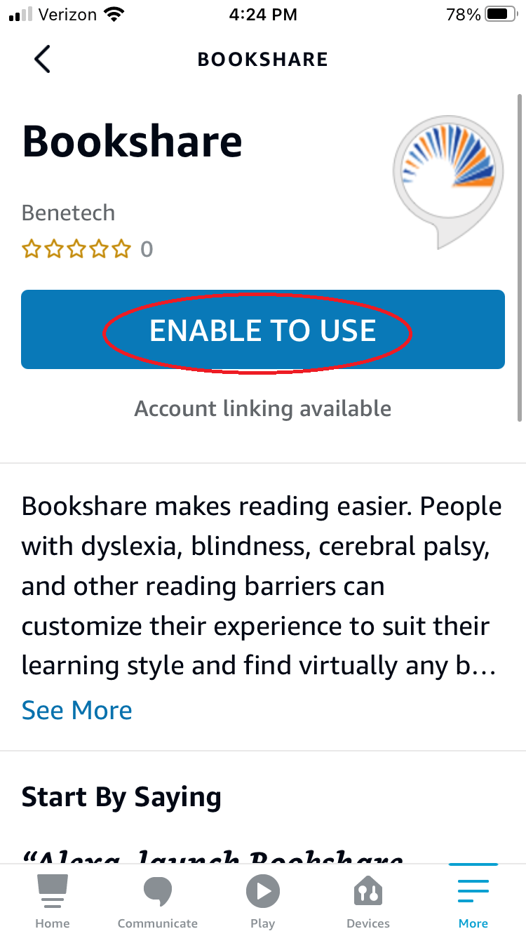

Link your Bookshare account to the Bookshare skill by selecting the **“Settings” button, then the “Link Account” link.**

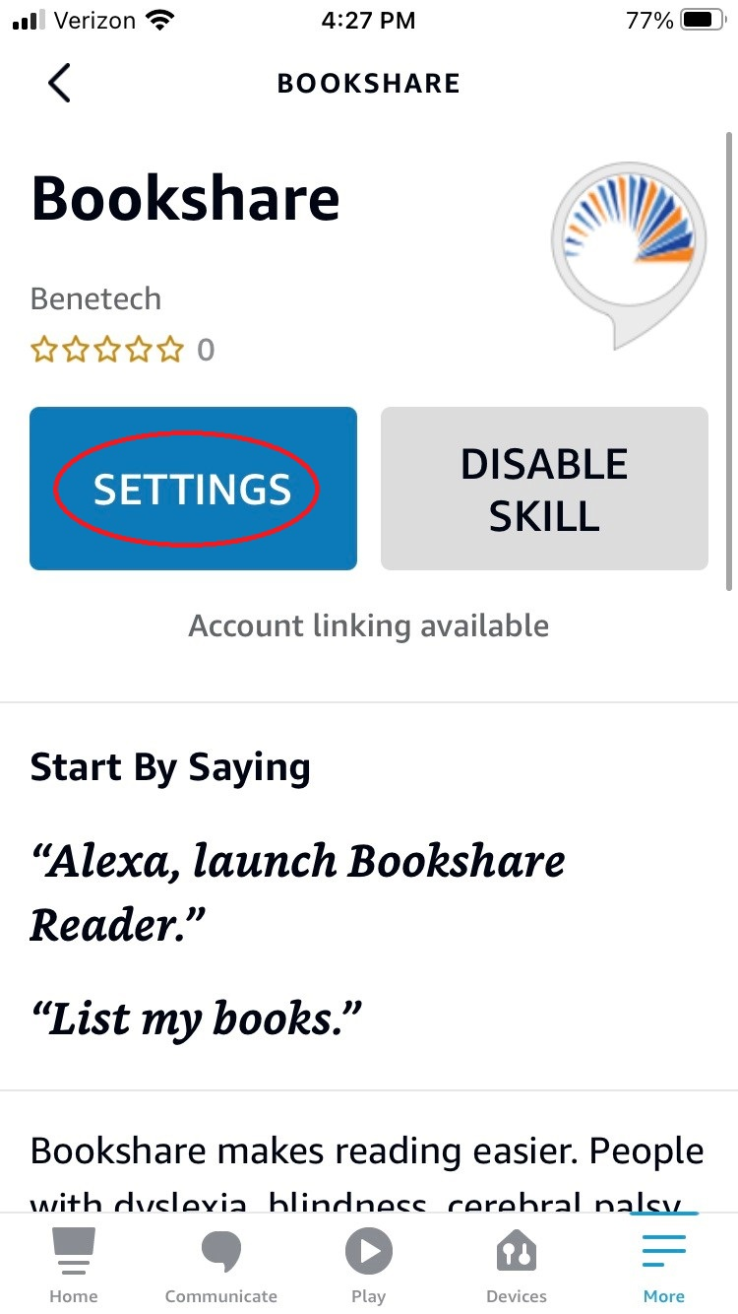

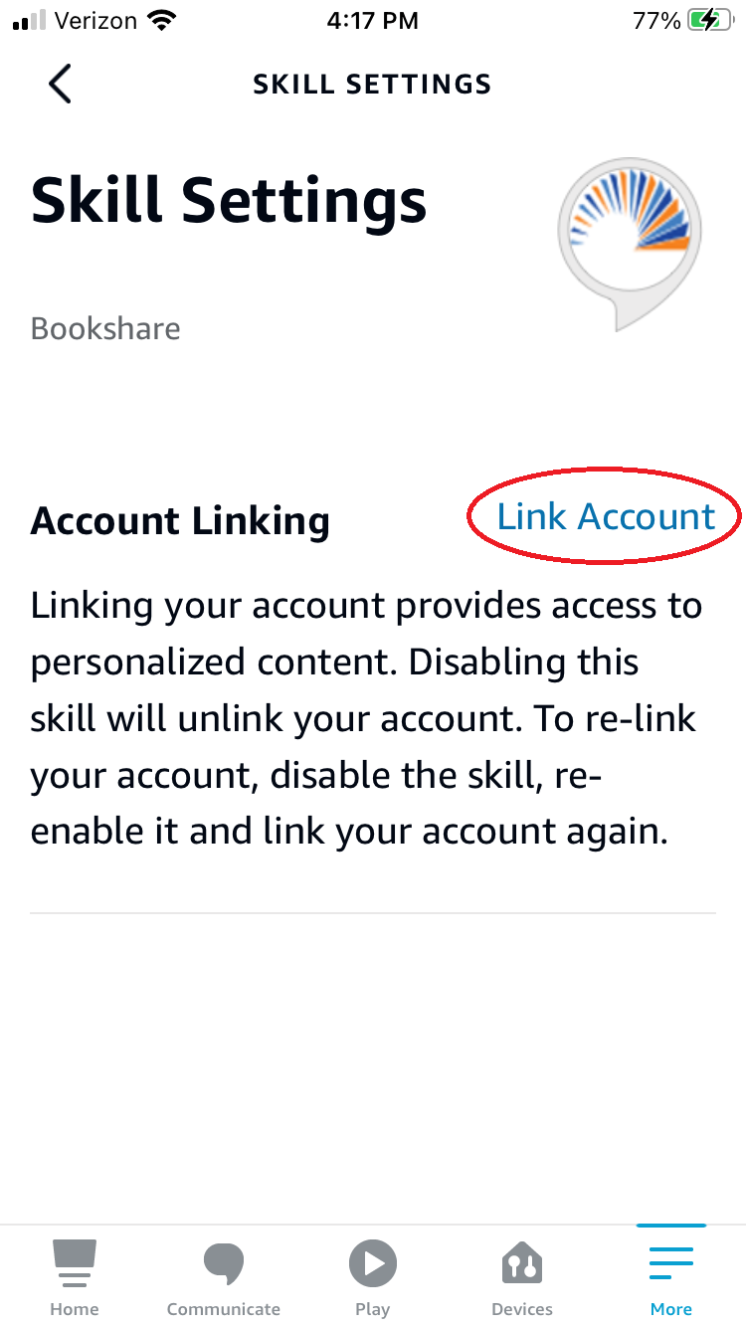

Next, enter your Bookshare username and password, then select the “Sign In” button. You will receive confirmation that your account is successful linked. Select the blue “Close” button. **You are now ready to listen to books on your Alexa enabled device**!





## Step 2: Get Reading with Audio Books for Alexa

The Bookshare Reader skill creates and uses a Reading List called "Amazon Alexa". By adding audio books to this reading list, you make them available for the Bookshare skill to find. **NOTE: All books added to the Amazon Reading List must be in AUDIO FORMAT.**

### Get books from your history for your *first Alexa reading experience*

Launch the Bookshare Reader by saying, **“Alexa, launch Bookshare Reader**” or **“Alexa, Open Bookshare Reader.”**   
  
The first time you launch the skill, Alexa will respond with **"Welcome to Bookshare Reader. It looks like you don't have any audio books available to read. Would you like to add books you have recently downloaded in Bookshare by saying “Get My History?”**

If you say, **“Get My History”,** Alexa will read you a list of books that you have previously downloaded or read on another device and ask which one you would like to add to the Amazon Alexa Reading List.

Say the name of the book you want to access, and she will respond, **“Okay, I’ve added <book title> to your reading list. Would you like to read it now?”**

Say **“yes”** to begin reading. When the audiobook is ready, Alexa will say **“Okay, let’s read”** and the book will begin. Note that there may be a delay when you first open a new book.

**NOTE:** If you want to switch to another book, you must pause the current book and say **“Alexa, launch Bookshare”** to get choose a different book from your book list.

### Read books once you have *used Alexa previously*

After you have used Alexa and added books from “My history”, the next time you open the skill, Alexa will say, **“Welcome to Bookshare Reader, would you like to continue reading <book title> where we left off?”**

If you say **“Yes”** Alexa will pick up reading in the same place you left off. If you say, **“No”,** Alexa will respond, **“Ok, would you like to read a different book or list my books?”** If you say**, “A different book,”** Alexa will respond**, “Which book from your reading list would you like to read?”** You will name the book title, or the corresponding number, and Alexa will begin reading. If you say**, “List my books”,** Alexa will read you a list of available books.

### Immediately Useful Voice Commands:

“Alexa, help” or “Alexa, tutorial” – to get to the help menu and listen to the Bookshare Tutorial and say “Shortcuts” to hear various shortcut commands

“Alexa, pause” – to pause reading the book

“Alexa, resume” – resume reading where you left off

"Alexa skip" or "Alexa next" - skip to the next section of the book

"Alexa back" or "Alexa previous" - go back to the previous section of the book

"Alexa stop" - exit the Bookshare skill. To reinvoke the skill, you will need to say "Alexa open Bookshare"

## Step 3: Add New Books to the Amazon Alexa Reading List via Bookshare for Alexa

**You can now search for new books in the Bookshare collection directly from your smart speaker!**

1. Launch the Bookshare skill by saying **"Alexa launch Bookshare."**

2. Say **Search for** [book title]. You can also say **Search for author** [author name].

Alexa will list the first 5 books in the search results. You can choose a book or say **"More results"** to hear more titles.

3. Say **"Add [book title]"**. Or you can ask for a book by it's number. Say **"Add book [number]"** or simply **"Book [number]"**.

After you choose a book, Alexa will say “**Okay, I added [book title] to your Reading List. Would you like to start reading it now?”** You can either say **“Yes”,** to begin reading, or search for another book.

## Add New Books to the Amazon Reading List via [www.bookshare.org](http://www.bookshare.org)

At this time, searching for new books is not yet available through the Bookshare Alexa skill, but you can add any book to the Amazon Alexa Reading List on the [Bookshare website](http://www.bookshare.org).

Log into your Bookshare account on the [Bookshare website](http://www.bookshare.org). From your My Bookshare page, select the **“My Reading Lists”** link. Here you will find the Amazon Alexa Reading List.

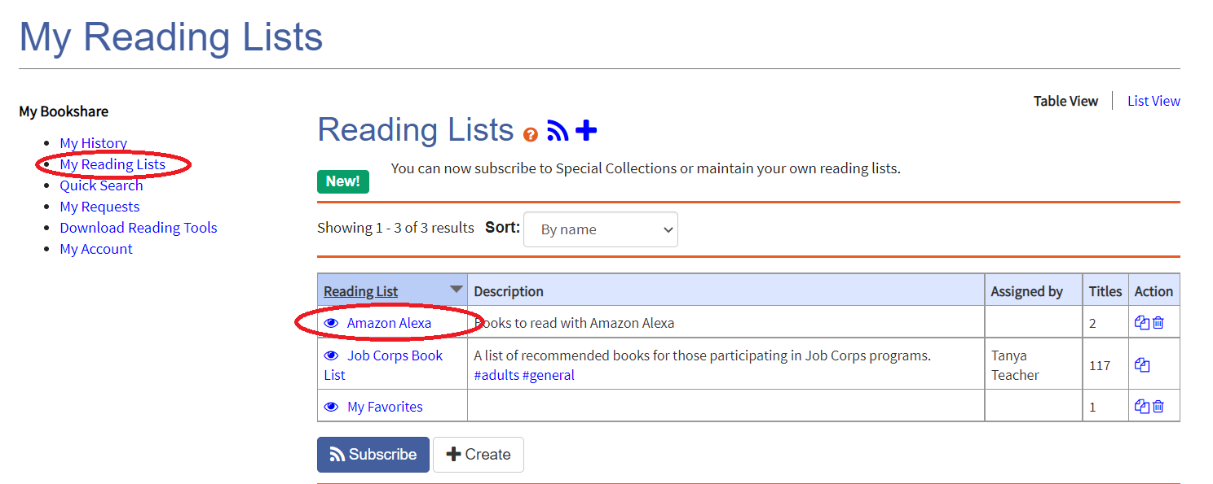

To add books to your Alexa Reading List simply [search](https://www.bookshare.org/cms/help-center/training/find-books) the Bookshare collection, on [www.bookshare.org](http://www.bookshare.org), to find the book you want to read, then select the “**Add to Reading List”** link choosing **Audio format.**

Bookshare Website Screenshot
Screenshot of a book list on the Bookshare website with the Add to Reading List link circled in red on the right side of the screen. 

Next, select the **“Amazon Alexa” Reading List** from the dropdown menu.  
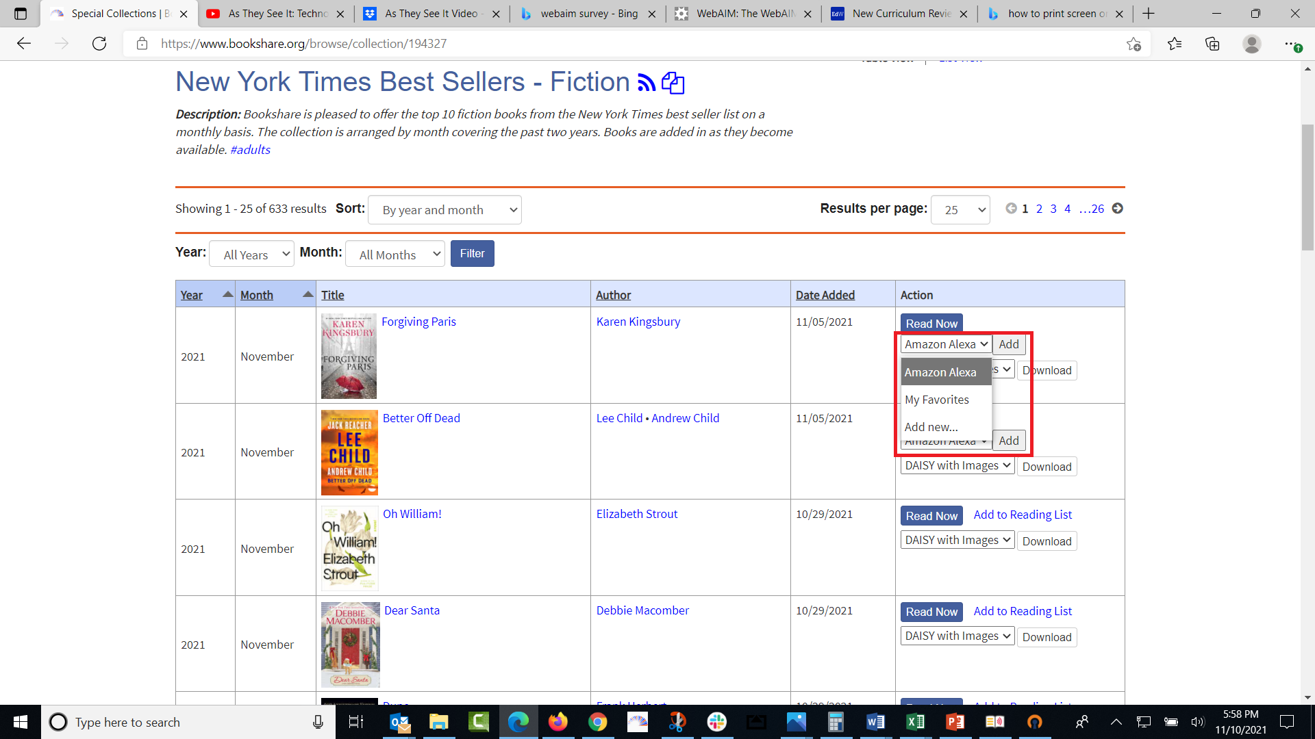

**Note: Not all books in the Bookshare collection are available in audio format, either because they are not well-formatted, are too large, or have too many images. It is a good idea to check in the Download drop-down menu to make sure the book is available in audio format before putting it on the Alexa list. If there are multiple copies of a book provided by different publishers, you might try a different version.**

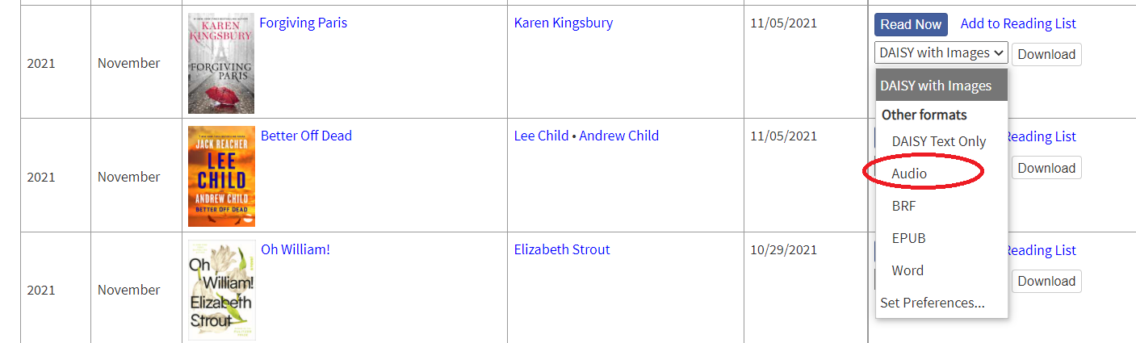

**Thank you for using Bookshare Reader for Alexa. If you would like to learn more, please visit our** [**Training and Learning Center**](https://www.bookshare.org/cms/help-center/learning-center)**.**

**You can also find more information on our** [**Alexa Smart Speaker Page!**](https://www.bookshare.org/cms/help-center/alexa-smart-speaker-beta-2021)

**Enjoy listening to your books!**