Getting Started with Bookshare’s API

Getting an API Key
To generate an API key for your app simply email partner-support@bookshare.org with a description of the application you’re developing.
This API key will be included at the end of every API call. Each application, even if it is registered in the same developer account, needs a unique API key.

Using User Authentication for API Calls
Bookshare’s API uses md5 hashed passwords for user authentication. Authentication occurs by including the hashed password as an http header labeled “X-Password” and the element “/for/username” in the URL. We recommended using user authentication for all of your API calls, although it is not required for some search calls.

Bookshare Membership – General Information
For the purpose of app development there are two main types of Bookshare accounts: Individual Members and Sponsors. Both account types can freely search for books in our library, however they have different download processes.
Since the request for downloading books varies between accounts, we recommend requesting a user’s account type after authenticating their user credentials with the Account Preferences call.
Individual members or Organizational members have a personal Bookshare account that allows them to download most books in our library if the account is fully authorized with an active subscription. Organizational members are a subset of Individual Members with greatly limited download access. Additionally there are some books in our collection that are “NIMAC-restricted” or regionally restricted where download access may be unavailable for Individual Members.
Sponsors help qualified members of their Organization download books. Sponsors, which are most often teachers, are a part of a larger Organization account that includes qualified Members, usually students. Unlike Individual members, they must always download books on behalf of one of their members. This process is built in to our API call for Sponsor downloads.

Displaying Member Information
Bookshare has two API calls for displaying member information. As noted in the sections below, both of these calls require user authentication.

User Information
This is the call recommended for user authentication which displays general user information. The format for this call is:
api.bookshare.org/user/info/display/for/Individual email?api_key=Your API key
There are a few different pieces of member information displayed with this call:
- Number of downloads remaining
  - How many downloads remain out of member’s monthly download limit
- UserID
  - Member’s unique ID number
- Display name
  - Member’s first and last name
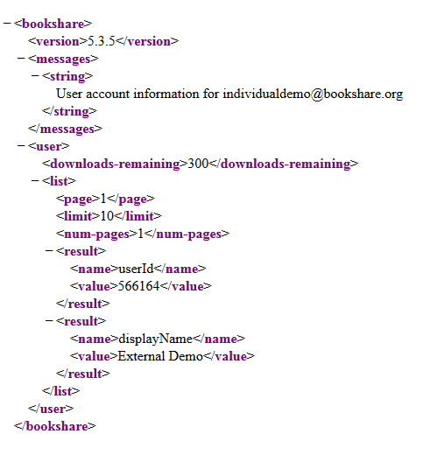

Account Preferences
You can use another API call to access the user’s account preferences, including their account type:
api.bookshare.org/user/preferences/list/for/Email or username?api_key=Your API Key
Some of the account preferences you can access are:
- Number of downloads remaining
  - How many downloads remain out of member’s monthly download limit
- Adult Content filtering
  - Whether books marked as “Adult Content” are blocked for this member
    - TRUE – they do not have access to adult content
    - FALSE – they can access adult content
- User type
  - Member’s account type
    - 1 – Individual Membership or Organizational Membership
    - 2 – Sponsor

Searching for Books
The general format for searching for books is:
api.bookshare.org/book/search/search criteria/search term?api_key=Your API key
Some of the common search criteria you may use are listed in the table below. A “Book Metadata Response” will display detailed information about one book, while a “Book List Response” will display a number of books that match the search criteria.
Please note that all ISBN searches must contain 13-digit ISBN numbers.
Search Details | URI | Response
ISBN Lookup | api.bookshare.org/book/isbn/Text | Book Metadata Response
Book ID Lookup | api.bookshare.org/book/id/Number | Book Metadata Response
Title Search | api.bookshare.org/book/search/title/Text | Book List Response
Author Search | api.bookshare.org/book/search/author/Text | Book List Response
Category Search | api.bookshare.org/book/search/category/Text | Book List Response

You can find a full list of search criteria at http://developer.bookshare.org/docs/read/api_overview/Request_and_Result_Formats. You can also combine multiple search criteria to refine your results. For example:
api.bookshare.org/book/search/grade/third+grade/category/Animals?api_key=Your API key
api.bookshare.org/book/searchFTS/guinea+pig/category/Animals?api_key=Your API key

Without user-authentication
You can search for books without using user-authentication, however only freely available books will appear available for download. Unauthenticated searches follow the general format listed above, api.bookshare.org/book/search/search criteria/search term?api_key=Your API key.
Example:
api.bookshare.org/book/search/title/romeo+juliet?api_key=Your API key

With user-authentication
Using user-authentication in your search API call will display which books are available for that particular member.
The general format for an authenticated search call is:
api.bookshare.org/book/search/search criteria/search term/for/email address or username?api_key=Your API key
Example:
api.bookshare.org/book/search/title/romeo+juliet/for/individualdemo@bookshare.org?api_key=Your API key
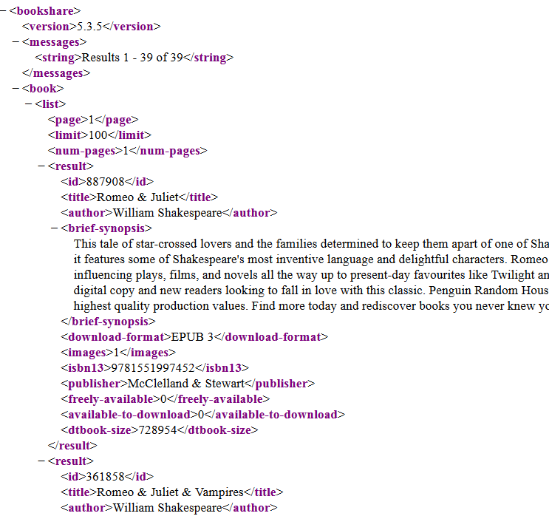

Downloading books

Download a book as an IM or OM
The general format for an Individual or Organizational member’s download API call is:
api.bookshare.org/download/content/book ID from search results/version/number indicating file format/for/Email or username?api_key=Your API key
Format options:
0 | BRF
1 | DAISY Text
3 | ePub 3
4 | DAISY with Images

Example:
api.bookshare.org/download/content/617463/version/1/for/individualdemo@bookshare.org?api_key={Your API key}

Download a book as a Sponsor
Sponsors can download any book from our collection, however they must select an Organizational Member to download the book on behalf of. The general format for a Sponsor’s download API call is:
api.bookshare.org/download/member/member ID from org roster/content/book ID/version/1 or 4/for/Sponsor email?api_key=Your API key
All Organizational Member ID numbers are listed on the org roster call:
api.bookshare.org/user/members/list/for/Sponsor email?api_key=Your API key

Downloading Different Formats
Our books are available in a variety of accessible formats, including BRF, DAISY, and EPUB.
The different book version numbers are:
0 - BRF
1 - DAISY
3 - EPUB 3
4 - DAISY with images

BRF (Braille Ready Format) is digital braille used with refreshable braille devices and braille embossers.
DAISY (Digital Accessible Information System) is a digital book file format that allows users to navigate by page, section, or chapter and set bookmarks or insert notes. DAISY contains the text of the book only, while DAISY with Images will also display images (if available).
EPUB 3 is a digital book file format that is compatible with a number of popular eBook readers, including iBooks and Google Books.
If the book requires additional time to package for download, a Book Packaging Status will be returned instead of the actual book. EPUB 3, DAISY with Images, and PDF files are not immediately available for download. The same download request can be repeated until the packaging is finished, at which point the response will be a Binary Download.
The Book Packaging Status contains the following fields: content-id and packaging-status. The content-id is equivalent to the book ID, and is a unique ID number for that particular title. The packaging-status shows the current status of the download. The different packaging-status messages include:
SUBMITTED – The request is queued up and waiting to be handled.
IN_PROGRESS – Book is in the process of being prepared for download.
CANCELLED – There was an error during the packaging and the book is not currently available.

User Download History
The user’s download history displays all books they have requested for download. By default the user’s history will display downloads in the past thirty days. The history includes a status for each request to indicate whether the download is preparing or available for download.
The general API call to look up a user’s download history is:
api.bookshare.org/user/history/for/email address or username?api_key=Your API key

Error Codes
You can find a full list of Bookshare’s API error codes at http://developer.bookshare.org.
Some of the most common error codes and their causes are listed below:
Error Code | Message | Meaning
0 | Book not found | Book, based on search criteria entered, is not currently available on Bookshare.
41 | Insufficient privileges {followed by reason} | This user does not have access to this particular book. For Individual Members, this book may be NIMAC-restricted. For Organizational Members, this book may not have been added to their Reading List.
82 | The Member for whom the title is being downloaded for needs IEP | This NIMAC title is not available to this particular member. If this member has an IEP, Sponsor should check with Bookshare Support to update account.

