Poet Quick Start Guide
- Register for Poet: https://diagram.herokuapp.com/ (click “register”)
- Sign up as a volunteer for Bookshare: https://www.bookshare.org/cms/get-involved/volunteer/opportunities-us
- Check the doodle poll: http://doodle.com/poll/45p8tc7uwki22hqz for a book ID number and to sign up for a section
- In Poet, go to “Poet Image Description”
- Click “edit” next to “describe image for uploaded book:” https://diagram.herokuapp.com/edit_book/describe
- Find your book, chapter, or section by scrolling down and/or using the table of contents as applicable
- Identify which images needed describing and the image type
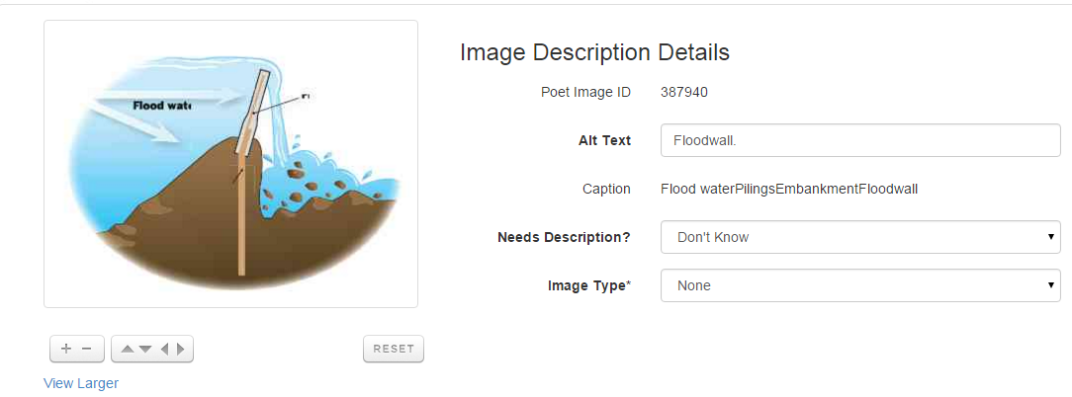
- Read the text to make sure you described what was missing
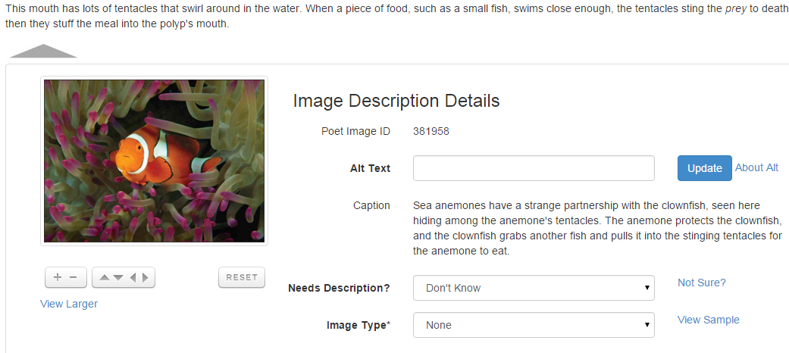

- Describe the images objectively
- Check the spelling and grammar
- Place everything in square brackets
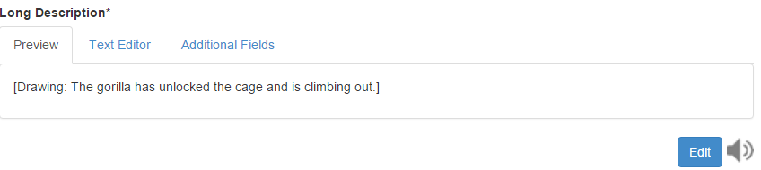
- Check the source
  - Delete any weird characters (such as &nbsp;)
  - Make sure to keep the <p> and </p>!
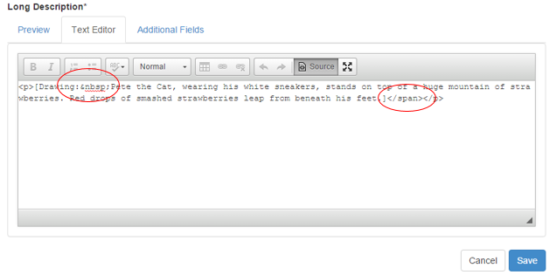
- Save!

