**Image 1 - A boy is sitting against a tree, smiling, and looking at the screen of a laptop. His arms are raised.

Graphic - Bookshare logo in a orange box.

Image 2 - A man is looking intently at a tablet screen.**

**Parent Guide to Bookshare**

**Image 3 - A boy and woman are smiling as they look at a computer screen. A open book is in the foreground.

Graphic - Blue box.

Image 4 - A woman is smiling as she looks at a tablet screen.**

[Bookshare](http://www.bookshare.org) is an ebook library that helps people read in ways that work for them. With Bookshare, books can be seen and heard which helps students improve their reading and comprehension. Bookshare offers school based and Individual Memberships. Students can have both! Bookshare is completely free for students and with over 1 million titles, there is something for everyone to read.

Is your child already on a school account? If so, skip to page 4 to learn how to use Bookshare at home.

**Sign Up for an Individual Membership Account**

If your child does not have a Bookshare account through school, you can sign up for an Individual Membership.

1. Go to [the Bookshare Website](http://www.bookshare.org/) ([www.bookshare.org](http://www.bookshare.org)) and select the "Sign up Today" button.

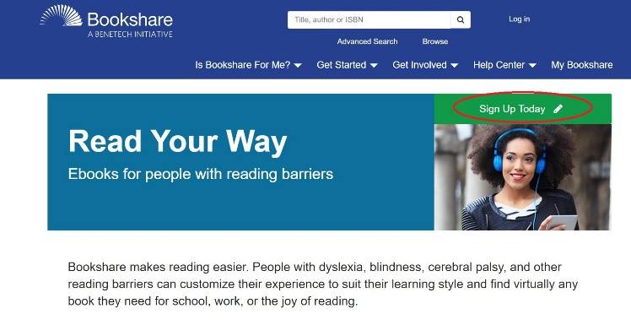

1. Select "Sign Up Individual."

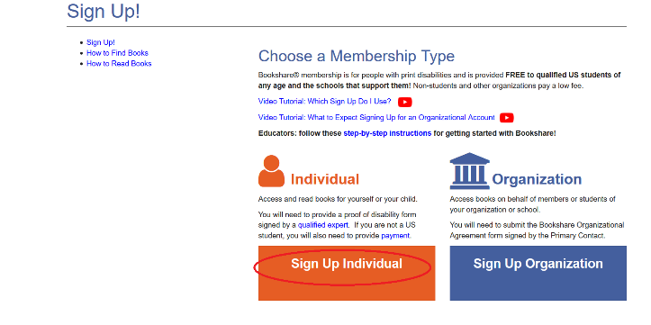

1. Confirm the account is for a person with a print disability. Visit the "[Who Qualifies](https://www.bookshare.org/cms/bookshare-me/who-qualifies)" page for information on qualifications.

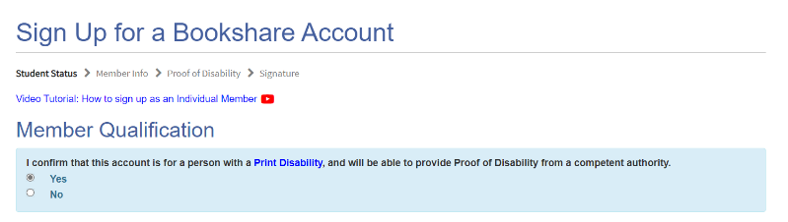

1. Under “Student Status,” indicate whether your child is a current U.S. student. Membership is free for students.

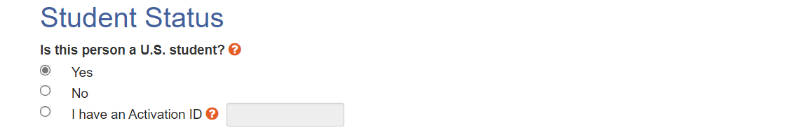

1. Enter your State, city and name of child’s school or select the “Find My School” button.

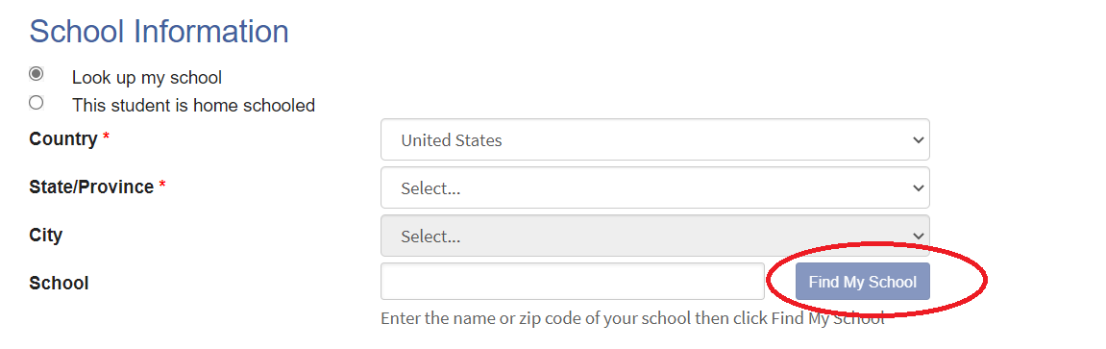

1. Select the school from the list. If not found select I cannot find my school. Select the Done button when finished, then the Next button.

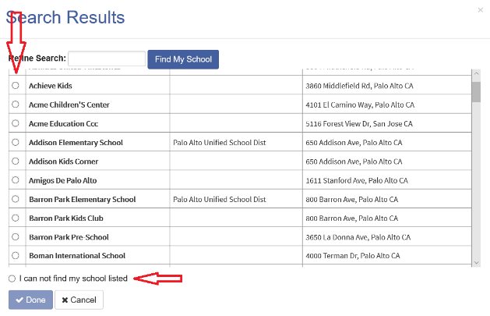

1. Enter your child’s information.

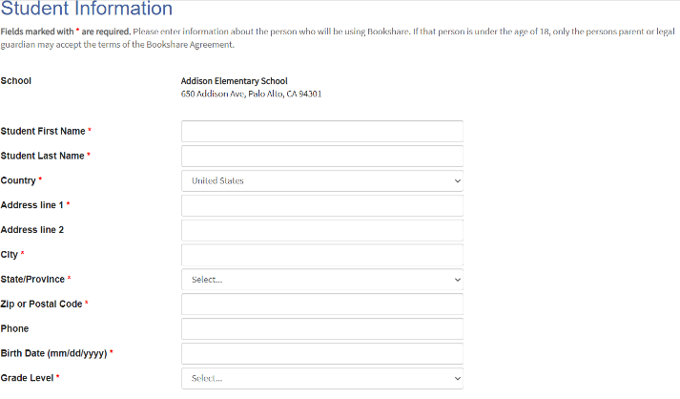

1. Enter parent or guardian information for student’s under 18.

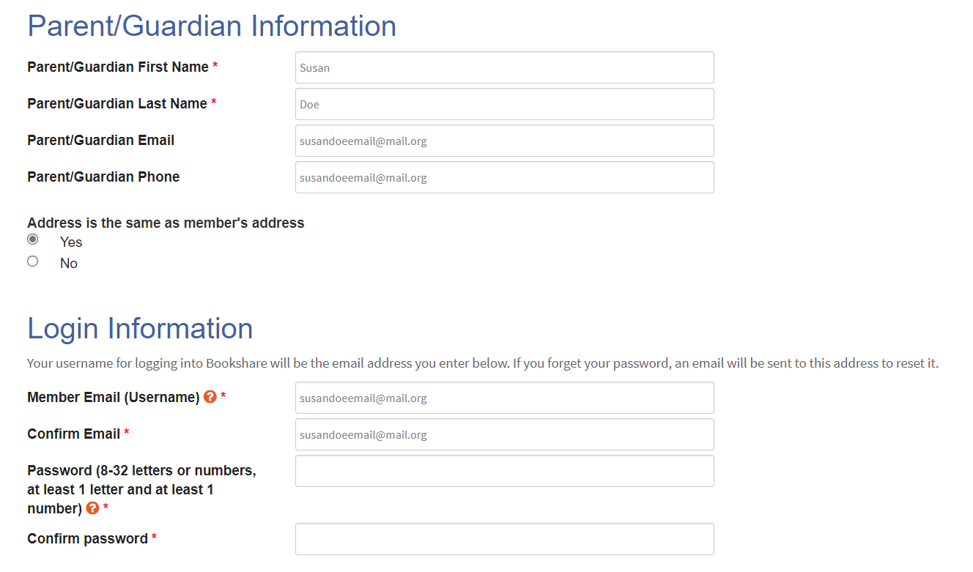

1. Enter an email address and password to be used to access the Bookshare account and select the “Next” button.



1. Download the Proof of Disability form and have it signed by a [Competent Authority](https://www.bookshare.org/cms/bookshare-me/who-qualifies), then email as an attachment to [membership@bookshare.org](mailto:membership@bookshare.org). If your child is a member of the NLS or Learning Ally you can provide that information instead.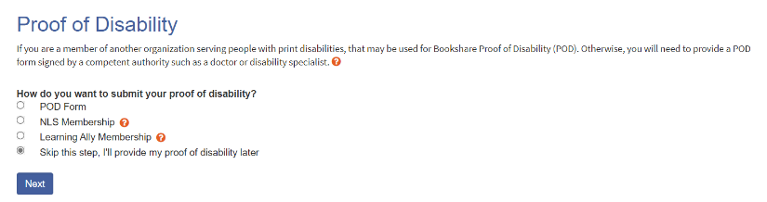
2. Review and accept the Bookshare terms, sign your name digitally, and select "Create Account."

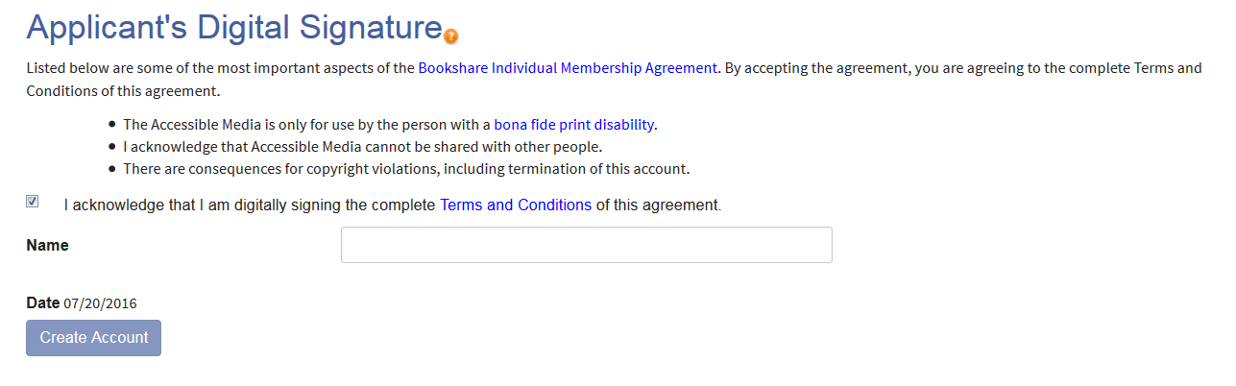

Within a few days you will receive a welcome email from Bookshare confirming that your Proof of Disability has been accepted and your account is now active. Log in with the email address and password you selected and find books for your child to read for school and fun! Learn more about reading books in the pages below.

**How to Use Your Child’s School Bookshare Account**

Teachers assign books to students and then students read on a computer, Chromebook or with an app on a mobile device. Let’s get started!

1. 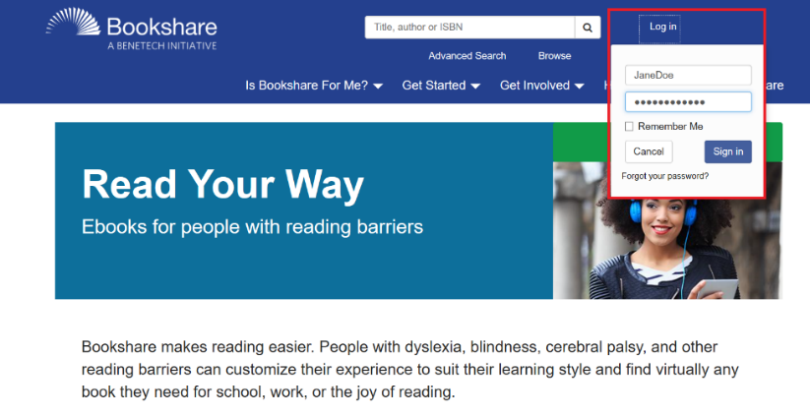Log into [Bookshare](http://www.bookshare.org) with the username and password created by your child’s teacher to see the books they have assigned.

1. 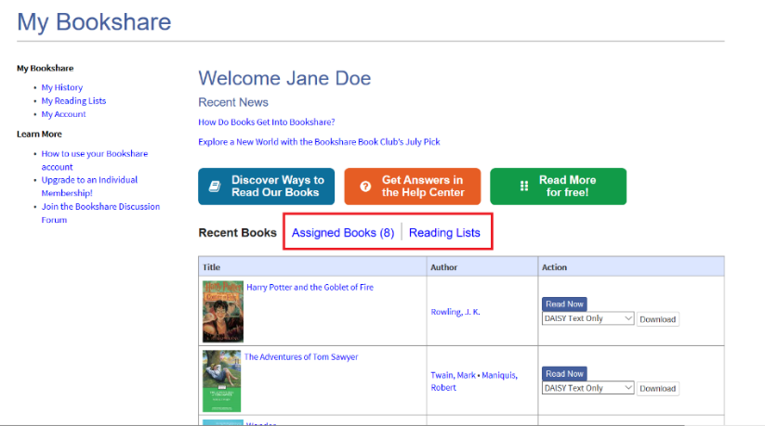Books that have been assigned will be under the “Assigned Books” link. Books that have been assigned on a Reading List are found under the “Reading List” link.

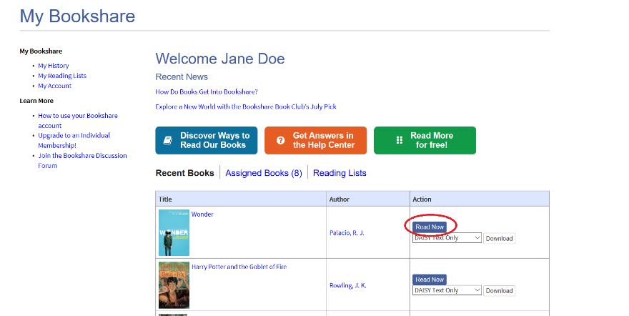

1. To read directly on a computer or Chromebook select the “Read Now” button and the book will open in a web browser.
2. Use the **settings button**  **(gear icon)** to customize audio, text, page and color settings to your reading style and preference. You can revert to default settings by selecting the “Reset to Defaults” button.

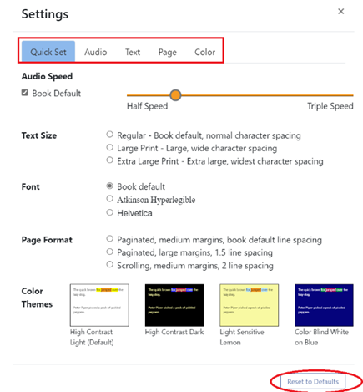

1. The Play icon  allows you to hear the book read out loud. The arrow keys to the left and right side of the play button move the cursor back or forward one sentence. You can begin reading anywhere on the page. Simply double click where you want to start

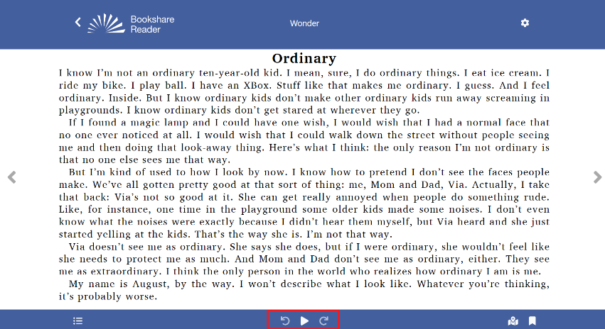

1. Use the Table of Contents icon icon bulleted list.  to select where you want to start reading.

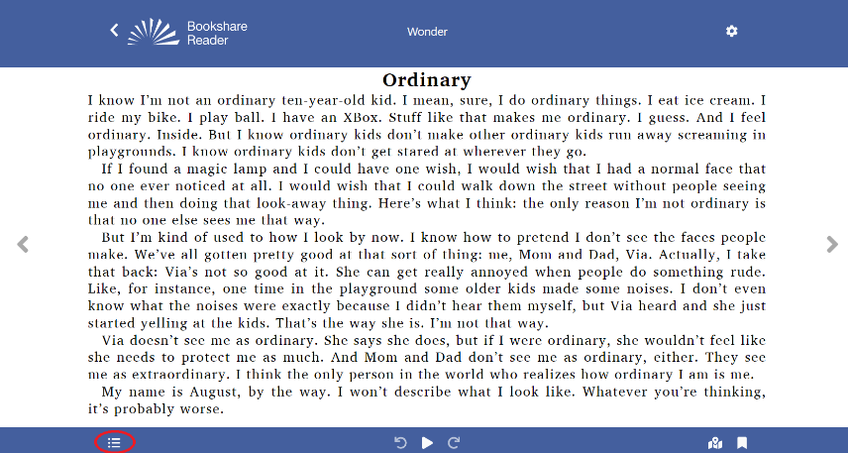

1. The bookmark icon icon bookmark. allows you to insert a bookmark to remember where you left off.

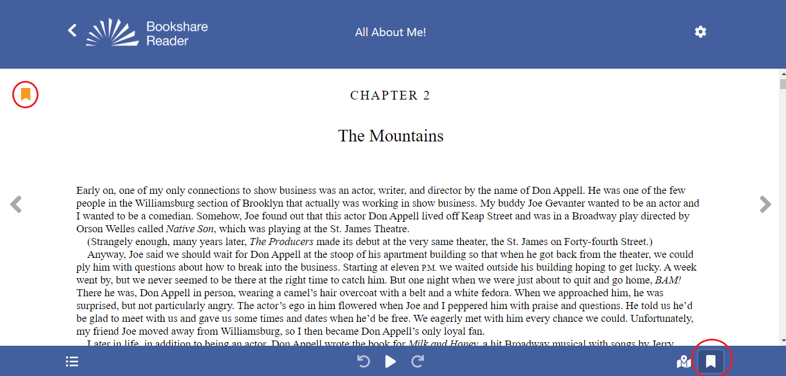

1. You can create multiple bookmarks in a book. To see your bookmarks, select the **“Table of Contents Icon”** and select **“Bookmarks**.

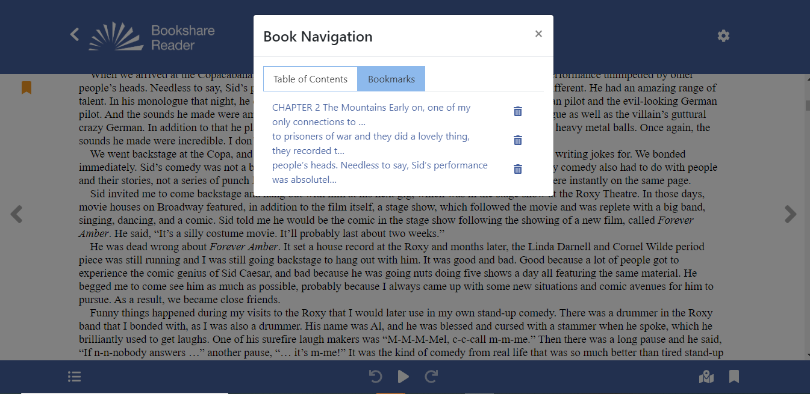

**Read Books with Other Devices**

1. Use the [Reading Tool Wizard](https://www.bookshare.org/cms/reading-tool-wizard) to find other ways to read books. First, select the type of device(s) that you have.

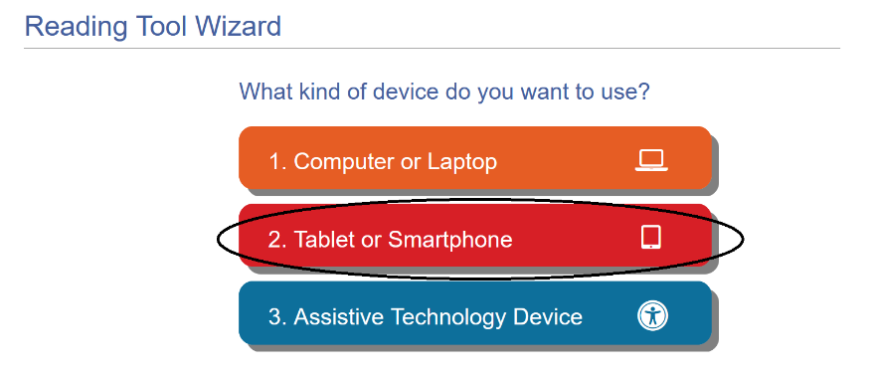

1. You will then find options for devices in that category. Select the specific type of device you have to find the recommended reading tools.

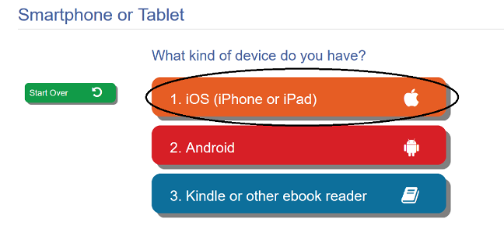

1. Select the logo or the name of the tool for more information on how to use it.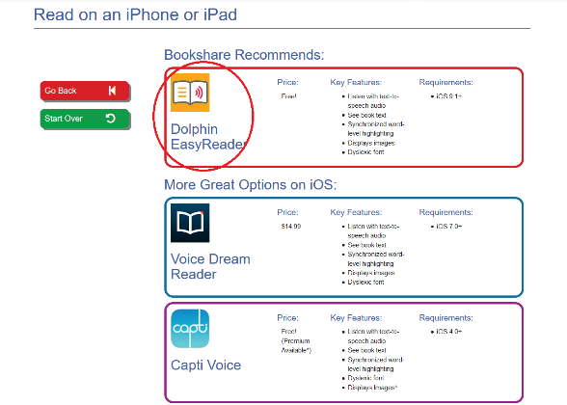

These tools integrate with Bookshare and require you to sign in to them using your child’s Bookshare username and password. Then search for the titles of the books you wish to read.

**Upgrade School Account to Include an Individual Membership**

Students on school accounts can only read books that have been assigned by teachers. You can help your child improve their reading by encouraging them to read more books for school and fun by upgrading their account to include an Individual Membership. Like the school account, it is also free and gives them full access to the Bookshare collection. It’s fast and easy to do!

1. Log in with your child’s username and password. On the “My Bookshare” page, select the “Upgrade to an Individual Membership” link under “Learn More.”

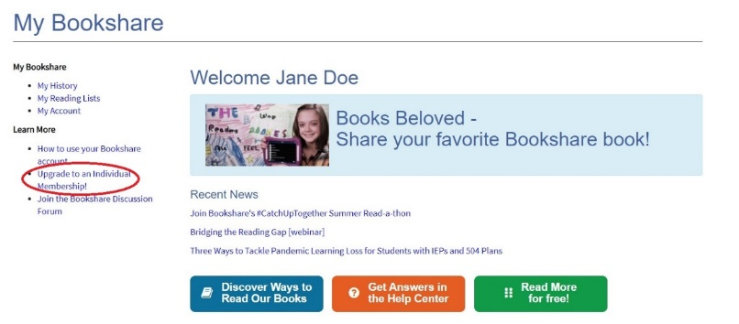

1. Review the instructions and select the link to sign up.

Screenshot of the page with instructions for signing up for the individual membership for members already on a school account


1. Complete the required information on the sign-up form.

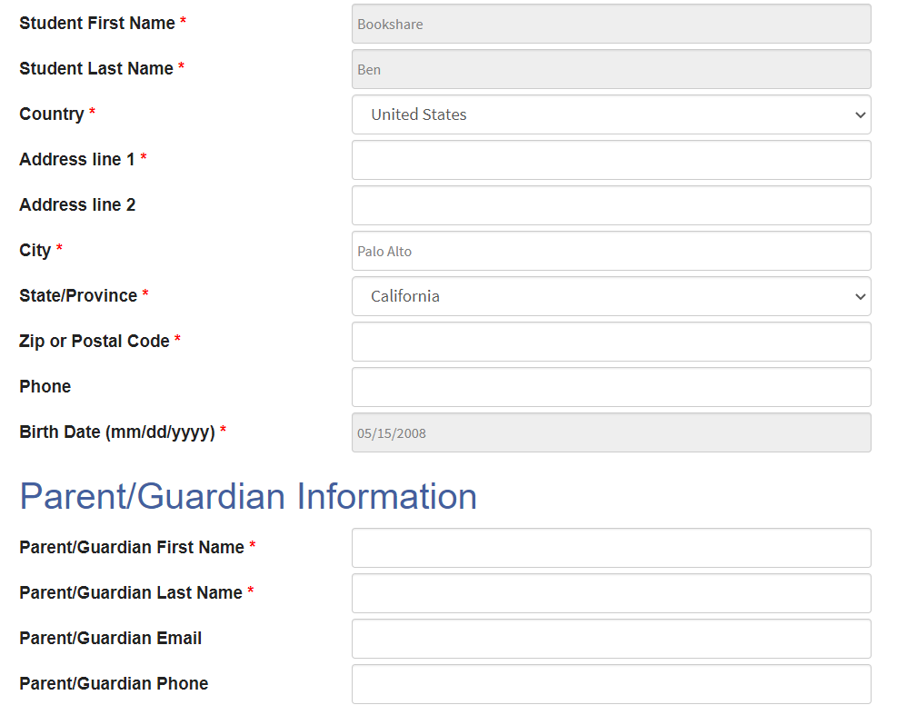

1. Enter an email address and password and select the “Next” button. Your child will now use this email address and password to log in to Bookshare.

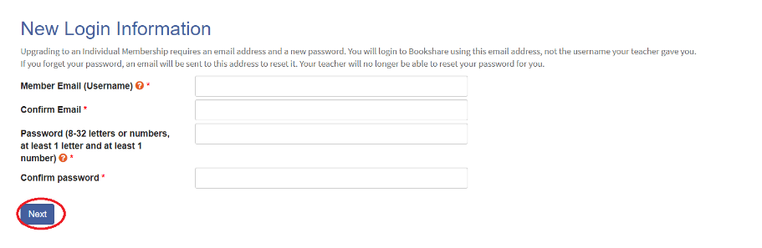

1. Under the “Account Management” heading you can opt to allow teachers to manage the account. This is helpful for account maintenance and resetting passwords if necessary. Agree to the terms, provide a digital signature, and select the “Create Account” button.

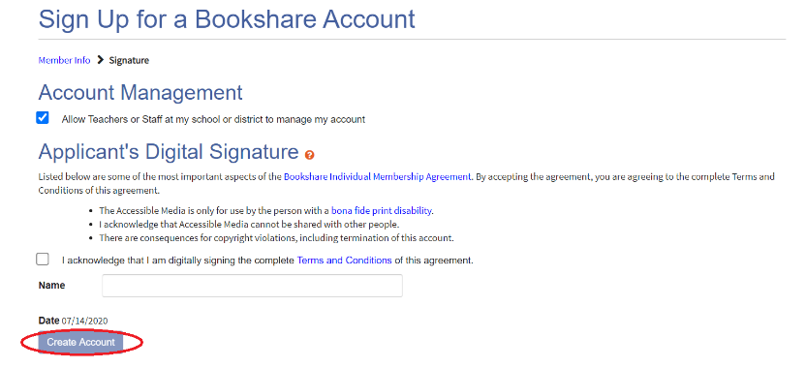

Your child can now read books from the entire Bookshare collection, as well as those assigned by his/her teacher.

**Frequently Asked Questions**

Q: Is Bookshare always free?

A: Bookshare will continue to be free for students after they graduate if they are enrolled in college or another educational program.

Q: Who chooses the books?

A: Teachers assign books for students who are on school accounts. If a student also has an Individual Membership then they and/or parents can find and read any book.

Q: Do the books expire?

A: Bookshare books never expire and can be accessed at any time.

Q: Can minors access adult content?

A: Members under 18 cannot access adult content.

Q: What if I can’t find the book I want?

A: You can [request](https://www.bookshare.org/cms/help-center/request-book) that a book be added to the Bookshare collection at any time.

Q: Do you have any human narrated books?

A: Yes, we have a growing collection of [human narrated books for all ages](https://www.bookshare.org/cms/get-started/human-narrated-audiobooks).

Q: How can I find out if my child already has a Bookshare account?

A: Ask your child’s teacher or contact Bookshare’s Customer Support team at 650-352-0198, or via [email](https://www.bookshare.org/contactUs).

Q: What if I need help using Bookshare?

A: For more guides and videos on using Bookshare visit the [Learning Center](https://www.bookshare.org/cms/help-center/learning-center), [Help Center](https://www.bookshare.org/cms/help-center) or contact Customer Support at 650-352-0198, or via [email](https://www.bookshare.org/contactUs).