**Image 1 - A boy is sitting against a tree, smiling, and looking at the screen of a laptop. His arms are raised.

Graphic - Bookshare logo in a orange box.

Image 2 - A man is looking intently at a tablet screen.**

**How-to Guide**

Schools: Get Started with Bookshare!  
  
**Image 3 - A boy and woman are smiling as they look at a computer screen. A open book is in the foreground.

Graphic - Blue box.

Image 4 - A woman is smiling as she looks at a tablet screen.**

# Step 1: Sign up Your School (if needed)

NOTE: If your school or district already has a Bookshare account, you can skip this step and ask an educator registered on that account to add you as a Sponsor to the existing account. If you are already a Sponsor, skip to *Step 2: Add Qualified Members and Assign Books*.

If your school or district does not already have a Bookshare account, or if you do not have easy access to an educator who uses the existing account, you should create a new account.

1. Sign Up at <https://www.bookshare.org/cms/get-started/sign>. Select "Sign Up Organization."

Screen shot of Sign Up page with callout around Sign Up Organization


1. Complete basic information about the organization and the designated Primary Contact.

Screen shot of Sign Up Form where organization address is entered.

Screen shot for Primary Contact information such as name, title, email.


1. Read and agree to the Bookshare terms online.
2. Download the Organizational Agreement form, scan and email the completed form to: [membership@bookshare.org](mailto:membership@bookshare.org).

Immediately after creating the account, the Primary Contact can begin adding students as members to Bookshare and other school employees as Bookshare Sponsors.  
  
**Step 2: Add Qualified Members and Assign Books**

1. Log in to [www.Bookshare.org](http://www.bookshare.org/) using the link in the top right of the page. (The email address entered when signing up is your Bookshare username.)
2. You will be directed to the “My Bookshare” page. Select the "Members" link in the left column.

Screen shot of My Bookshare page which is where Sponsors and members manage their accounts.


1. Select the "Add a Member" button to add members one at a time.

Screen shot of Manage members page where new members are added.


1. Complete the first two sections by entering information on a [qualified student](https://www.bookshare.org/cms/bookshare-me/who-qualifies/qualifications). Be sure to set a user name and password for the student. User names can be anything including: email addresses, nicknames, or student IDs. Select "Save."

Screen shot of the Add New Member box.


*Tip: Write down the user names and passwords on the useful form found in the “Help Center" under “Training and Resources > Brochures and How-To Guides>*[*Student Login Form*](https://www.bookshare.org/cms/sites/default/files/bookshare_student_login_information.pdf)*.”*

1. To assign books to the member now, select "Assign Books." Note: You can also assign books at a later time.

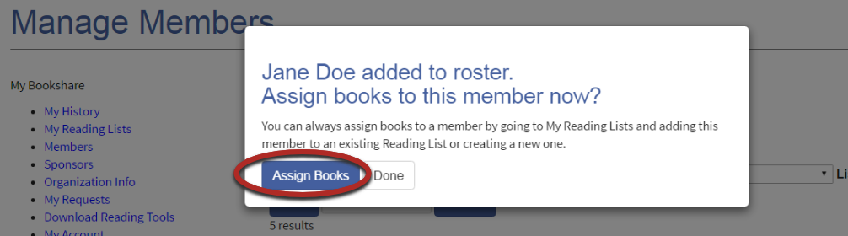

1. Search for books to add to the Reading List by entering a title, author, or ISBN in the Search Box.

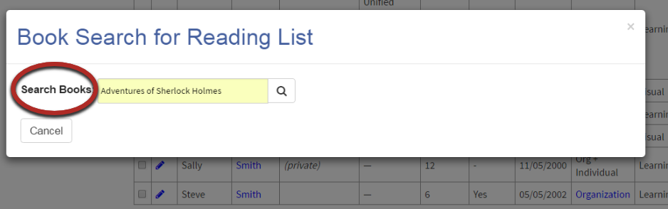

1. Place a check mark next to the desired title(s) and select "Assign Books."

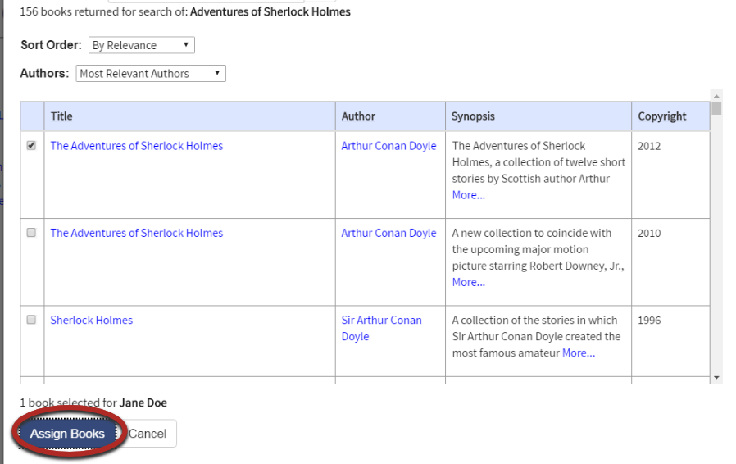

1. By assigning books to this student, you are creating a personal Reading List for him or her. The name of the Reading List will default to the name of the student, but you can rename it if you wish. You can also include a description of the list, but this is not required.

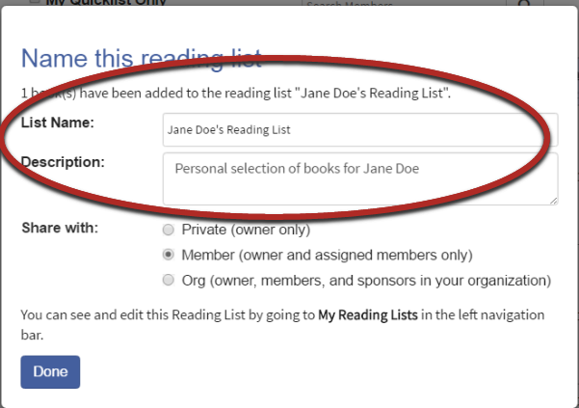

1. Select "Org" to share with other sponsors and members in your Organization. To keep list private or to share just with student members, select the appropriate button. Then select "Done."

Screen show showing the options for sharing Reading List


You have now added qualified students, assigned books to them by creating at least one Reading List and learned how to share Reading Lists with other Sponsors in your organization. Your students are ready to read!

To add other students or create other Reading Lists, select “My Bookshare” at the top right side of the window. For more in-depth help on creating and sharing Reading Lists or adding students, please visit <https://www.bookshare.org/cms/help-center> or select the “Help Your Students Access Books Independently” link on the right side of your “My Bookshare” page.

**Step 3: Students Read**

Students log in either through the Bookshare website to use Bookshare Web Reader or through a [Bookshare Integrated application](https://www.bookshare.org/cms/help-center/other-reading-tools).

Bookshare Web Reader allows students to read quickly and easily in an Internet browser without downloading software or books. For a reading experience that includes self-voicing with word highlighting, we recommend using Bookshare Web Reader on the following browsers:

* Google Chrome version 33+
* Safari version 6.1+
* Google Chrome version 14-32 ([Bookshare Chrome Extension installation required](https://chrome.google.com/webstore/detail/bookshare-web-reader/bkfmjmjngglphchhiemnghidpnddofmo?hl=en))
* Chromebooks version 14+ ([Bookshare Chrome Extension installation required](https://chrome.google.com/webstore/detail/bookshare-web-reader/bkfmjmjngglphchhiemnghidpnddofmo?hl=en))

For a student who typically uses a screen reader, we recommend opening Bookshare Web Reader in Internet Explorer.

**To read in Bookshare Web Reader, students:**

* Log in to Bookshare with the user name and password created by the Sponsor.
* Read books assigned to them on a Reading List or books previously downloaded for them, found under "My History" on their “My Bookshare” page.

1. To read a book assigned on a Reading List, students select "View Your Assigned Books (Reading Lists)” in the top middle section of their screen

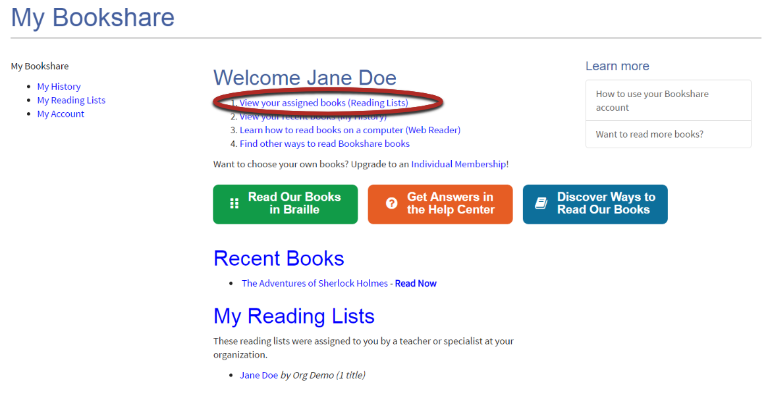

1. Students open the appropriate Reading List, find the desired title, and select "Read Now."

Screen shot of Read Now Button members use to open book in Web Reader


Screen shot showing the Read Now button which enables members to read their book.


1. Next, Bookshare packages the book and prepares it for reading in their browser. Depending on the size of the book, it may take 30-60 seconds. The book will then be ready to be viewed – and heard – in the Bookshare Web Reader.

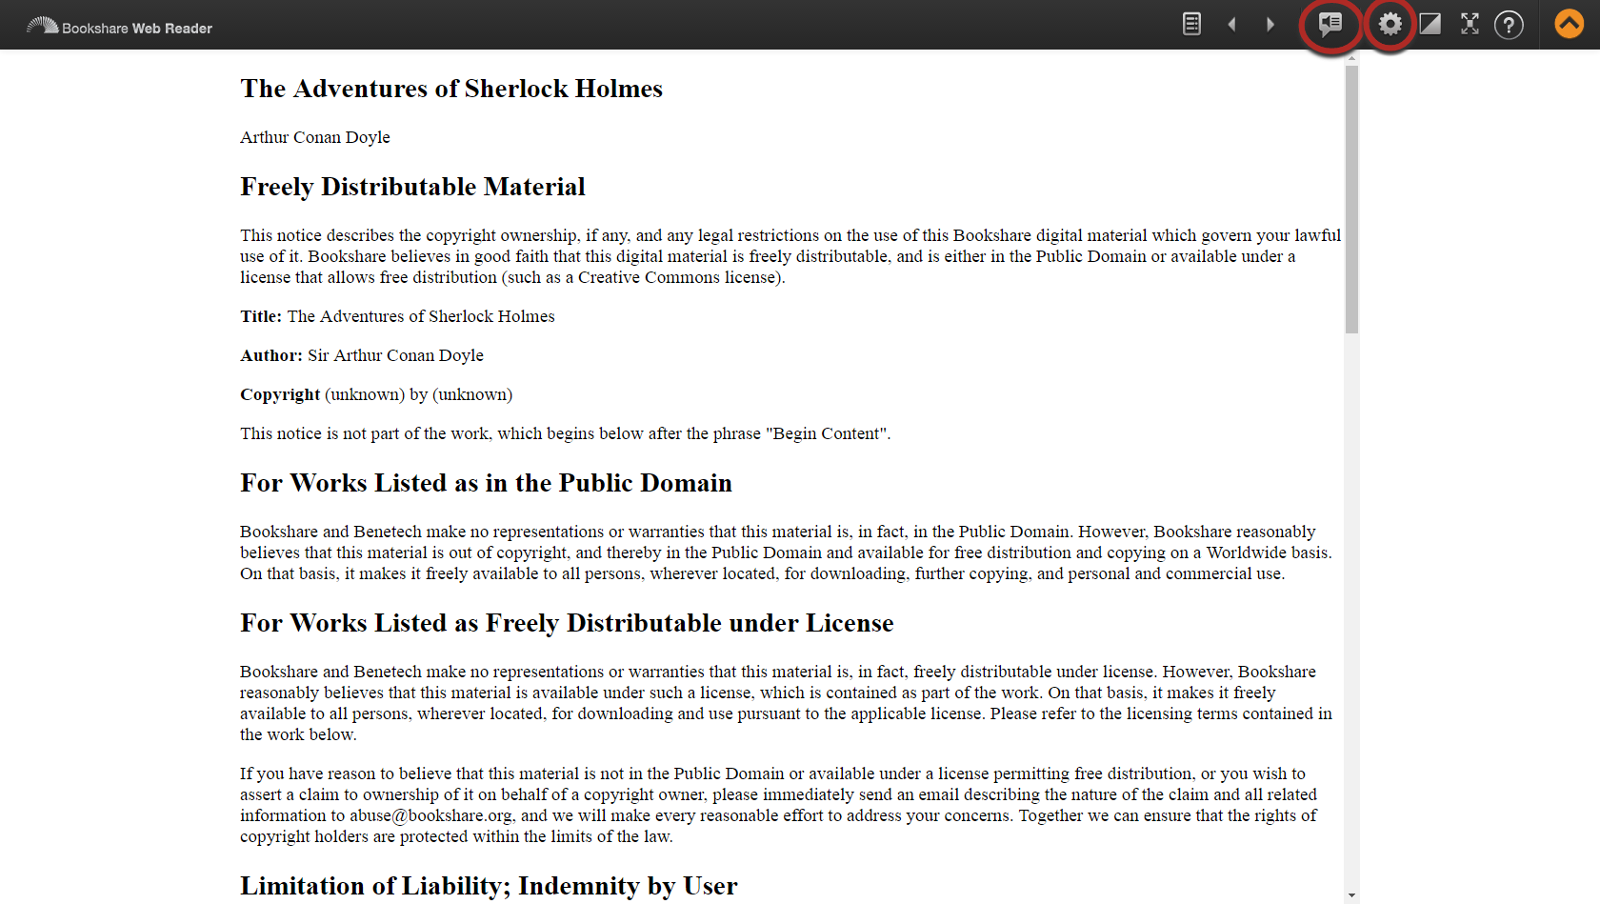

1. To hear the book read aloud, students select “Play.” Speaker Icon
2. Students can use the settings button to change the font size and/or text and background color combination, if desired.

Settings for changing font and appearance of book in Web Reader.


1. Students use the Table of Contents icon 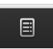 to select where they want to start reading.

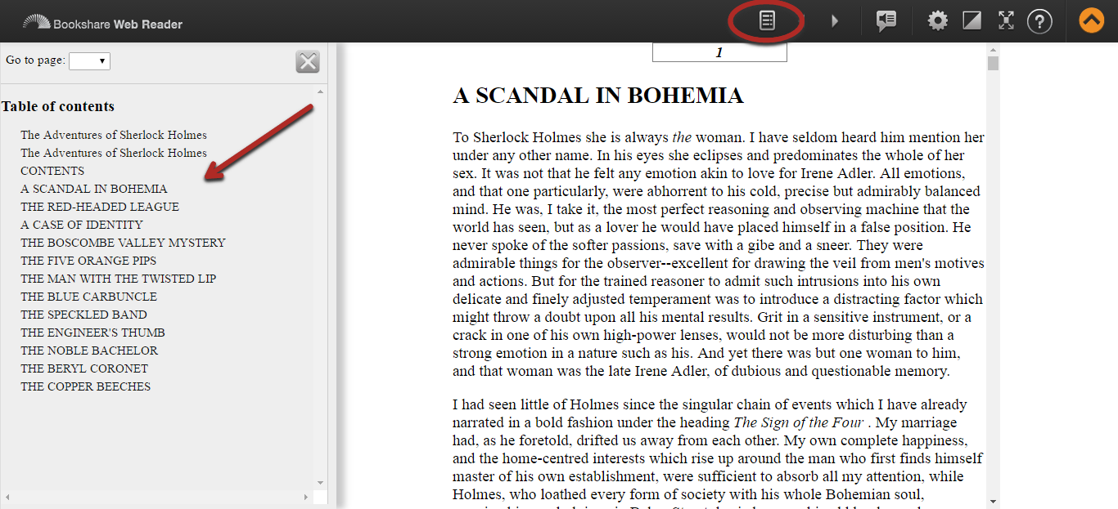

For additional assistance with Bookshare Web Reader, please click the “?” link at the top right of the Bookshare Web Reader screen.

**To read in a Bookshare Integrated Application, students:**

1. Log in to the reading application.
2. Search for the book using the tool’s search function.

*Note: With VoiceDream Reader and Capti Narrator, students can see in “History” the books that have recently been downloaded for them or that they opened in Bookshare Web Reader*.

1. Download the book through the tool’s download function.
2. Read!

For a partial list of Bookshare Integrated Applications, go to: [Bookshare Member Preferred Reading Tools](https://www.bookshare.org/cms/help-center/other-reading-tools).

For answers to other questions, please visit [https://www.Bookshare.com/cms/help-center](https://www.bookshare.com/cms/help-center).