Quick Start Guide for Bookshare Reader for Web

Recommended Web browsers:
- Google Chrome version 33+
- Safari version 6.1+
- Chromebooks version 14+
- The New Microsoft Edge

Web Browsers with limited features:

- Mozilla Firefox version 6+
- Safari version 6.0+
- Internet Explorer 9, 10 and 11
- iPad with iOS 7+
- The Web Reader is not supported on other mobile devices.

Read with Bookshare Reader

Log into your Bookshare account.
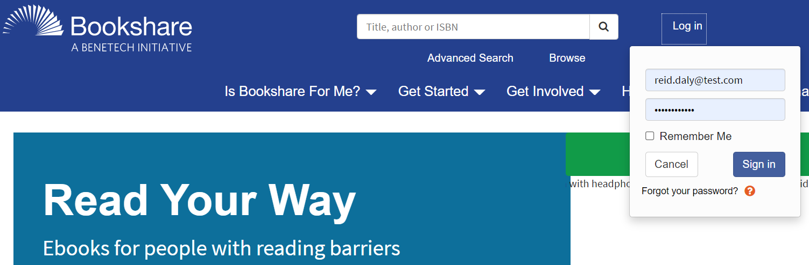

Find a book to read! Search for a book using the search box, Advanced Search, or Browse. You can also select the “My Bookshare” link to find assigned books for students, Reading Lists, or recently read books.
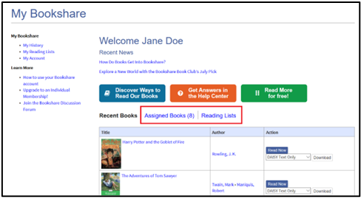

After you find the book you want to read, select the “Read Now” button to open the book.
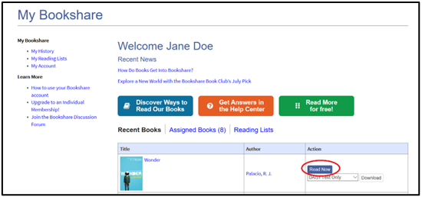

The book will open in your browser and is ready to be read in Bookshare Reader.
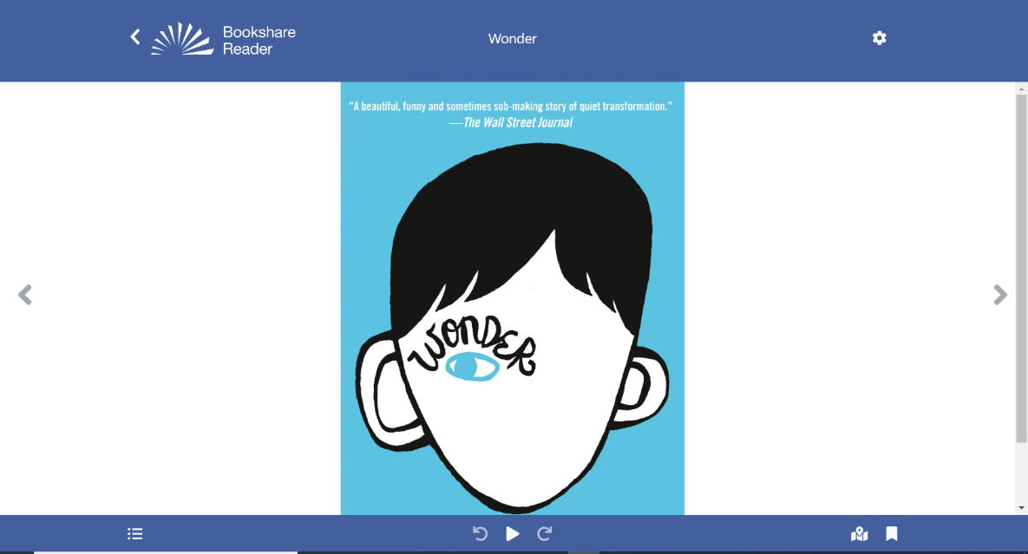

Use the settings button (gear icon) to change audio, text, page and color settings. Choose “Quick Set” to quickly customize all of your key settings.

Get Reading!

The Play icon allows you to hear the book read out loud. The arrows move the cursor back or forward one sentence. You can begin reading anywhere on the page. Simply double click where you want to start!
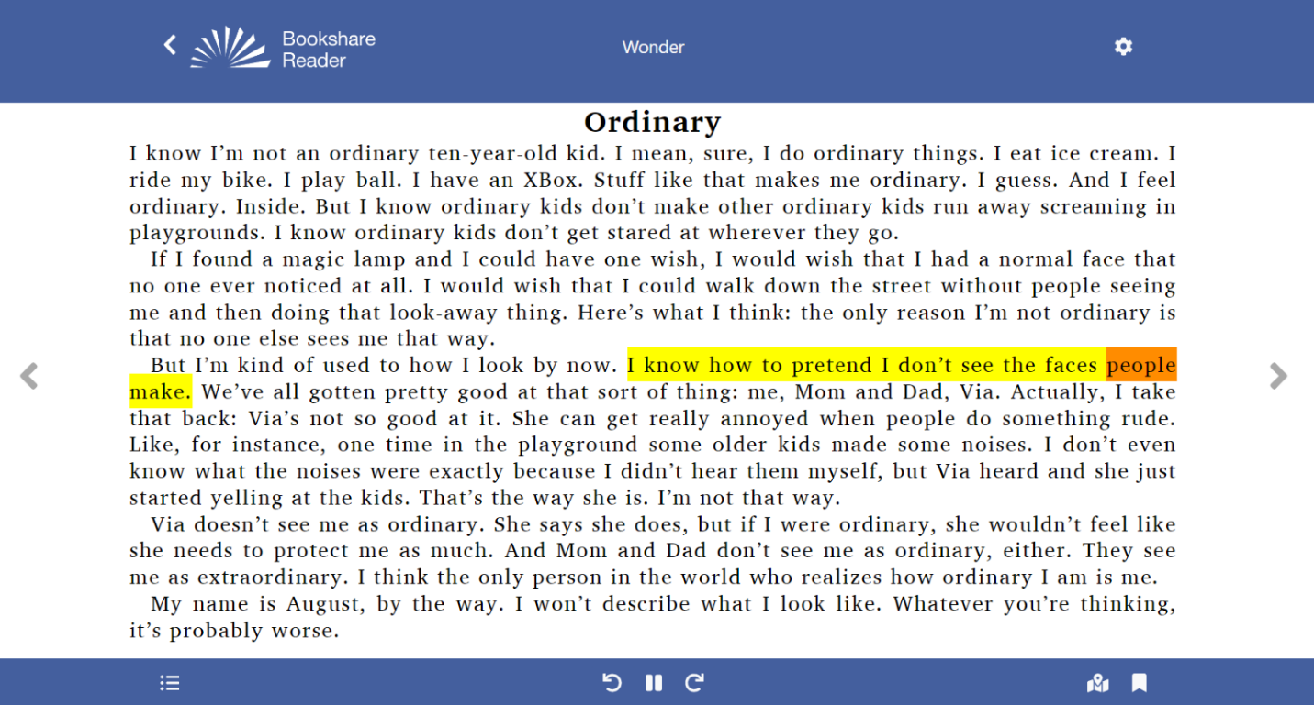

The “Table of Contents” icon allows you to navigate through the book.
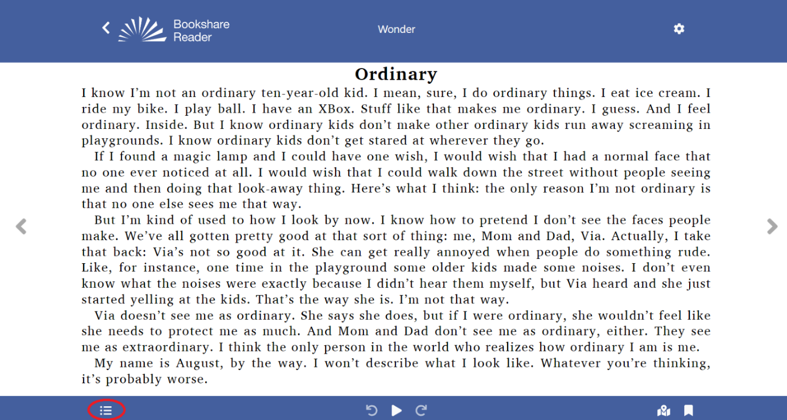
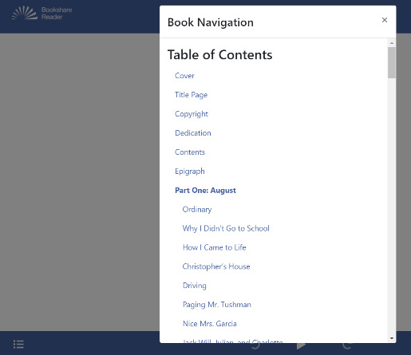

You are ready to read! Thank you for choosing Bookshare Reader. For more information, please go to our
Training and Learning Library.

