**Image 1 - A boy is sitting against a tree, smiling, and looking at the screen of a laptop. His arms are raised.

Graphic - Bookshare logo in a orange box.

Image 2 - A man is looking intently at a tablet screen.**

**How-to Guide:**

Students: How to Read Bookshare Books

**Image 3 - A boy and woman are smiling as they look at a computer screen. A open book is in the foreground.

Graphic - Blue box.

Image 4 - A woman is smiling as she looks at a tablet screen.**

**How to Find and Read Your Assigned Books**

Here you will learn how to read your assigned books. You can read quickly and easily with Bookshare Web Reader in an internet browser (Google Chrome or Safari) right on your computer or Chromebook. You can also read books with an app on a mobile device or with other Assistive Technology tools. The “[Reading Tools” wizard](https://www.bookshare.org/cms/reading-tool-wizard) can help you determine what tools will work best with your devices.

1. Log into [Bookshare](http://www.bookshare.org) with the username and password created by your teacher to see what books have been assigned to you.

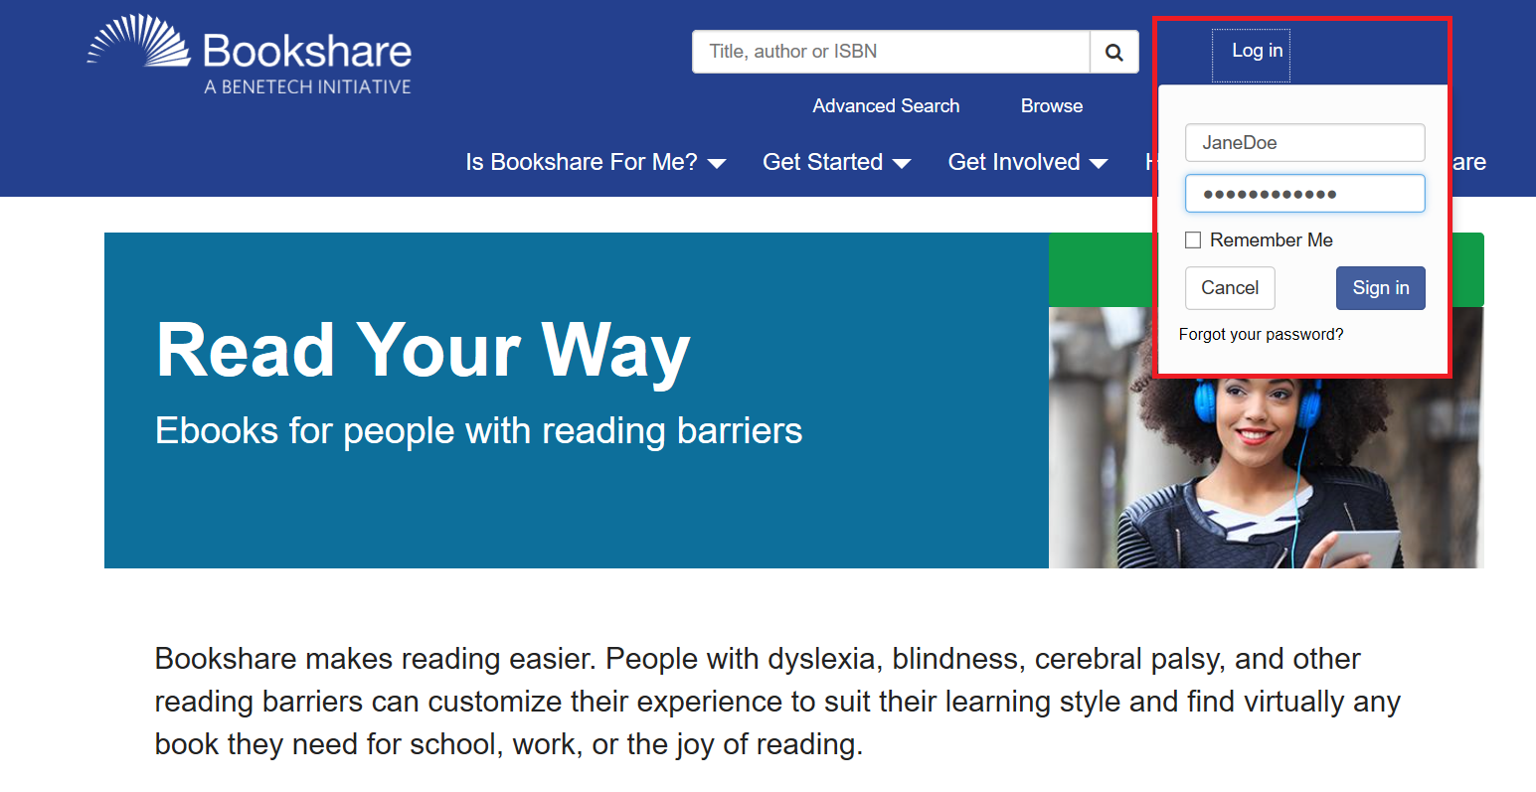

1. Books that have been assigned to you will be under the “Assigned Books” link. Books that have been assigned on a Reading List are found under the “Reading List” link. Ask your teacher if you are not sure where to find your book.

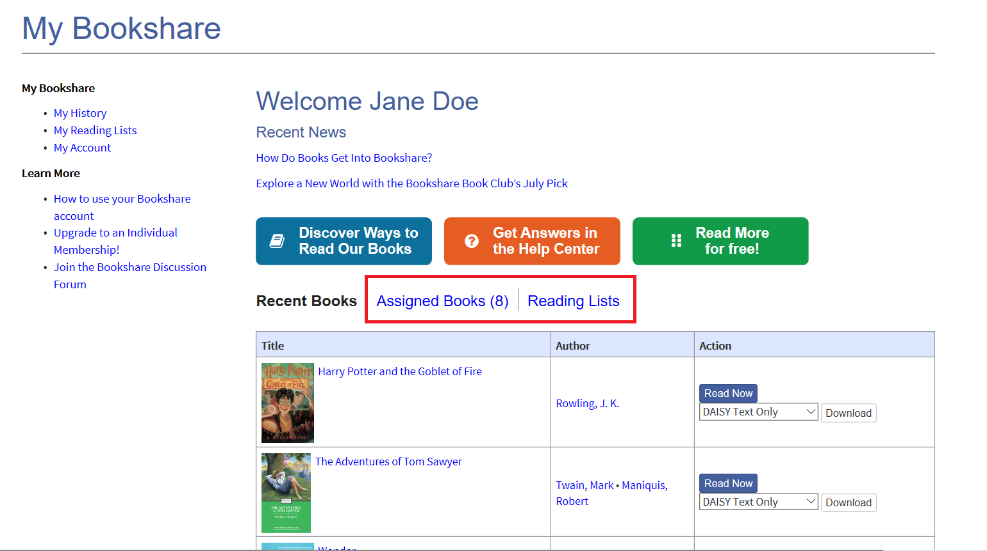

1. To read directly in your web browser select the “Read Now” button.

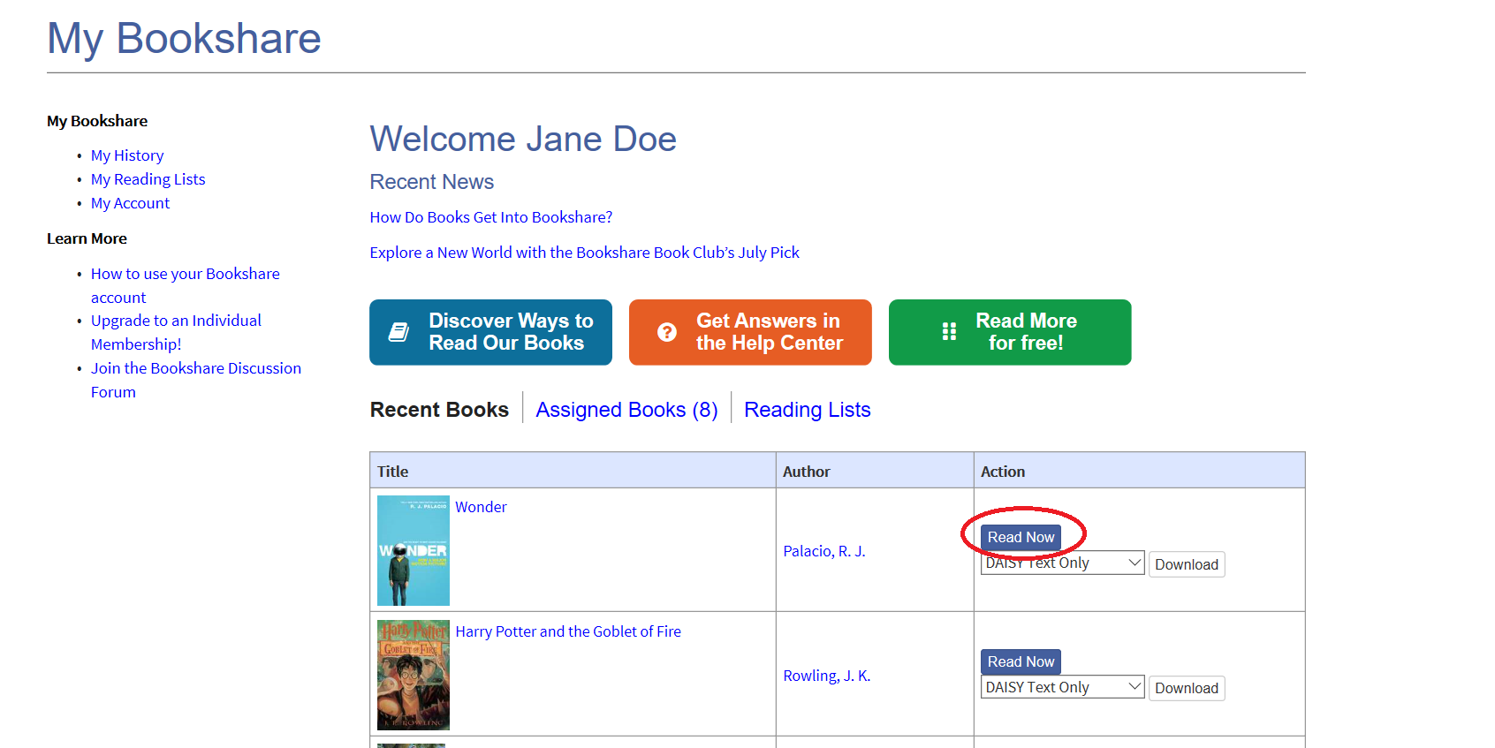

1. The book will be prepared for reading in your browser. Depending on the size of the book, it may take 30-60 seconds. The book will then be ready to be viewed – and heard – in the Bookshare Web Reader.

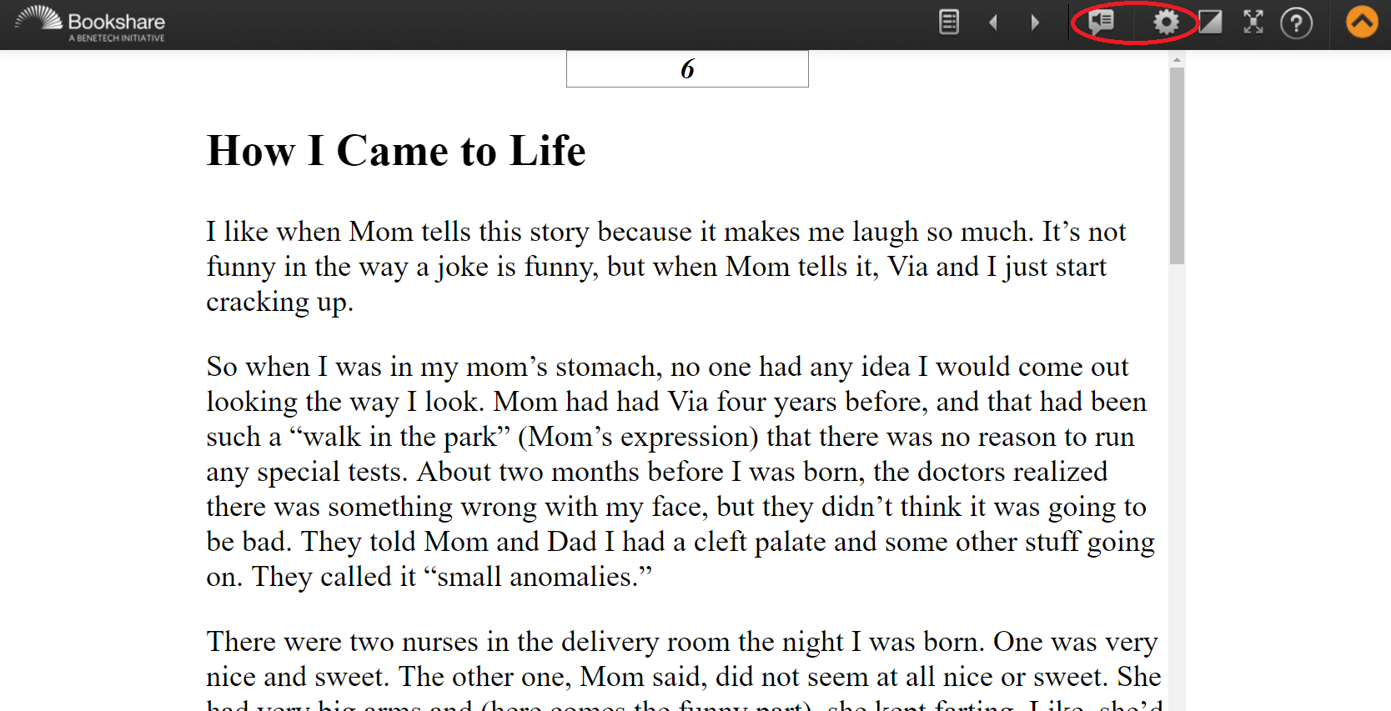

1. To hear the book read aloud, select “Play.” Speaker Icon
2. Use the settings button to change the font size, text and background color combination and voice and rate of speech if desired. Select “Save” after making changes.

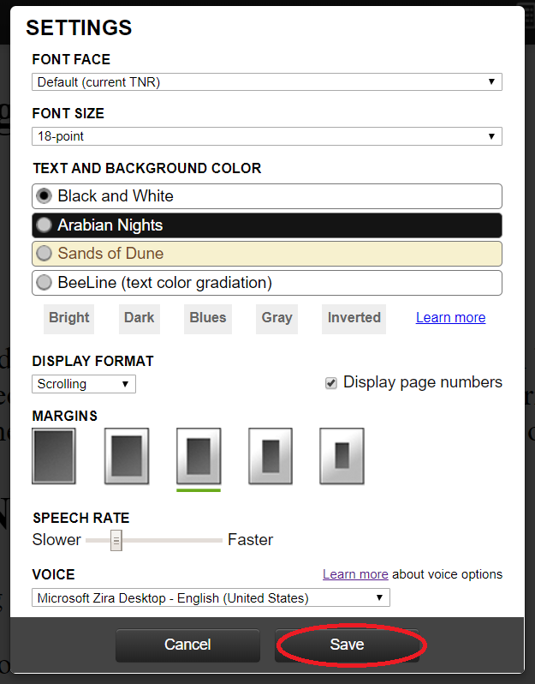

1. Use the Table of Contents icon 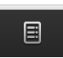 to select where you want to start reading.

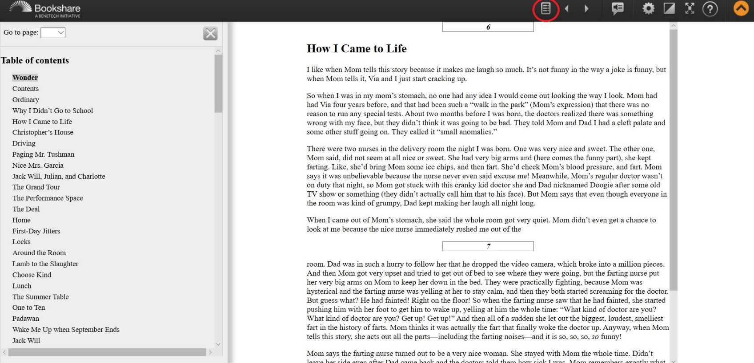

**Read Books with other Devices**

1. Use the “[Reading Tool” wizard](https://www.bookshare.org/cms/reading-tool-wizard) to find other ways to read your books. First, select the type of device(s) that you have.

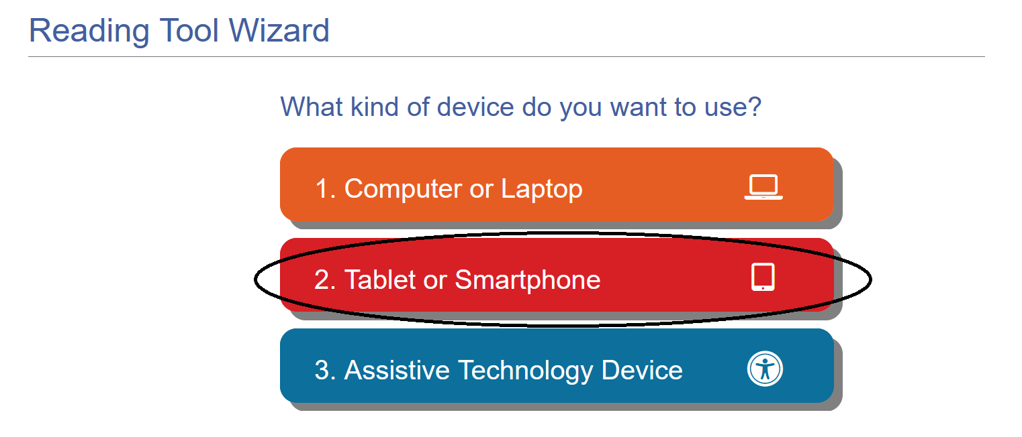

1. You will then find options for devices in that category. Select the specific type of device you have to find the recommended reading tools.

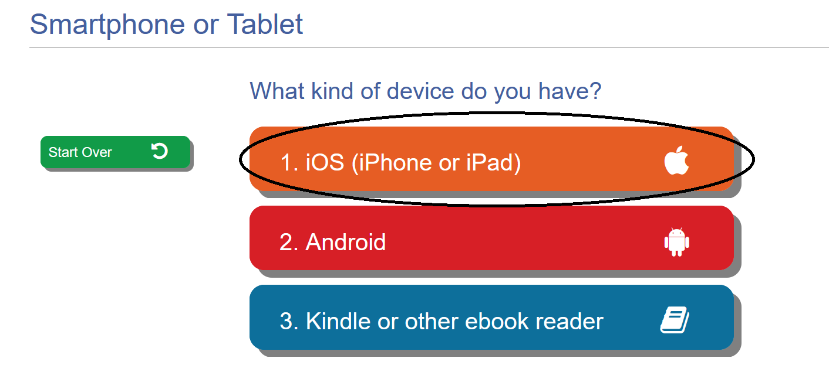

1. Select the logo or the name of the product to learn more about the tool and how to use it.

. 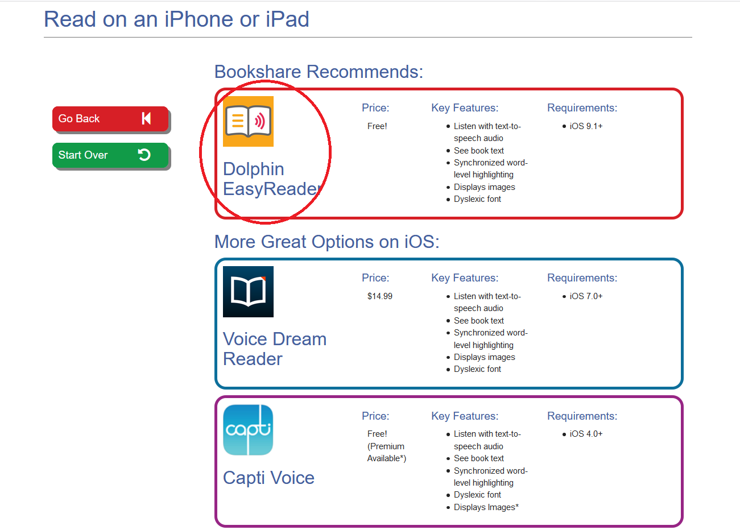

1. These tools integrate with Bookshare and require you to sign in to them using your Bookshare username and password. Then search for the titles of the books you wish to read. If you are only a member on your school account you can only read books that your teachers have assigned to you. If you wish to read more books, your account can be upgraded to include a free Individual Membership which gives you full access to the Bookshare collection. [Learn more](https://www.bookshare.org/cms/help-center/can-parents-sign-their-child-individual-membership)!