**Image 1 - A boy is sitting against a tree, smiling, and looking at the screen of a laptop. His arms are raised.

Graphic - Bookshare logo in a orange box.

Image 2 - A man is looking intently at a tablet screen.**

**How-To Guide**

Students: How to Read Bookshare Books

**Image 3 - A boy and woman are smiling as they look at a computer screen. A open book is in the foreground.

Graphic - Blue box.

Image 4 - A woman is smiling as she looks at a tablet screen.**

# Read Bookshare Books on Your Computer

# 

1. Log in to your [Bookshare account](http://www.bookshare.org/) with your username and password.

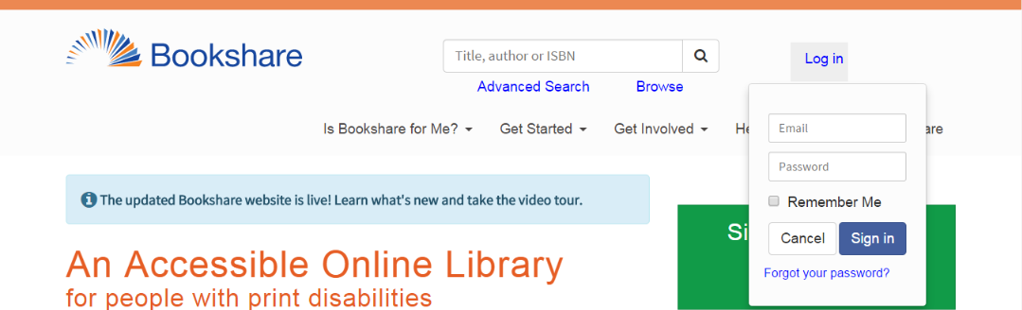

1. Select "View your Assigned Books (Reading Lists) in the top middle section of the screen.

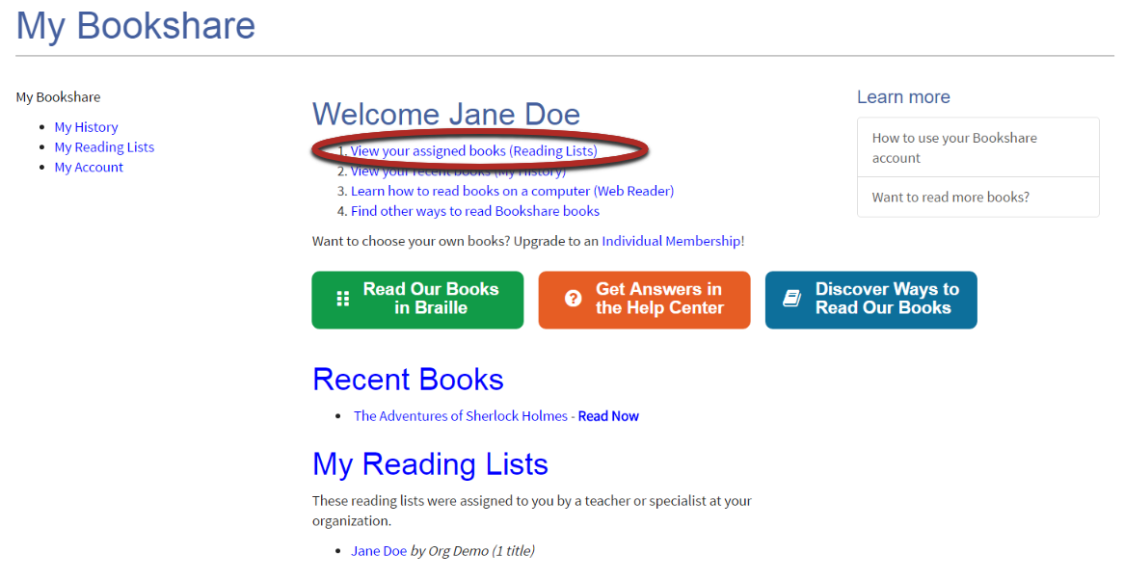

1. Find the book you wish to read and select "Read Now."

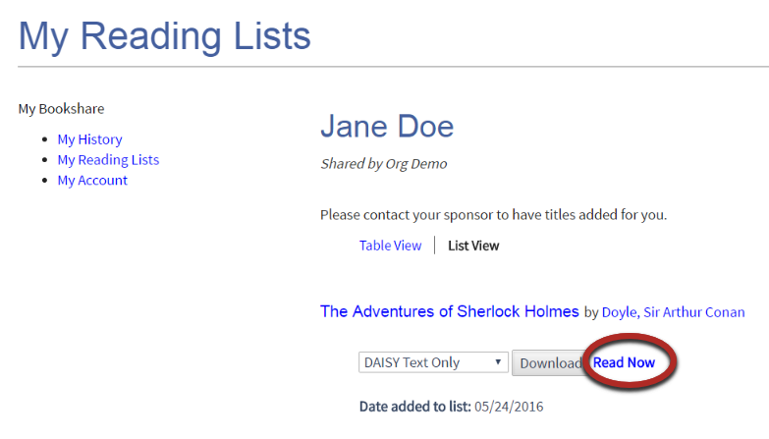

1. Your book will open up in Bookshare Web Reader. It may take 30-60 seconds. The book will then be ready to be read – and heard.

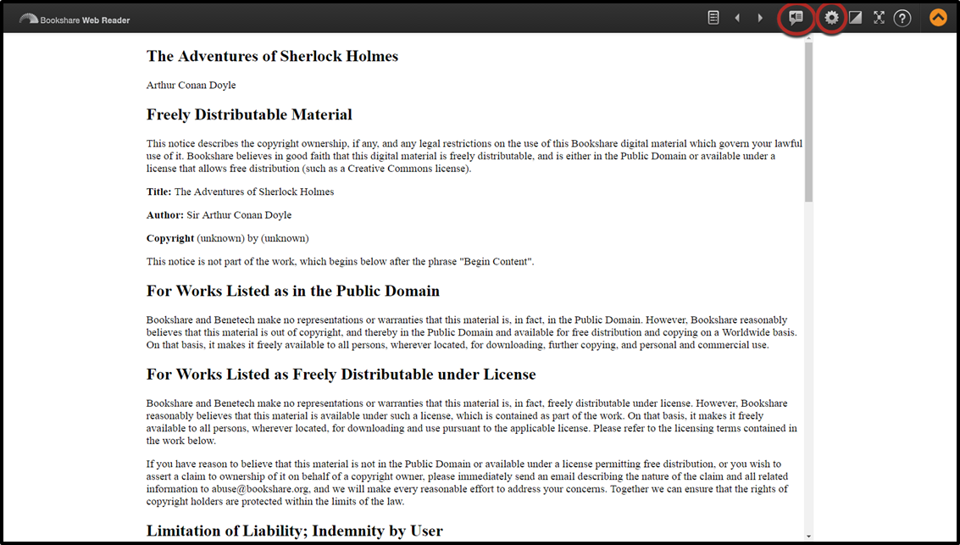

1. Select the Table of Contents icon 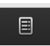 to select where you want to start reading.

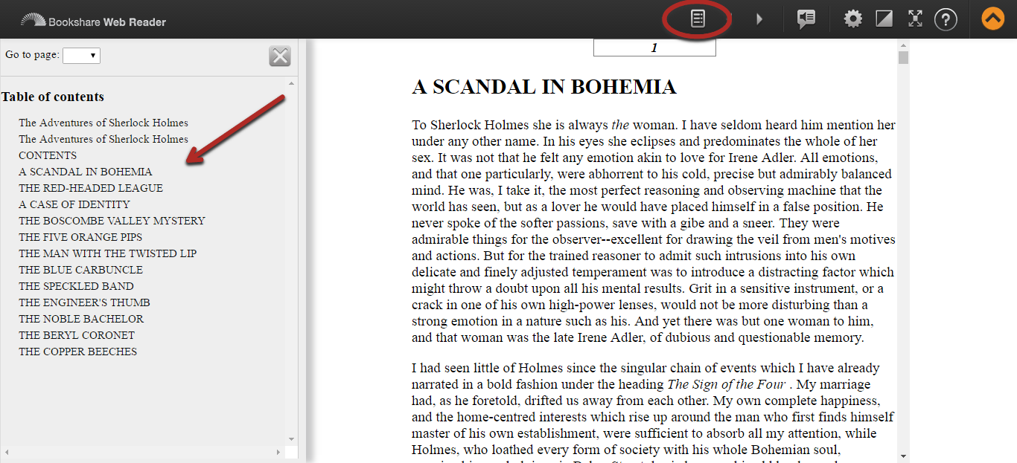

1. To hear the book read aloud, select “Play.” Speaker Icon
2. In Settings,  change the text size and/or text and background color combination, if desired.

Settings for changing font and appearance of book in Web Reader.


*Note: By selecting "My History," you can also find and open in Bookshare Web Reader any books you previously opened or downloaded (or that have been downloaded for you).*   
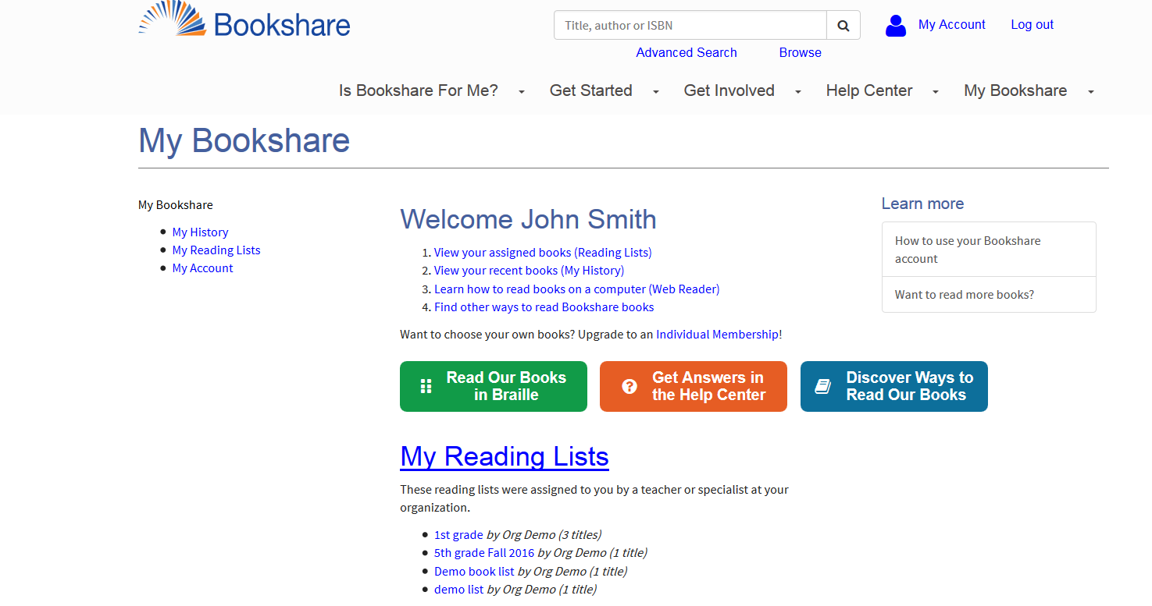  
  
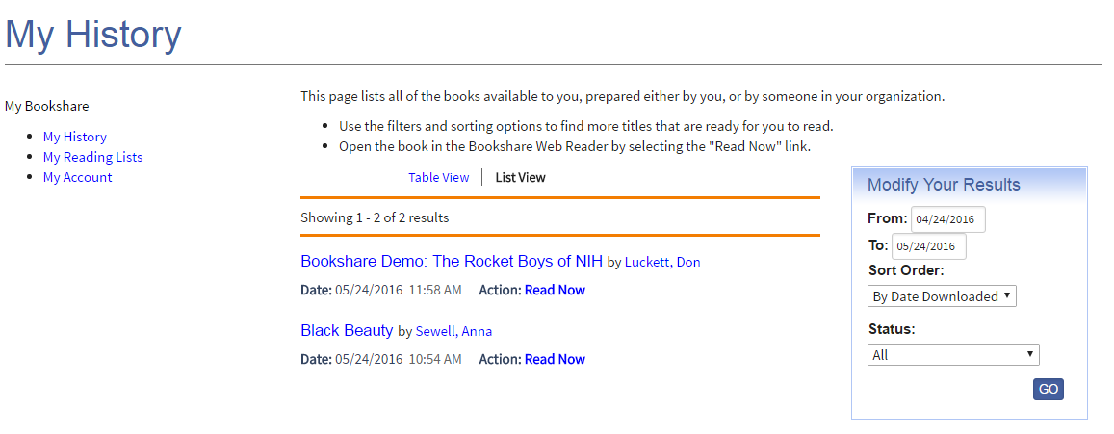

For additional assistance with the Bookshare Web Reader, please select the "?" button at the top right of the Bookshare Web Reader Screen. For other questions please visit [Bookshare Help Center](https://www.bookshare.org/cms/help-center/search/topic/web-reader)

# Read Bookshare Books in a Bookshare Integrated Application

# 

1) Log in to a compatible reading application (visit the [Member Preferred Reading Tools](https://www.bookshare.org/cms/help-center/reading-tools/member-preferred-tools) page for a partial list) and search for your book.

*Note: In Voice Dream Reader and Capti Narrator, you can see in “History” the books that have recently been downloaded for you or that you opened in Bookshare Web Reader*.

3) Download and open the book.

4) Read!