**Three zoned graphic. To the far right is a boy sitting against a tree, smiling, and looking at the screen of a laptop. His arms are raised. In the middle is the Bookshare logo in a orange box. To the far right is a man looking intently at a tablet screen.**

**Quick Start Guide to Sign Up for Bookshare**

## **Sign Up for an Individual Bookshare Membership:**

Go to [www.bookshare.org](http://www.bookshare.org) and select the **"Sign up Today" button.**

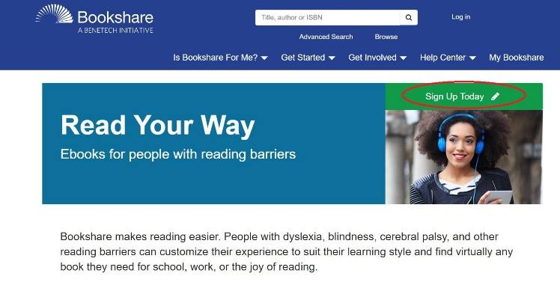

Select "**Sign Up Individual**", on the left side of the screen.

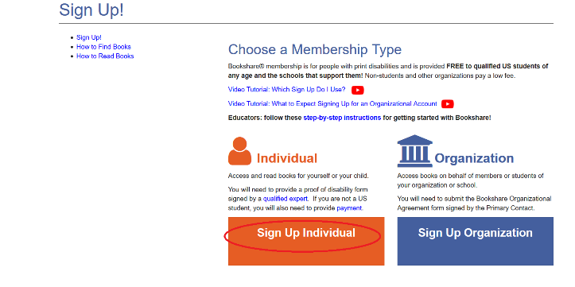

**Confirm the account is for a person with a print disability**. Visit the "[Who Qualifies](https://www.bookshare.org/cms/bookshare-me/who-qualifies)" page for information on qualifications.

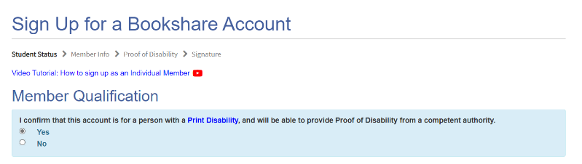

Under **“Student Status,”** indicate whether your child is a current U.S. student. **Membership is free for US students. If you are an adult who is a non-student, select “NO”,** and you will be prompted to enter your information to create your membership.

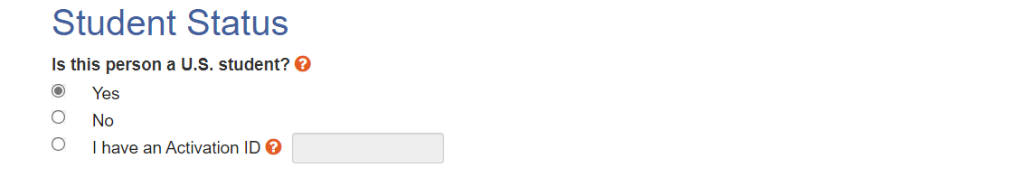

**If registering a student, or an adult who is a student,** enter your state, city and name or child’s school, or select Home School, if applicable. **It you are an adult who is a non-student, you will not have access to this section.**

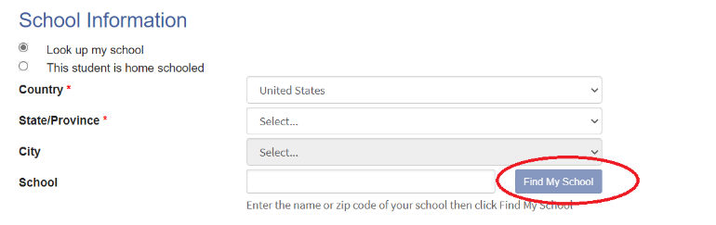

**Enter your own information if you are an adult, or enter your child’s information, if you are a parent** registering a student.

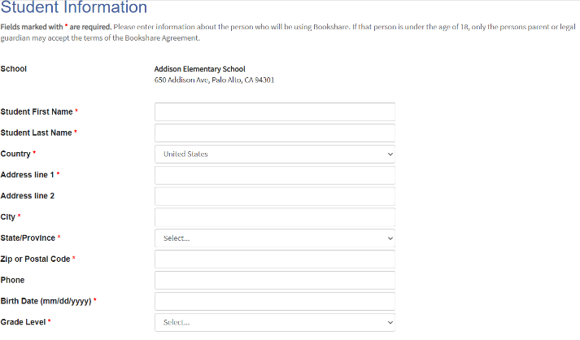

Enter parent or guardian information **for students under 18.**

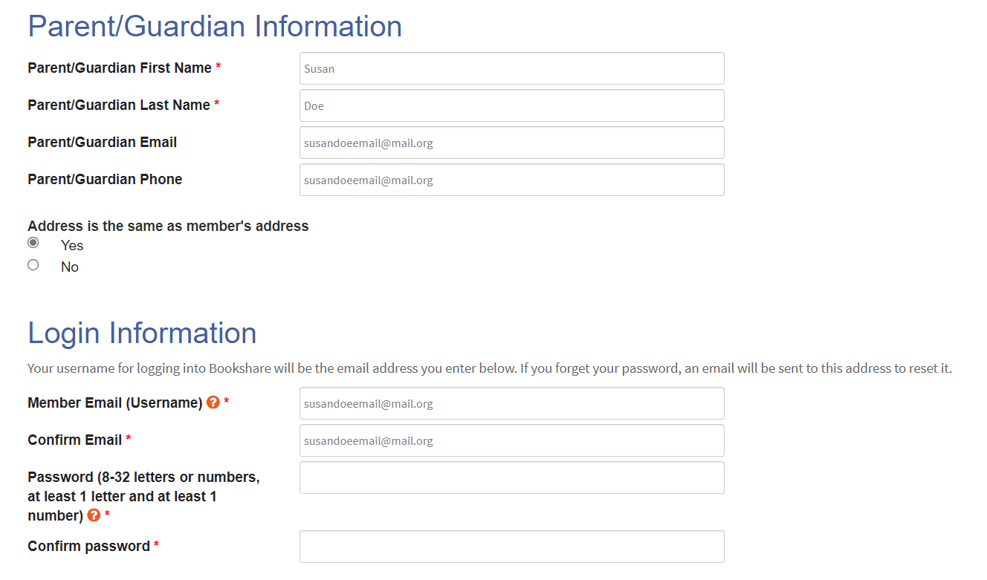

Enter an email address and password to be used to access the Bookshare account and select the **“Next” button.**



Download the Proof of Disability form, and have it signed by a [Competent Authority](https://www.bookshare.org/cms/bookshare-me/who-qualifies), then email as an attachment to [membership@bookshare.org](mailto:membership@bookshare.org). **NOTE: If you or your child is a member of the National Library Service (NLS) or Learning Ally you can provide that information instead. Click the blue “NEXT” button.**

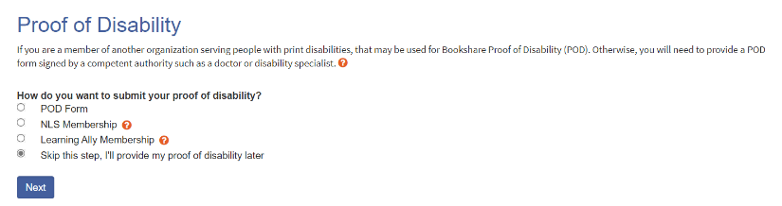

Review and accept the Bookshare terms, sign your name digitally, and select **"Create Account."** **This is the last step and will submit your account to the Bookshare team. THIS IS THE LAST STEP IN THE PROCESS.**

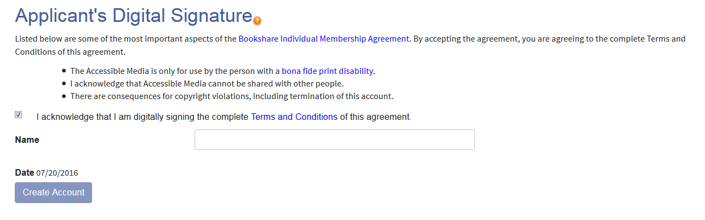

Within a few days you will receive a welcome email from Bookshare confirming that your Proof of Disability has been accepted and your account is now active. Log in with the email address and password you selected and find books for yourself or for your students to read!

**Thank you for choosing Bookshare! For more information, please visit our** [**Training and Learning Library**](https://www.bookshare.org/cms/help-center/learning-center)