**Image 1 - A boy is sitting against a tree, smiling, and looking at the screen of a laptop. His arms are raised.

Graphic - Bookshare logo in a orange box.

Image 2 - A man is looking intently at a tablet screen.**

**How-to Guide:**Sign up for an Individual Membership

**Image 3 - A boy and woman are smiling as they look at a computer screen. A open book is in the foreground.

Graphic - Blue box.

Image 4 - A woman is smiling as she looks at a tablet screen.**

**Sign up for Bookshare**

1. Go to [the Bookshare Website](http://www.bookshare.org/) and select the "Sign up Today" button.

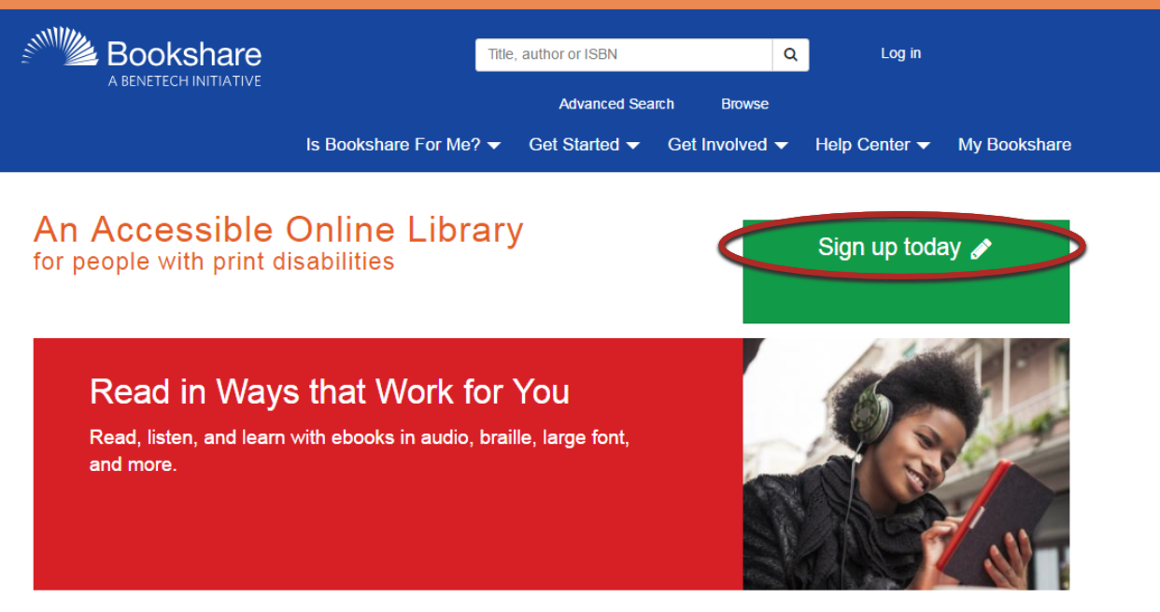

1. Select "Sign Up Individual."

Screen shot of Sign Up page with callout around Sign Up Organization


1. Select the "yes" radio button to confirm the account is for a person with a print disability and fill in the information requested on the form.

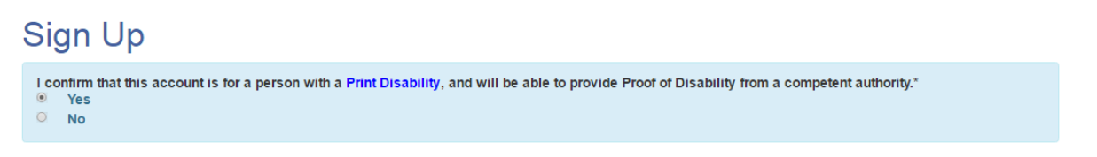

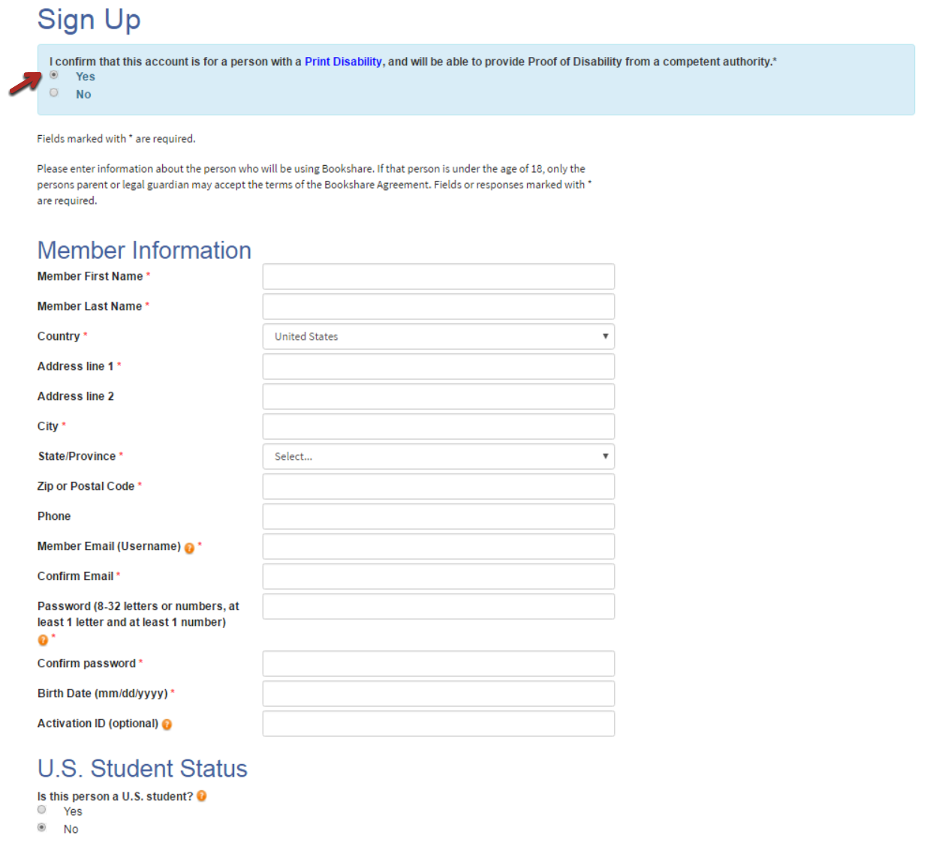

1. Under “U.S. Student Status,” indicate whether you are a current U.S. student, then complete the necessary information if applicable. Membership is free for students.

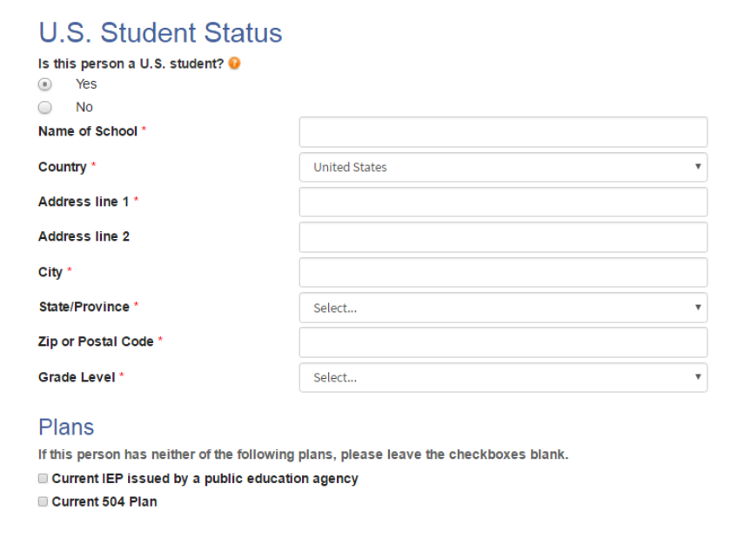

1. Review and accept the Bookshare Individual Membership Agreement, sign name, and select "Create Account."

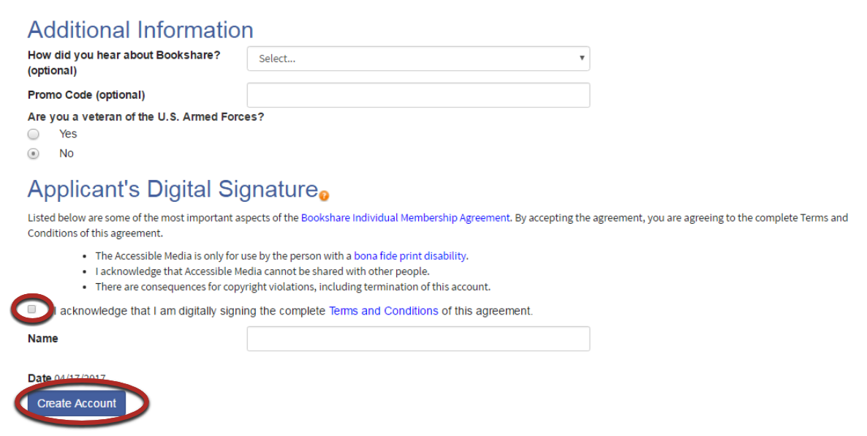

1. You will be taken to your "My Bookshare" page. Select "Submit POD."

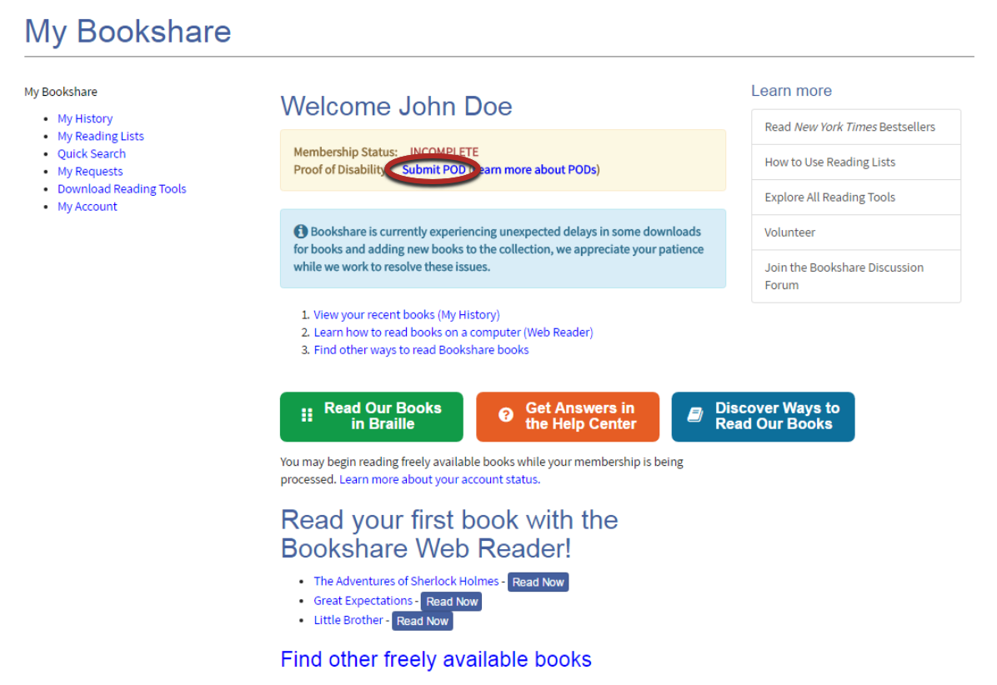

1. Download the Proof of Disability form or submit a copy of your NLS or Learning Ally information.

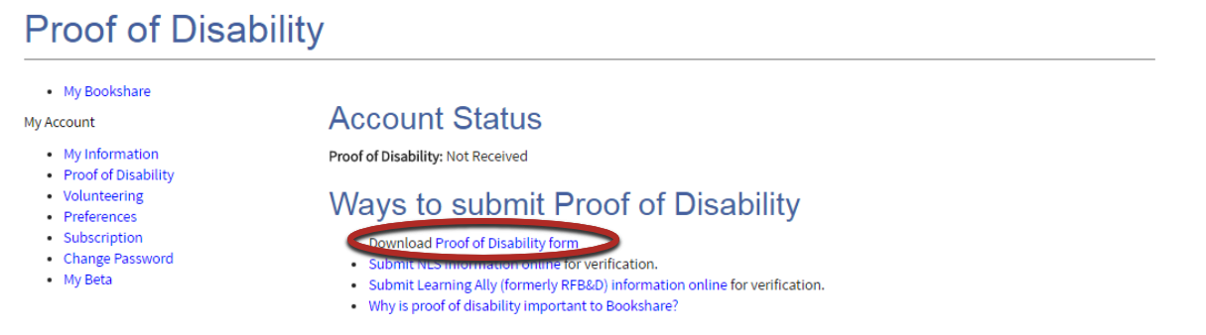

1. If using the Proof of Disability form, select type of disability and have a Competent Authority sign the form. Visit the "[Who Qualifies](https://www.bookshare.org/cms/bookshare-me/who-qualifies)" page for examples of Competent Authorities. Once completed, email as an attachment to [membership@bookshare.org](mailto:membership@bookshare.org) or mail to the address on the form.

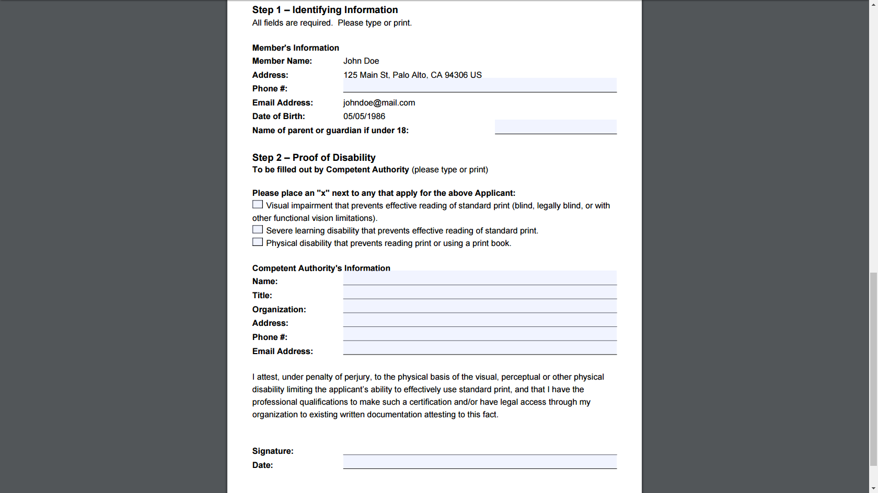

1. Once you receive an email from Bookshare confirming that your Proof of Disability has been accepted, log into the Bookshare website and select "My Account" on the "My Bookshare" page. *Note: Students do not need to purchase a subscription*.

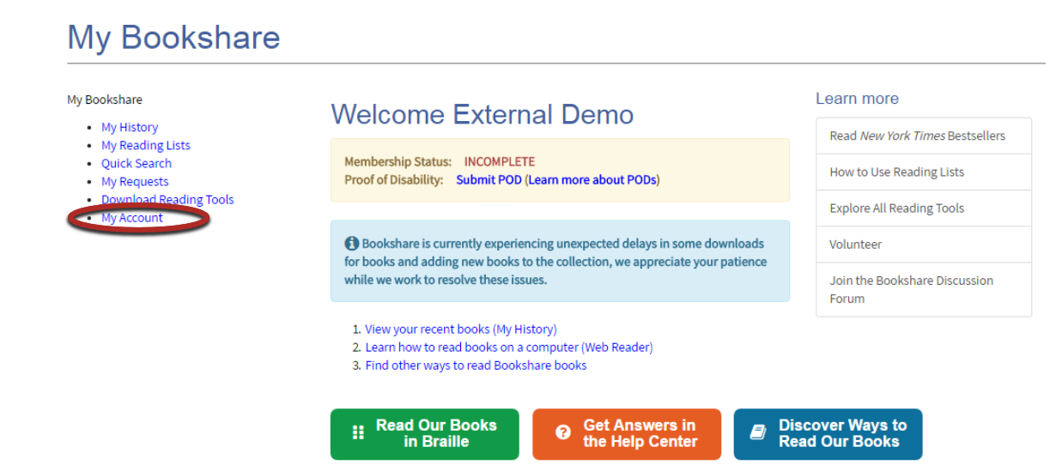

1. Next, select "Subscription."

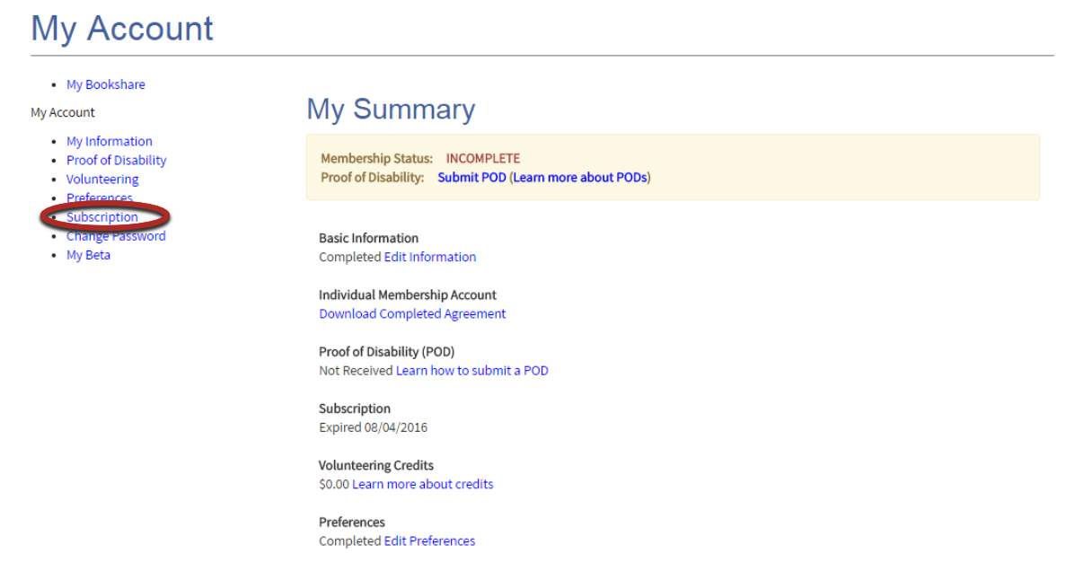

1. Select payment method, fill in necessary information and select "Preview Order.”

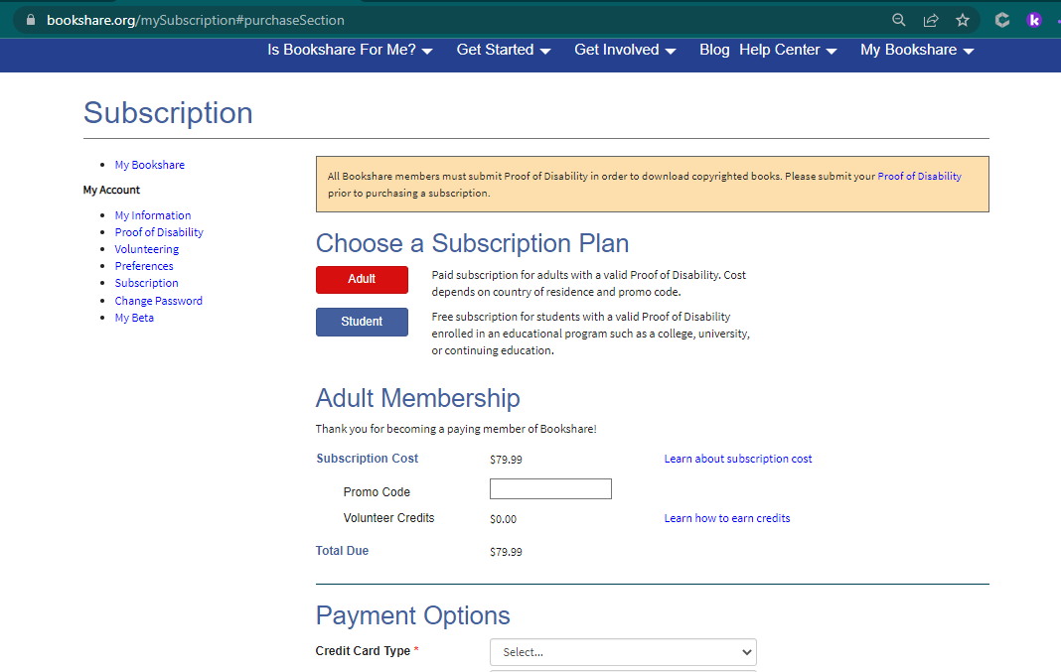

1. Review order and select "Purchase."

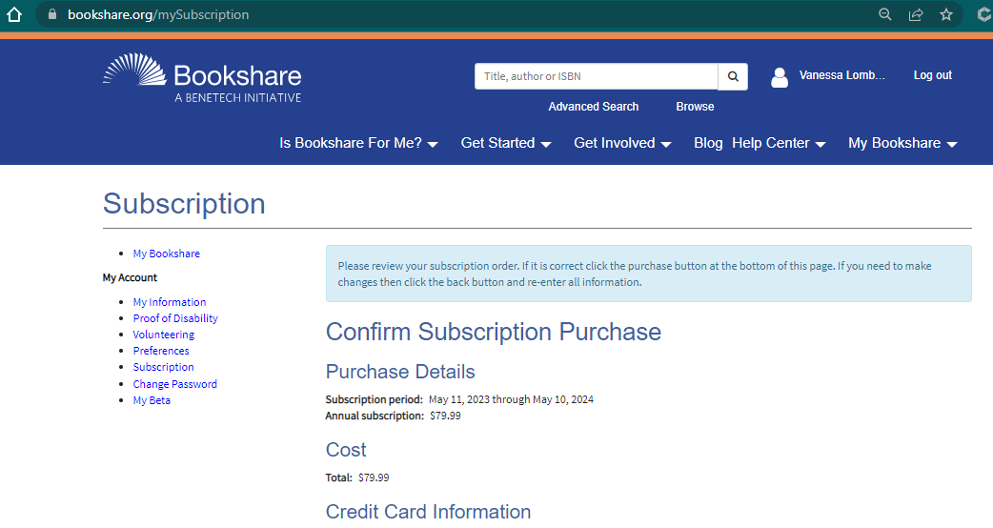

1. Check your "My Bookshare" page for account status. Your account will be active once Bookshare has received your payment.