**Three zoned graphic. To the fart left is a boy is sitting against a tree, smiling, and looking at the screen of a laptop. His arms are raised.
In the middle is the Bookshare logo in a orange box.
To the far right is a man looking intently at a tablet screen.**

**How-to Guide:**

Subscribe to or Copy a Reading List

## Subscribe to or Copy a Reading List

# You can Subscribe to and/or copy Reading Lists from other Sponsors in your organization and Reading Lists curated by Bookshare. Reading Lists to which you subscribe will automatically update with new titles as the owner of the list makes changes. Copying a list takes a "snapshot" of a Reading List, which you can then customize by adding or removing books or changing the name.

1. To subscribe, select "My Reading Lists" on your "My Bookshare" page.

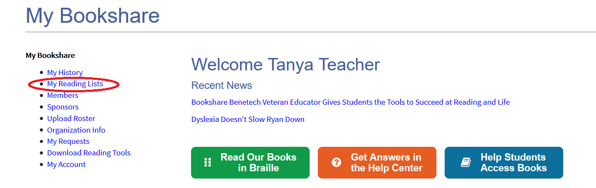

1. Select the "Subscribe" button. A list of available Reading Lists will appear.

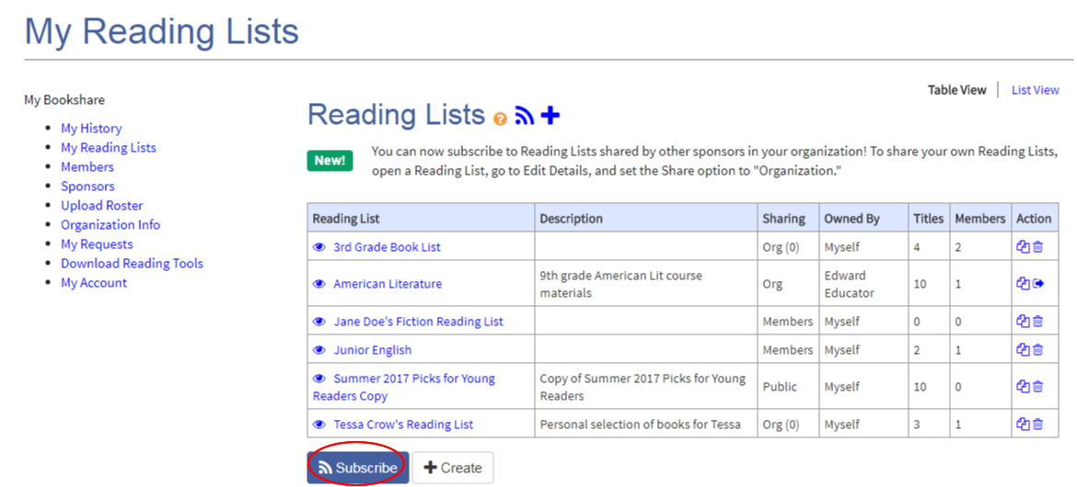

1. You can view by All Reading Lists, your Organization's Reading Lists or Public Lists (curated by Bookshare) and can sort by "Owner" to see who within your organization created the lists and/or public lists.

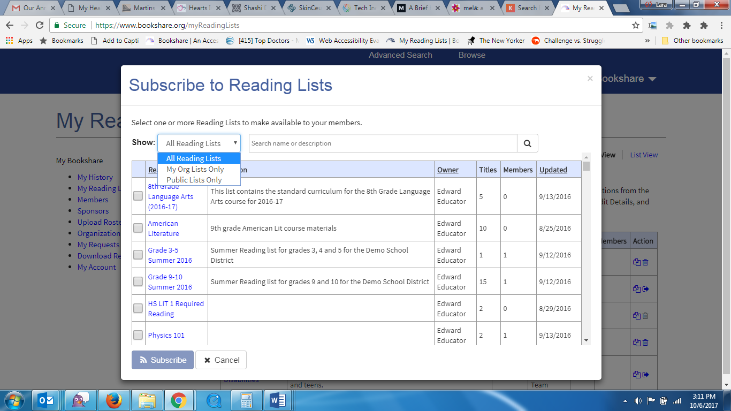

1. Select a list(s) and then "Subscribe."

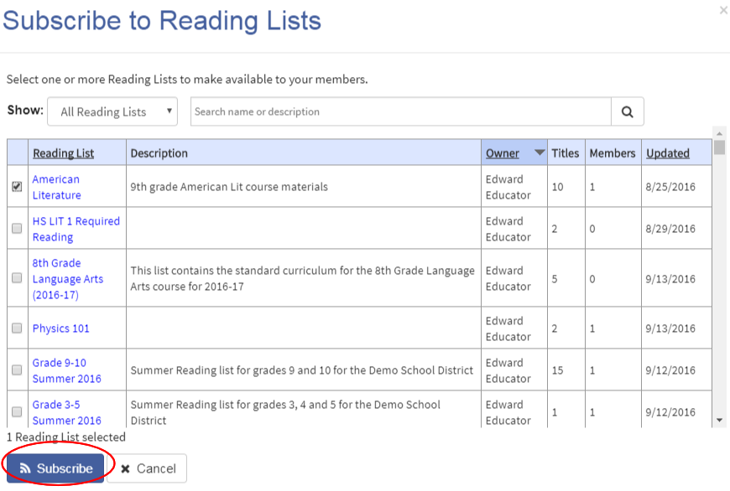

1. Next, select the Reading List to which you just subscribed to on your "My Reading Lists" page.

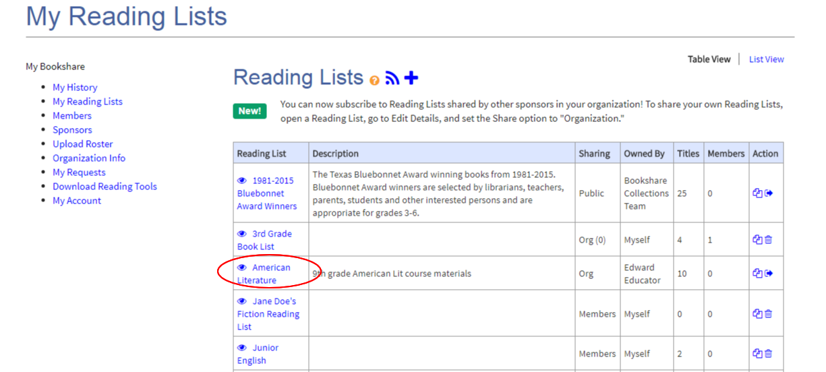

1. Select "Assigned Members" to add students from your Member Roster and select "Add Selected Members."

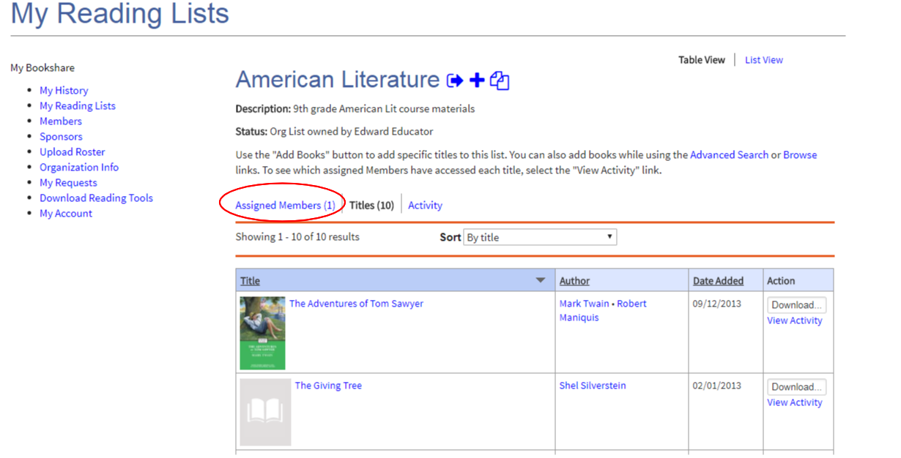

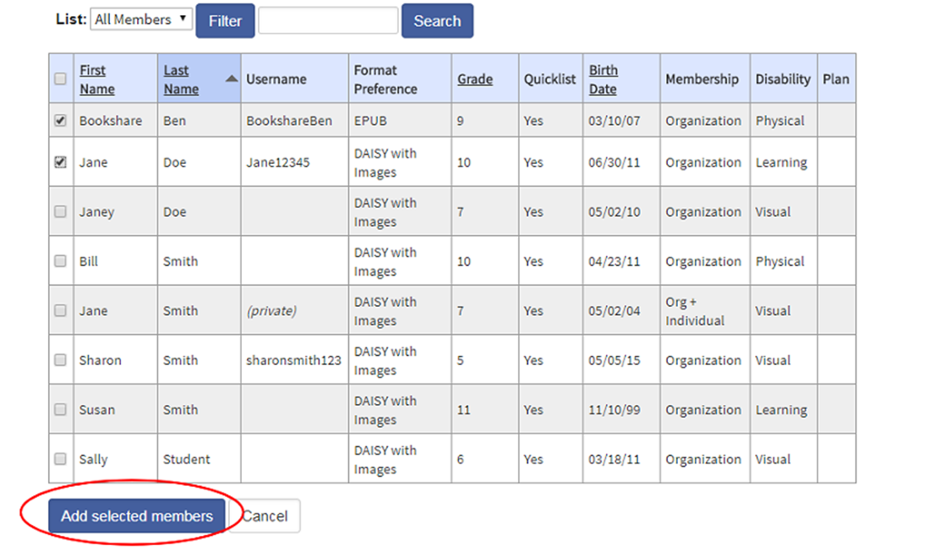

.

1. To copy a list to which you have subscribed in order to modify it, go to your "My Reading Lists" page, find the Reading List you wish to copy, and select the Copy icon under the "Action" column.

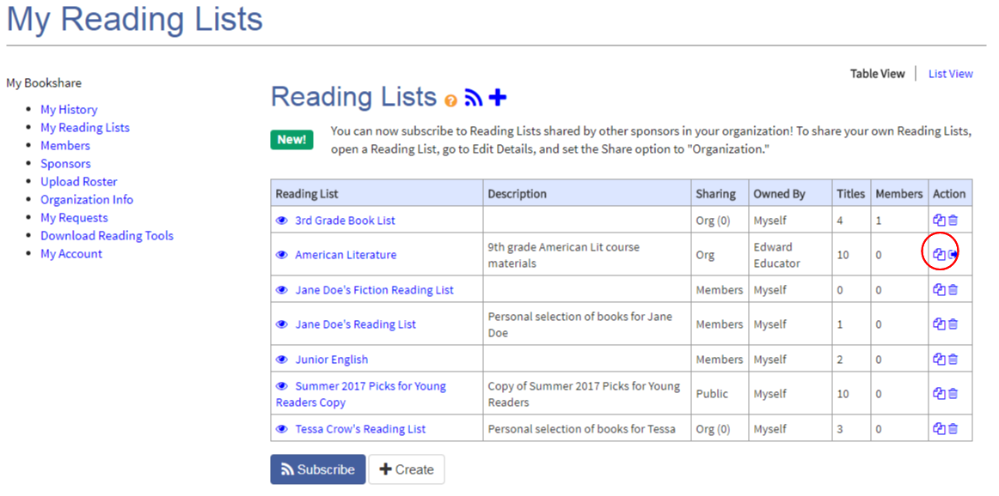

1. The list will now appear as a copy under "My Reading Lists." You may now add books to it or delete books from it.

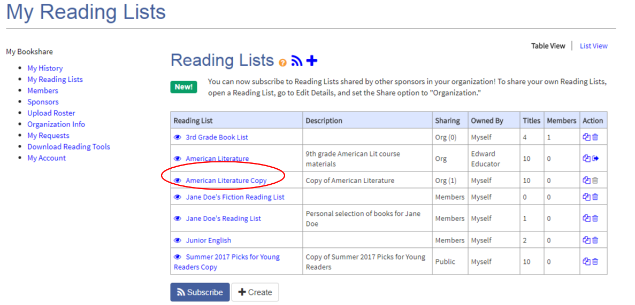

1. To modify your newly copied list, select it and then use the icons next to the Reading List name to complete your desired action.

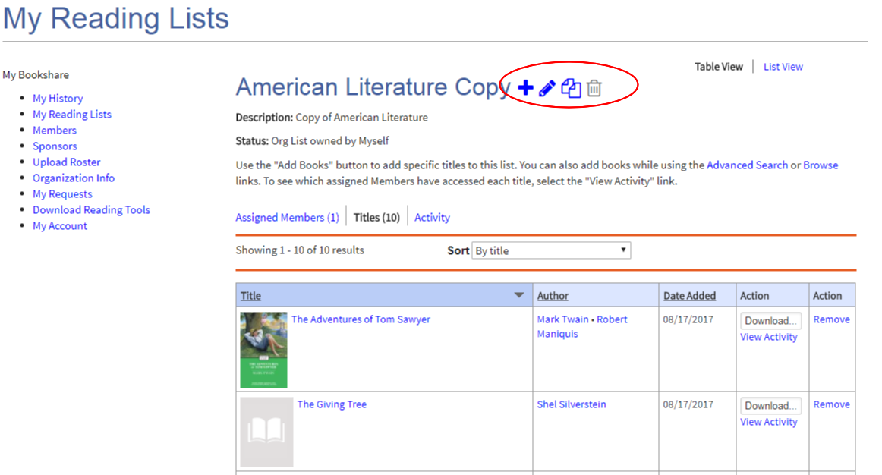

1. Select the "Assigned Members" link to add or edit members.

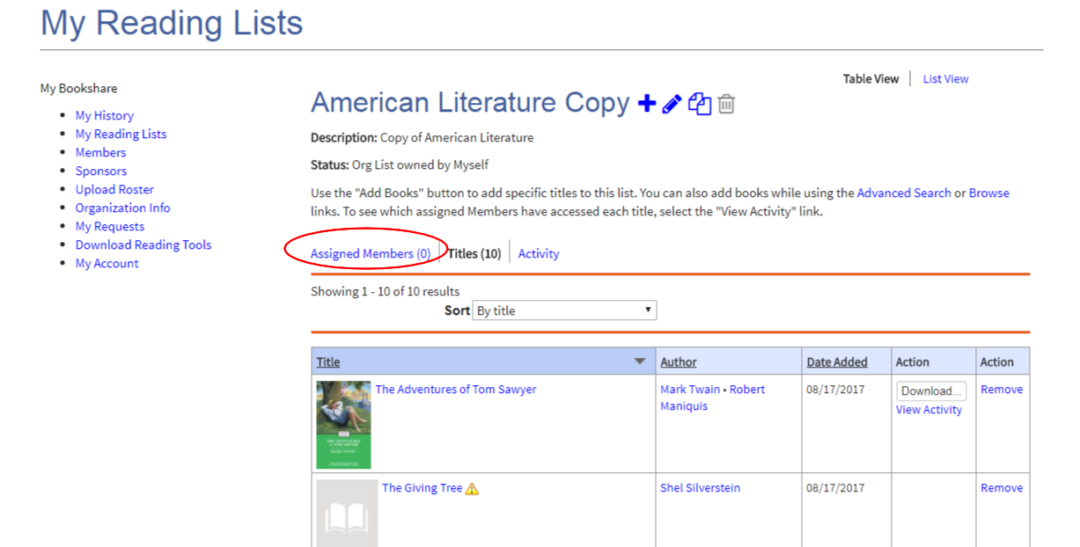

1. To copy or subscribe to one of Bookshare’s curated lists, you can also select “Browse” from any page on the Bookshare website to access the page of Special Collections.

  
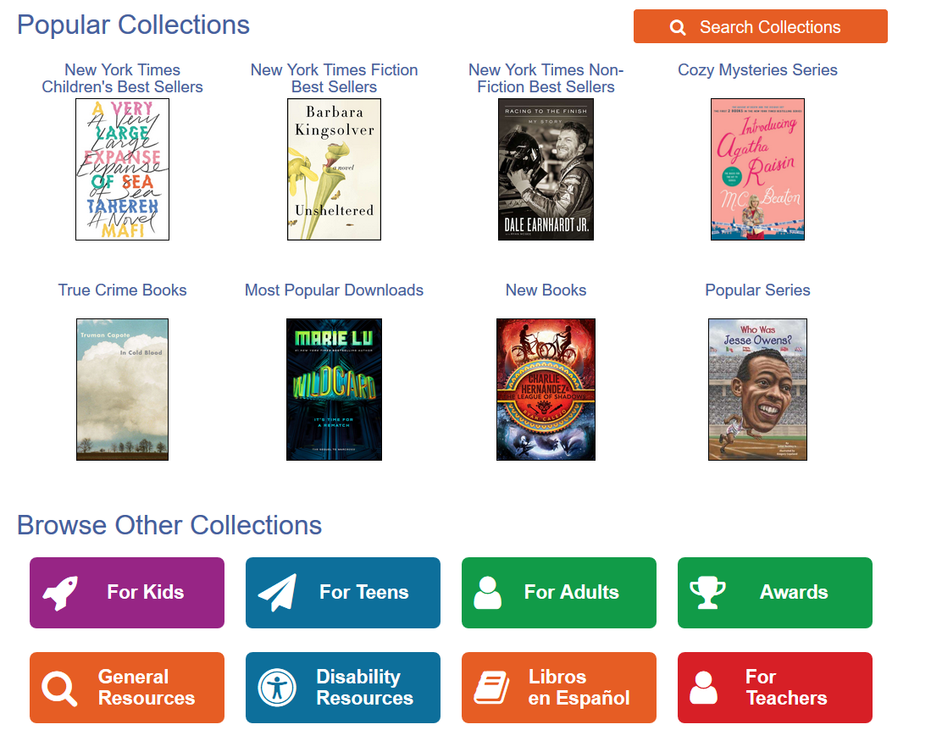

1. Select the list you wish to subscribe to/copy and select the appropriate icon (you must be logged in to your Bookshare account to do this). This list will now appear on your “Reading Lists” page under “My Bookshare.”

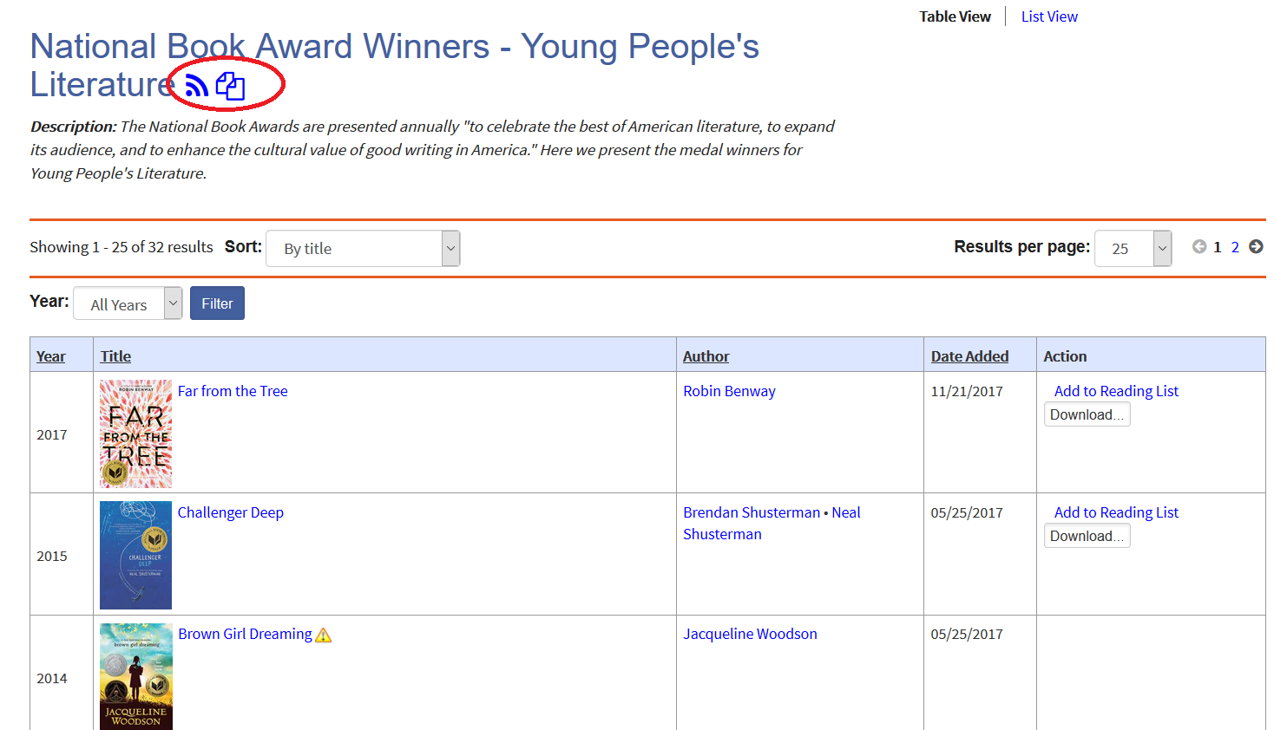

Thank you for choosing Bookshare. If you would like to learn more, please visit our [Training and Learning Center!!](https://www.bookshare.org/cms/help-center/learning-center)