**Image 1 - A boy is sitting against a tree, smiling, and looking at the screen of a laptop. His arms are raised.

Graphic - Bookshare logo in a orange box.

Image 2 - A man is looking intently at a tablet screen.**

**How-to Guide:**

Read Bookshare Books in MS Word

**Image 3 - A boy and woman are smiling as they look at a computer screen. A open book is in the foreground.

Graphic - Blue box.

Image 4 - A woman is smiling as she looks at a tablet screen.**

## Bookshare Books in Microsoft Word

# Bookshare books can be downloaded as Word documents and read with any compatible editor or reading tool. With a Word document, members can:

# Customize the font size, colors, styles, and more

# Annotate text

* Divide one book file into separate files by chapter or other subsection

# And more, depending on the tool used

A fast, easy way to read and hear Bookshare books is in Word Online using the built-in Immersive Reader tool. You will need a Microsoft Online account. If you don't already have one, set it up on [Microsoft's Account website](https://account.microsoft.com/account/). Then follow the steps below:

1. Log in to your Bookshare account, select your desired book and select the “Download” button.

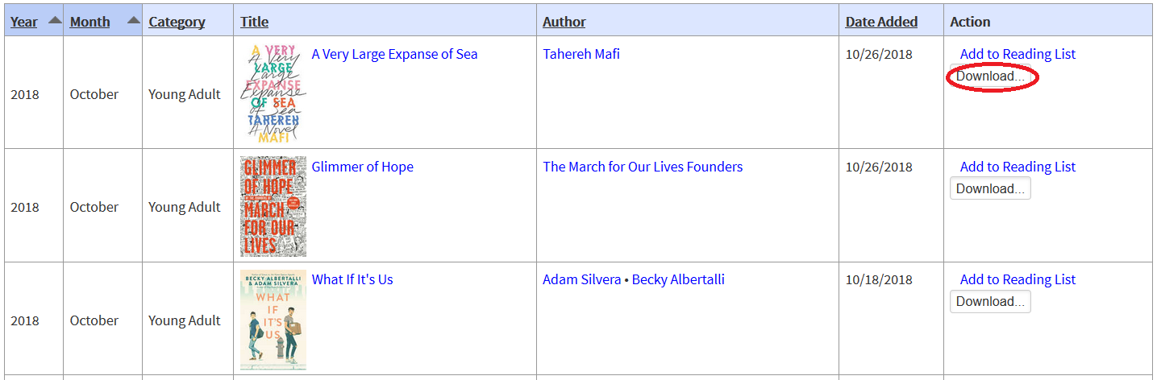

1. If you are a Sponsor on an organizational account, select the member(s) for whom you wish to download the book and select “Word” as the download format.

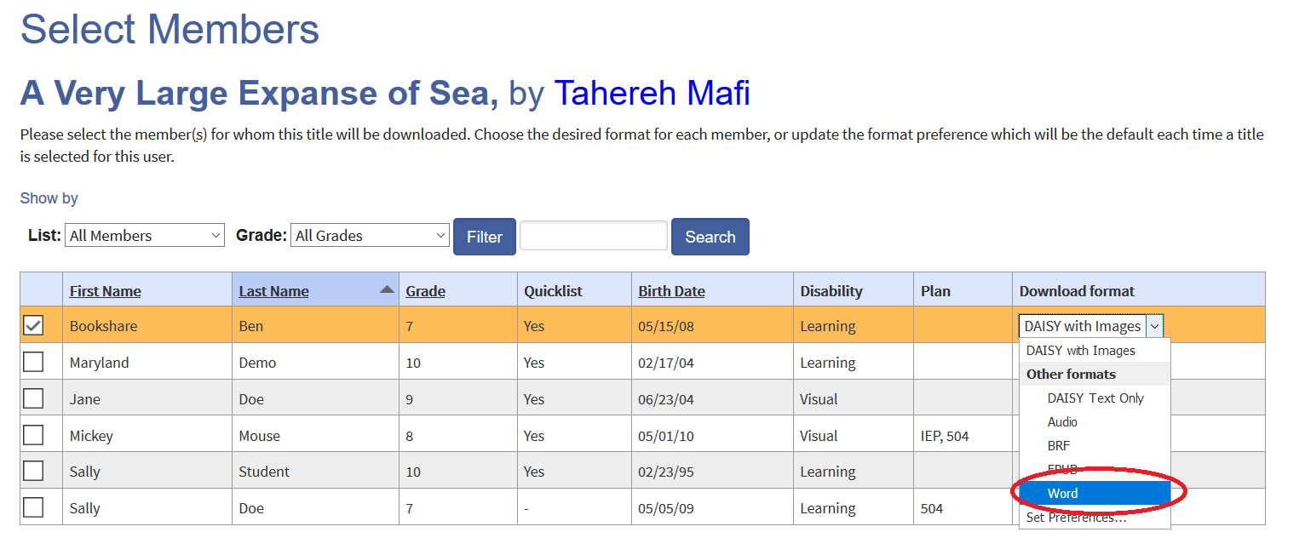

1. Select the “Download” button to confirm download.

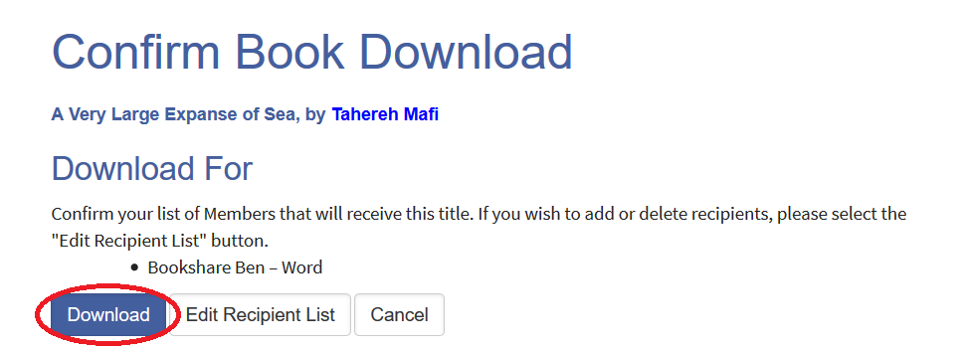

1. You will be taken to “My History”. Select “Available” under “Status.”

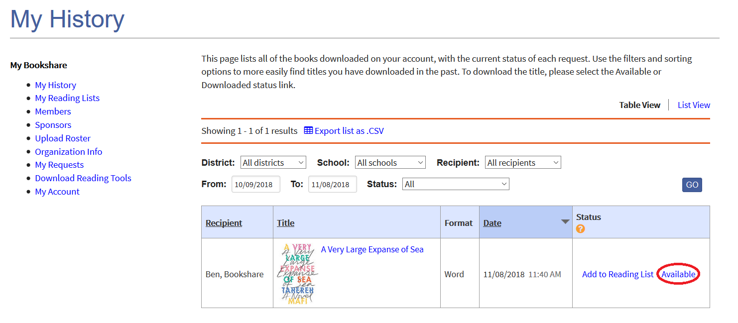

1. Depending on your browser, you will either have an option to Open or Save the file, or the file will automatically download.

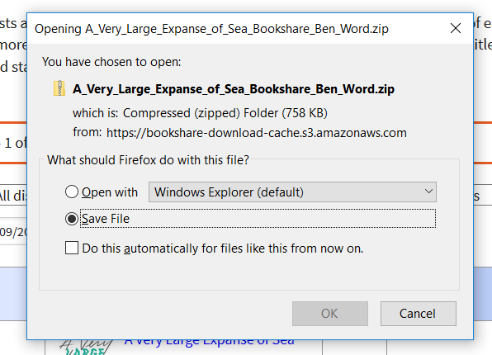



1. Find the zipped file in your Downloads folder and extract the zipped file. We recommend creating a folder just for Bookshare books.



1. Navigate to the [Office Online website](https://products.office.com/en-us/office-online/documents-spreadsheets-presentations-office-online). Select the Word icon.

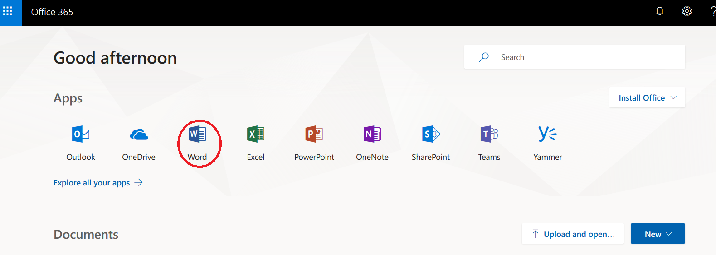

1. Select the “Upload and open” button.

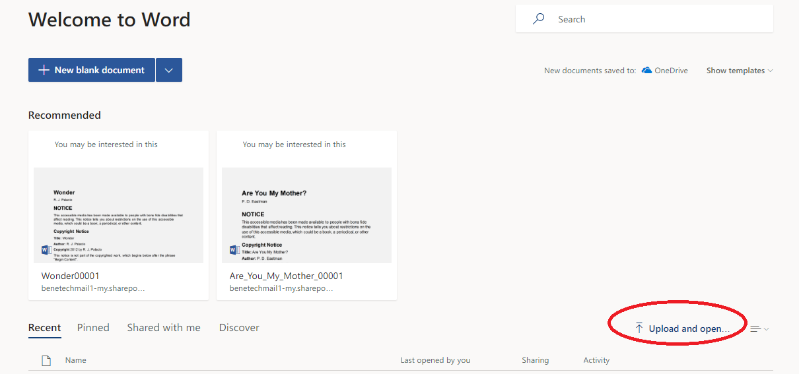

1. Navigate to your Downloads folder, find the appropriate book file and select “Open.”

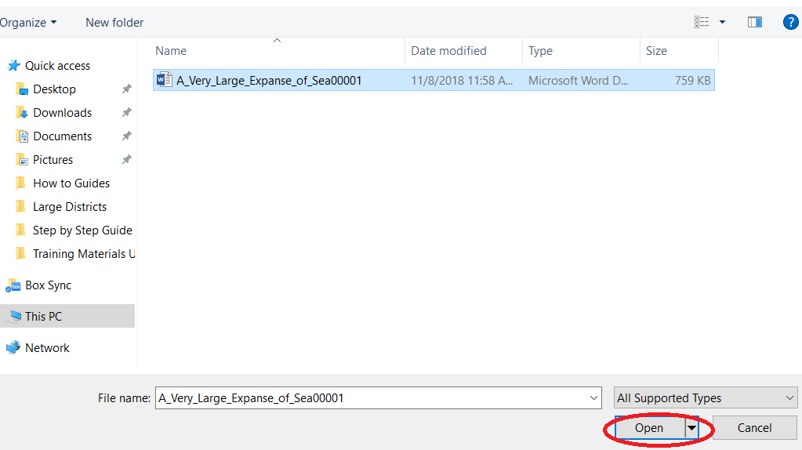

1. The book will open in Word Online. Navigate to your desired page, then select “View” on the toolbar, then “Immersive Reader.”

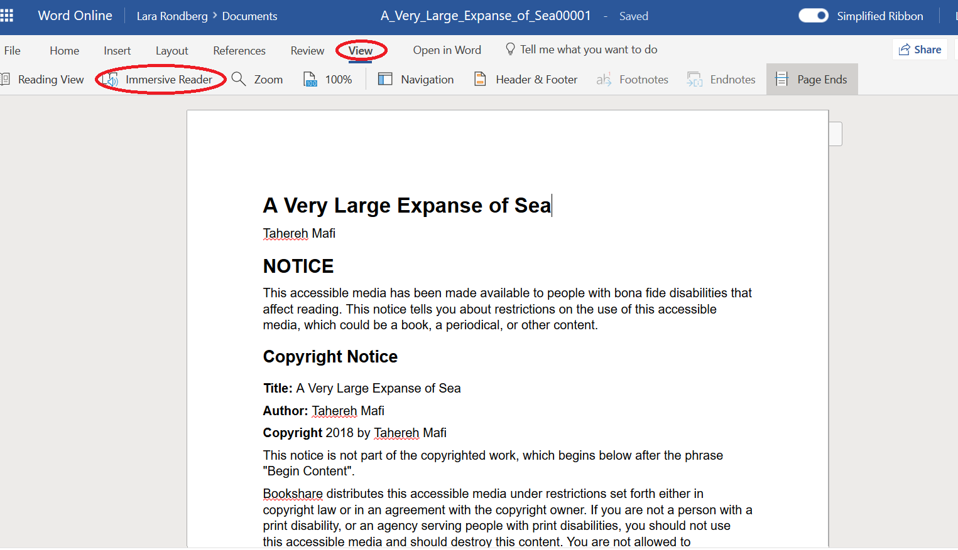

1. The book will open in Immersive Reader, which will enable you to listen to the book and follow along with highlighted text. Select the green play button to enable text to speech.

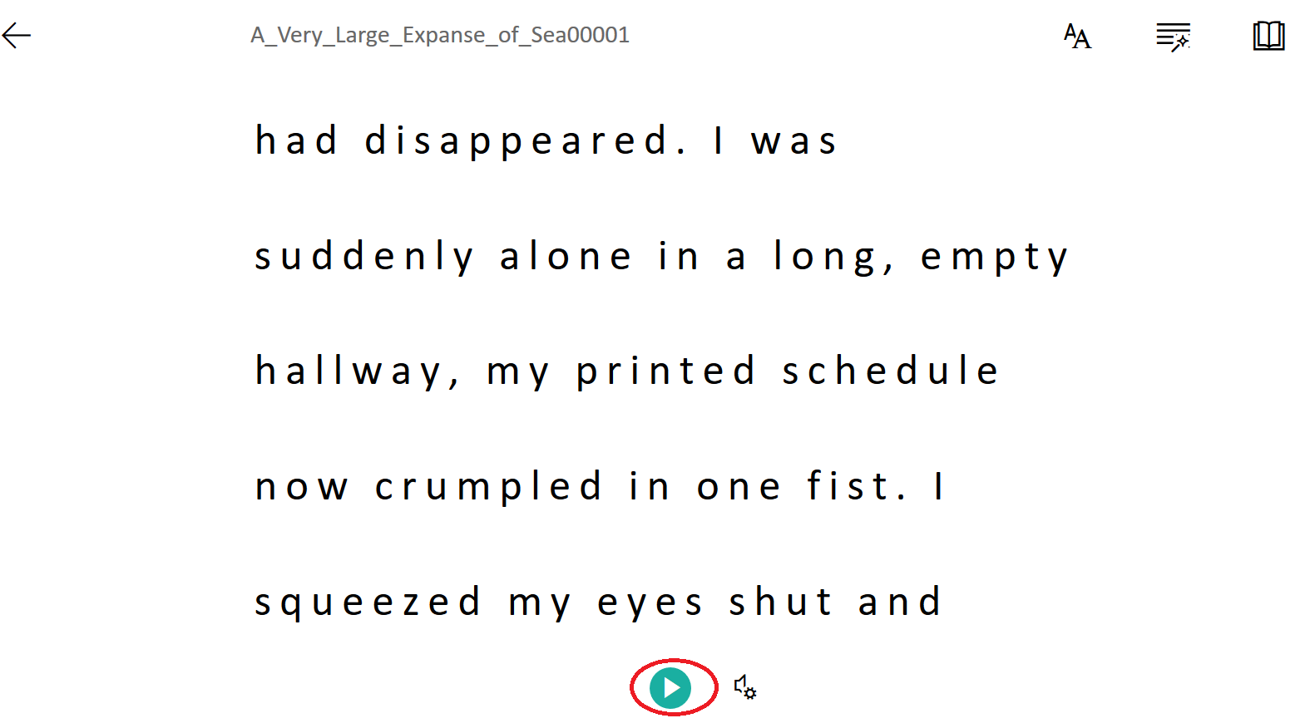

1. Select the speaker icon next to the play button to adjust audio settings.

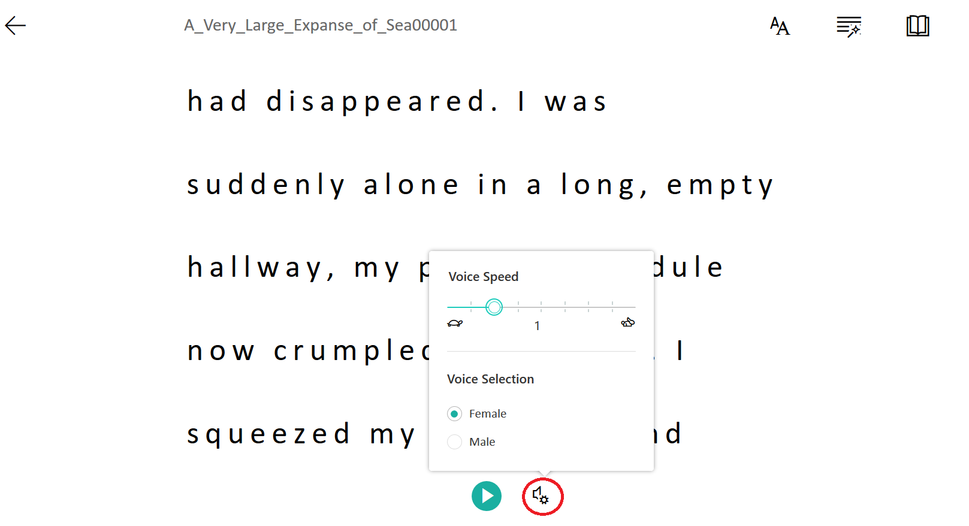

1. Select the icons at the top of the page to customize the text, grammar and reading preferences which includes the option to see images from Boardmaker in word definitions.

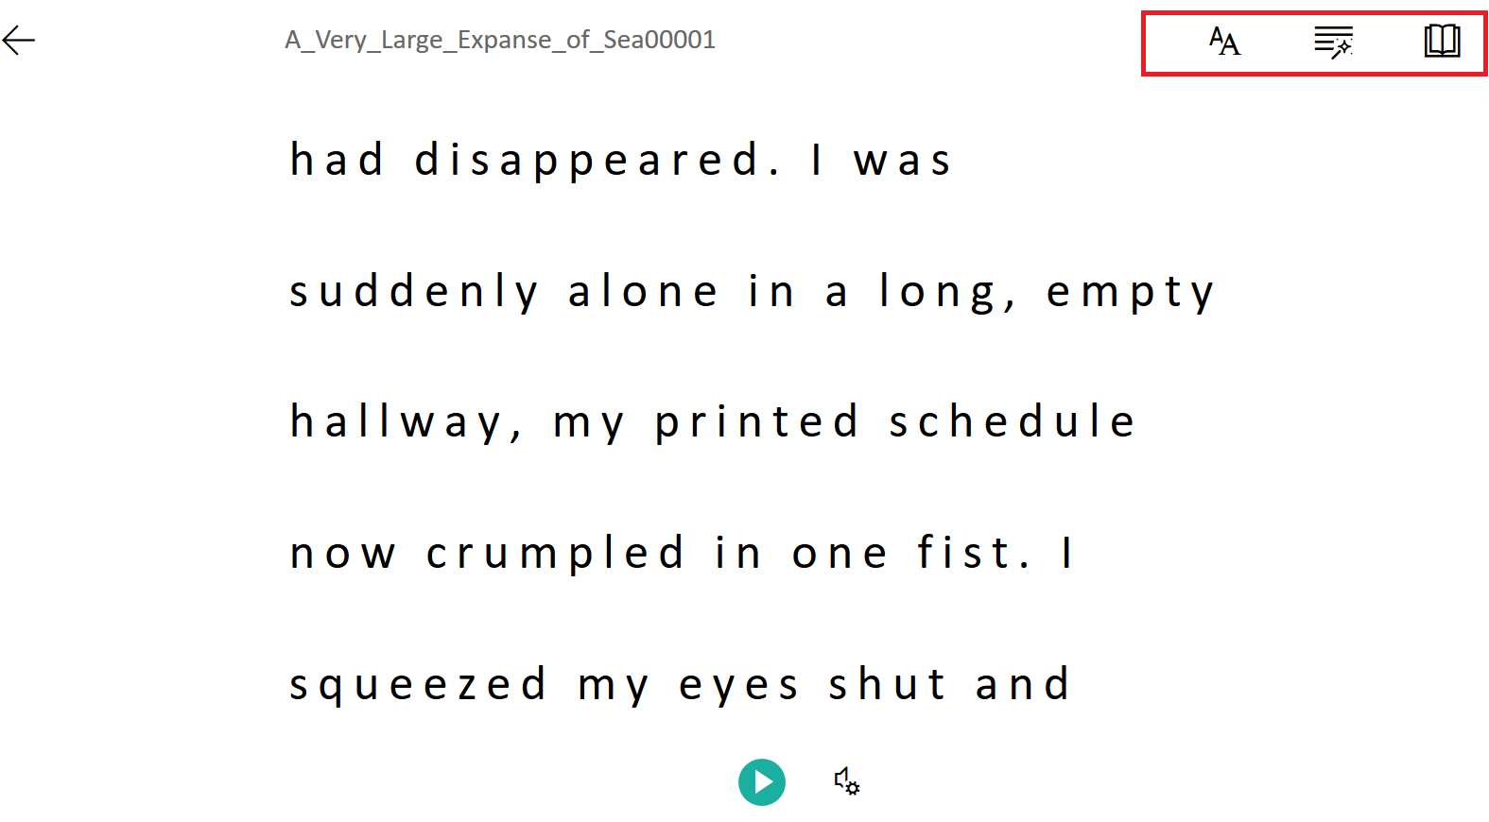

Text Grammar Reading Preferences

