Find Your Reading Companion Conversation History on the Bookshare Reader Mobile App
Reading Companion saves your past conversations so you can revisit previous questions and answers anytime.

Accessing Your Conversation History
Open Reading Companion in a book or document. Select the "See past conversations” button on the screen. This opens a list of all your past conversations for that book or document.
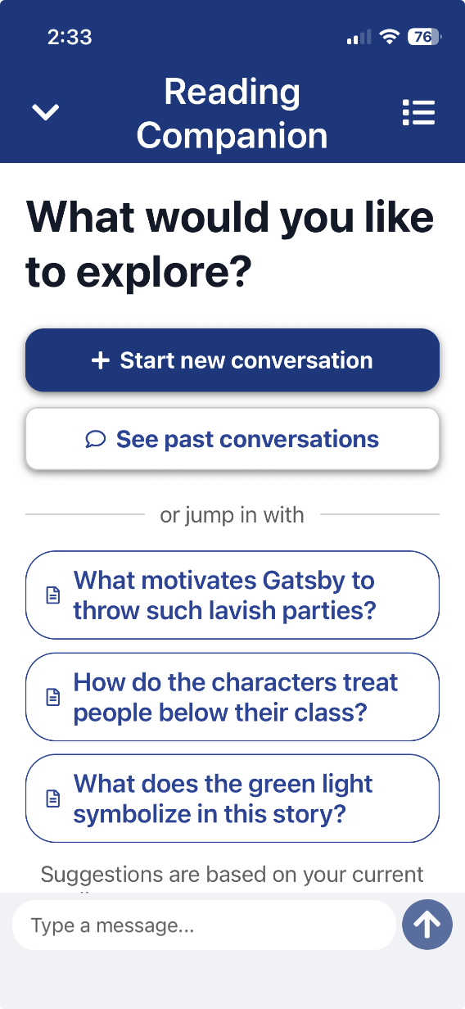

Reviewing Past Conversations
Your conversation history is organized by date. Select any past conversation to review the full exchange, including your questions and Reading Companion’s responses.
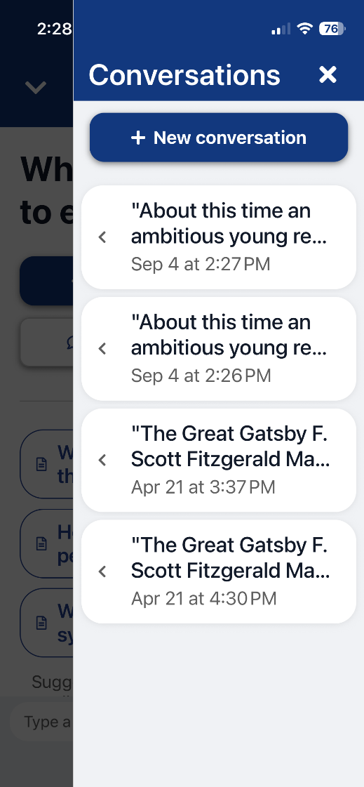

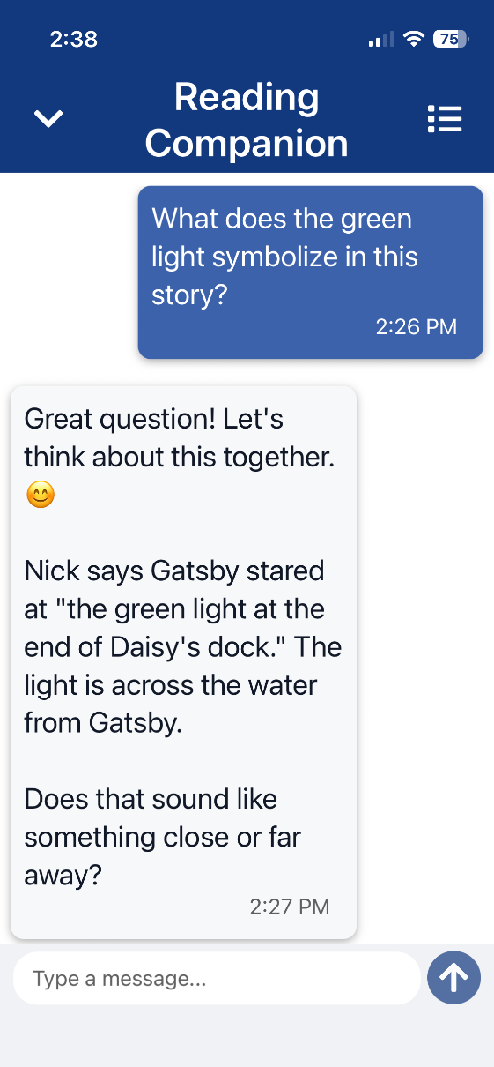

This is useful for:
- Reviewing explanations or practice questions from a previous study session
- Picking up where you left off with a reading assignment
- Revisiting step-by-step breakdowns of problems you worked through
Tip: Each document you read has its own conversation history, so you can easily find help related to a specific assignment

Questions? Email us at bookshareplus@benetech.org and our team will be happy to help.

