Teachers: Log In, Upload, and Transform a Document for Students
Upload your classroom materials to Bookshare Plus and let AI automatically transform them into accessible documents that your students can read online.
Step 1: Log into Bookshare
Go to www.bookshare.org and enter your teacher username and password. Once you log in, you will arrive at your My Bookshare page.
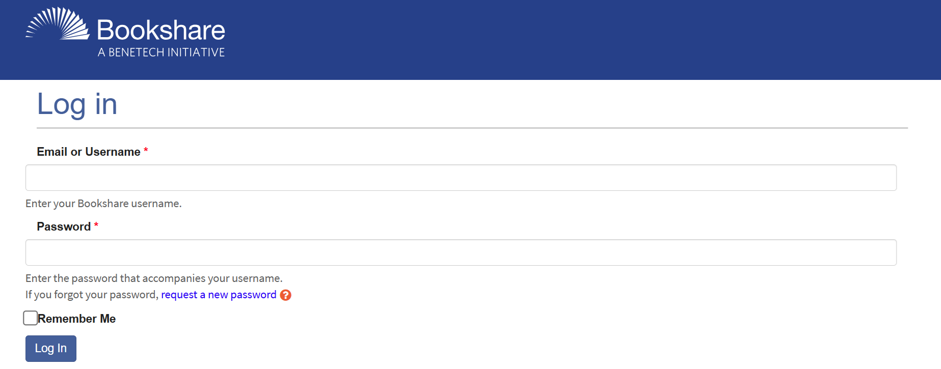
Step 2: Go to My Documents
On the My Bookshare page select the "My Documents (beta)" link from the left sidebar menu.
Step 3: Upload Your Materials
On the My Documents page, you have two ways to upload materials:
- Upload from your computer: Select the “Upload file from device” button to select the files you want.
- Upload from Google Drive: Select the "Upload from Google Drive" button, connect to your Google Account, and select files directly from your drive.

Supported File Types
- PDF
- JPG image files
- PNG (screenshots)
- HEIC (Apple image format)
- PPTX files (presentations)
Note: You can upload files up to 200 pages or 20MB in size.
Step 4: Receive Your Transformed Document
After you upload your files, Bookshare Plus AI automatically transforms them into an accessible format.
- The document initially shows an "In Progress" status while being processed. Processing usually takes less than 30 seconds to 2 minutes.
- When processing is complete, a pop up announces the conversion has been successful, and the options to Read Online, Assign, and Add to Reading List appear.
Step 5: Assign Documents to Students or Add to Reading List
To assign a document directly to one or more students, select the "Assign" button next to the document, check the box next to the student's name, then select the Assign button. Assigned documents will automatically appear on the student’s assignments page on bookshare.org and under My Assignments in the My Library screen in the Bookshare Reader mobile app.
To share a document with an entire class or group, select the "Add to Reading List" dropdown button next to the document. You can:
- Add the document to an existing reading list
- Create a new reading list and add the document to it.

What Does AI Transformation Do?
Bookshare Plus AI excels at the following transformations to make your content accessible:
- Generates image descriptions to make visual content accessible to screen readers
- Creates proper heading structures so students can navigate content easily
- Converts math and chemistry equations into MathML format that screen readers can read aloud
- Organizes lists and tables so they are readable with assistive technology
- Converts diagrams and graphs so that visual data is readable with assistive technology

Questions? Email us at bookshareplus@benetech.org and our team will be happy to help.

