Managing Your Documents
Once you have uploaded and transformed your learning materials, the My Documents page is your hub for managing your documents. Access the My Documents page under the My Library heading on your Bookshare home page.

Viewing and Sorting Your Documents
Each document card displays the file name, upload date, and available actions. Documents are listed with the most recently uploaded files at the top.
You can sort by Title or Date Uploaded, and view results ascending or descending.
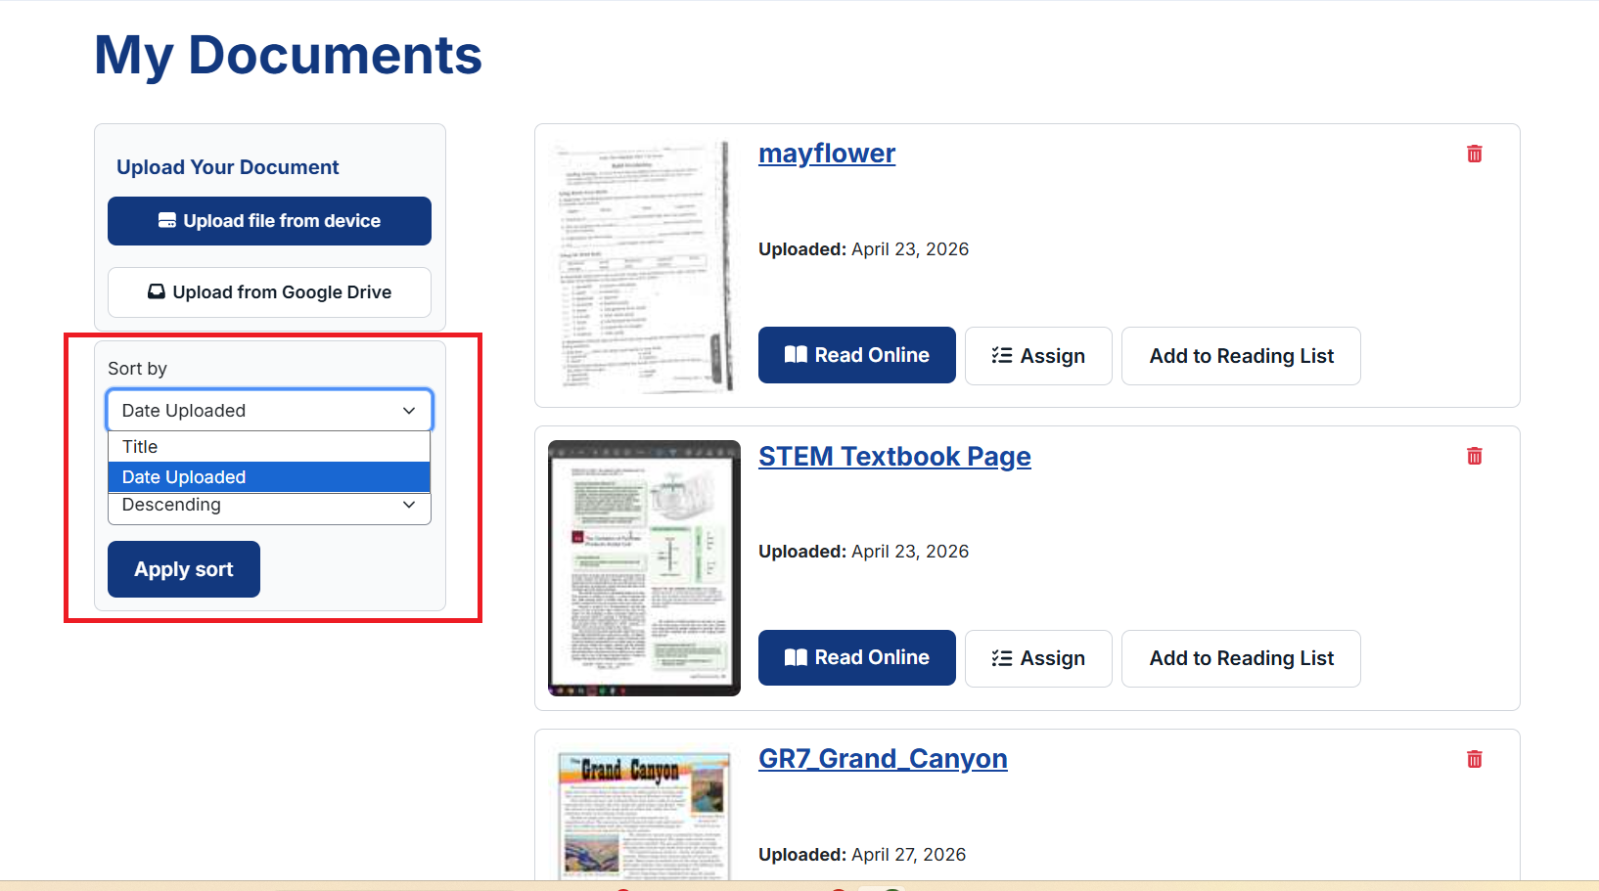

Deleting Your Documents
Use the trashcan icon to delete a document.
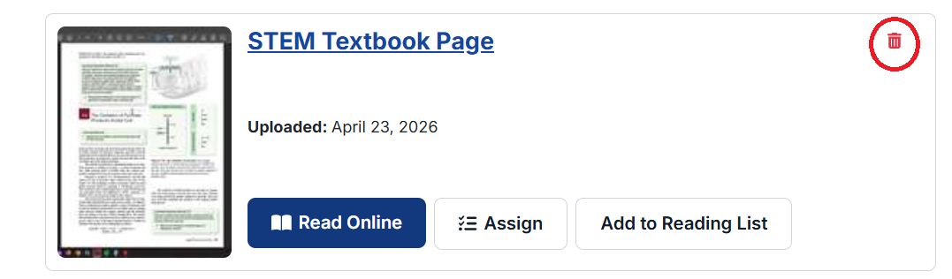

Questions? Email us at bookshareplus@benetech.org and our team will be happy to help.

